Minutes

Discrete Positioning and Delivery Workflow (DPDW)
Conference Call

April 24, 2018
10:30am – 11:05am EST

DPDW Subgroup Chair:
Thomas Schwere, Varian Medical Systems
(thomas.schwere@varian.com)

IHERO Task Force Co-Chairs
Dick Fraass, Ph.D., FAAPM, FASTRO, FACR
John Buatti, MD

Mission Statement: The American Society for Radiology Oncology (ASTRO) has formed a multi-society Task Force to undertake an initiative to promote the Integration of the Healthcare Enterprise (IHE) – Radiation Oncology (RO), fostering seamless connectivity and integration of radiotherapy equipment and the patient health information systems. The Task Force will include members from ASTRO, RSNA, American Association of Physicists in Medicine (AAPM), the American College of Radiology (ACR) and the Medical Imaging and Technology Alliance (MITA). In addition, members of the International community have also been invited to participate in IHE-RO. The IHE-RO Task Force, in close collaboration with radiotherapy product manufacturers, will develop appropriate integration profiles for radiation therapy and setup a demonstration of seamless communication among the full array of radiotherapy products.

In Attendance:
Jill Moton (AAPM)
Thomas Schwere (Varian)
Istvan Matyas (Siemens)
Gergely Parditka (Brainlab)
Sanjay Bari (Elekta)
Harold Beunk (ICT)

Call to Order
The meeting was started at 10:30am EST.

Design Topics

Actor Combinations
Thomas quickly showed and explained the same actor combinations as already used in an earlier TCon:
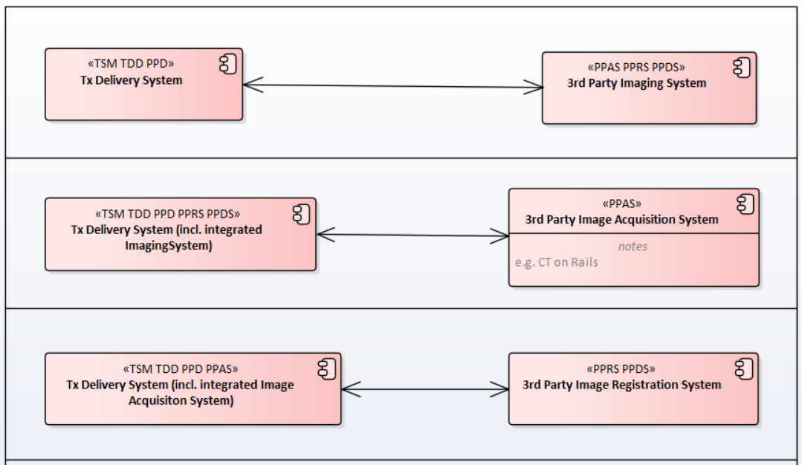
Harold mentioned that this is kind of IPDW+, i.e. TMS would always run in the IPDW regime, TSM would also run in the IPDW regime apart from outsourcing some dedicated steps to a 3rd party system. That outsourcing would use the Push model (N-EVENT-REPORT) as currently specified in DPDW when requesting an actor to perform a UPS.
The group was open for that “new” approach and will continue discussion in the next TCon. If the group agrees on following that path, the focus should first be on finalizing IPDW profile (using protocols instead of instructions from DICOM supplement 160).

Monitoring Use Cases
Gergely raised his concern about removing monitoring use cases from the profile. Monitoring seems to be quite important (e.g. deep inspiration breath-hold). Current solutions most likely use proprietary interfaces. So, there is indeed a need to standardize this.
For the next TCon Gergely will collect the information needed in a monitoring system and the interactions between the monitoring device and the delivery device. We can then also check how this fits into the monitoring scenarios we worked out during the last year.

Adjournment
The meeting was adjourned at 11:05am EST.

Appendix A: Administration and Process Information
Documents are published at the following locations. If you have problems in accessing the document, please contact the Chair (thomas.schwere@varian.com).

Process of Authoring:
Steps:
- Download a local copy of the document from locations below
- Open this copy and remove all change bars
- Ensure, that Changes Bars are switched on
- Make your changes
- Provide the updated version to the Chair

Location of Documents:
DPDW Subgroup Minutes
http://wiki.ihe.net/index.php?title=RO_DPDW_WorkingGroup

DPDW Profile
The DPDW Profile is an IHE-RO document.
The current version is available in the IHE-RO Org Wiki:
http://www.ihe-ro.org/
Please find the current document under this page:
http://www.ihe-ro.org/doku.php?id=doc:profiles

Supp 160
DICOM Supplement 160 (Patient Positioning and Workflow) in s DICOM WG-07 document.
The current version is available at the DICOM ftp server:
ftp://d9-workgrps:goimagego@medical.nema.org/MEDICAL/Private/Dicom/WORKGRPS/WG07/Sup/Sup160_PatientPositioningAndWorkflow

Mailing List:
The mailing list for the DPDW subgroup is:
iherodpdw2018@aapm.org

Appendix B: Task Assignments
Per end this TCon (2015-01-27).
No | TX / Area | Old Number | Title | Group | Owner
1 | ./. | ./. | Use Case Delivery-Device Independent Imaging |  | David Wikler
2 | RO-DPD-200 | RO-DPD-01 | Worklist Query for Positioning Acquisition | Acquisition | Martin Vonach
3 | RO-DPD-201 | RO-DPD-02 | Retrieve Device Position Information | Acquisition | Martin Vonach
4 | RO-DPD-202 | RO-DPD-03 | Request RT Patient Position Correction | Correction | Martin Vonach
5 | RO-DPD-203 | RO-DPD-04 | Store RT Patient Position Modification Instruction | Correction | Martin Vonach
6 | RO-DPD-204 | RO-DPD-05 | Store RT Repositioning Results to Object Storage | Correction | Martin Vonach
7 | RO-DPD-205 | RO-DPD-06 | Worklist Query for Repositioning | Correction | Martin Vonach
8 | RO-DPD-206 | RO-DPD-07 | Notify on Radiation Delivery Status Change | Delivery | Thomas Schwere, Sanjay Bari
9 | RO-DPD-207 | RO-DPD-08 | Retrieve RT Patient Position Correction Instruction | Correction | Martin Vonach
10 | RO-DPD-208 | RO-DPD-09 | Subscribe/Unsubscribe to Treat UPS Status | UPS Notification | Thomas Schwere
11 | RO-DPD-209 | RO-DPD-10 | Notify on Radiation State | Delivery | Thomas Schwere, Sanjay Bari
12 | RO-DPD-210 | RO-DPD-11 | Retrieve Positioning Acquisition Results | Registration | Chris Pauers
13 | RO-DPD-211 | RO-DPD-12 | Worklist Query for Positioning Registration | Registration | Chris Pauers
14 | RO-DPD-212 | RO-DPD-13 | Worklist Query for Position Monitoring | Monitoring | Stephen Phillips
15 | RO-DPD-213 | RO-DPD-16 | Store Monitoring Results to Object Storage | Monitoring | Stephen Phillips
16 | RO-DPD-214 | RO-DPD-17 | UPS Final Update at Session Termination | Framework | Thomas Schwere, Sanjay Bari
17 | RO-DPD-215 | RO-DPD-18 | UPS Completed / Cancelled at Session Termination | Framework | Thomas Schwere, Sanjay Bari
18 | RO-DPD-216 | RO-DPD-19 | Indicate Ready for Monitoring | Monitoring | Stephen Phillips
19 | RO-DPD-217 | RO-DPD-20 | Notify Device to start UPS | UPS Notification | Thomas Schwere, Sanjay Bari
20 | RO-DPD-218 | RO-DPD-21 | Create Positioning Acquisition and Positioning Registration UPS | Workflow | Thomas Schwere
21 | RO-DPD-219 | RO-DPD-22 | Create Treat UPS and Radiation Delivery Instruction for Continuation | Workflow | Thomas Schwere
22 | RO-DPD-220 | RO-DPD-23 | Notify Treatment Session Actors on Starting Session | UPS Notification | Thomas Schwere, Sanjay Bari
23 | RO-DPD-221 | RO-DPD-24 | Notify Device to stop UPS | UPS Notification | Thomas Schwere, Sanjay Bari
24 | RO-DPD-222 | RO-DPD-25 | UPS Progress Update for Discrete non-Treatment Steps | UPS Notification | Thomas Schwere, Sanjay Bari
25 | RO-DPD-223 | RO-DPD-26 | Worklist Query for Positioning Correction Reconciliation | Registration | Chris Pauers
26 | RO-DPD-224 | RO-DPD-27 | External Verification | External Verification | Sanjay Bari
27 | RO-DPD-225 | ./. | Notify Device to resume UPS | Monitoring | Stephen Phillips
28 | RO-DPD-226 | ./. | Create new Positioning UPS | Monitoring | Stephen Phillips
29 | RO-DPD-227 | ./. | UPS Final Update after Positioning Information Acquisition | Workflow
30 | RO-DPD-228 | ./. | UPS Final Update after Treatment Interruption | Workflow | Thomas Schwere

