IHE Change Proposal
Tracking information:
IHE Domain | LAB
Change Proposal ID: | CP-LAB-239
Change Proposal Status: | Assigned
Date of last update: | 3-9-2015
Person assigned: | Riki Merrick

Change Proposal Summary information:
Since chapter on HL7 Implemenation Notes is duplicated in 2a and 2 b - fix discrepancies
Submitter’s Name(s) and e-mail address(es): | Dmytro Rud (dmytro.rud@roche.com)
Submission Date: | 2014-12-11
Integration Profile(s) affected: | LTW
Actor(s) affected: | Order Placer, Order Filler, Order Result Tracker
IHE Technical Framework or Supplement modified: | LAB TF release 5.0
Volume(s) and Section(s) affected: | 2a: 2.4.2 and 2.4.6.2 and 2.4.6.3  2b: 2.4.2 and 2.4.6.2 and 2.4.6.3
Chapter 2.4 - HL7 Implementation Notes chapter is duplicated in the volumes 2a and 2b.

Thereby, these copies are not fully identical:

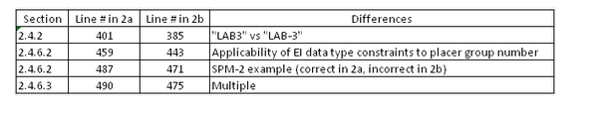
Proposed changes: Either remove entire chapter from 2a or 2b and dependent on which is removed

In Volume 2a:
2.4.2 line 401 – change “LAB3” to LAB-3”
2.4.6.2 line 459 – add “placer group number”

In Volume 2b
2.4.6.2 line 471 fix example to read “SPM|1|^45611&Cytology|...”
2.4.6.3: line 478 – add “and Order Groups (see ORC-4 in ORC segment static definition)”
In this volume the Condition Predicate is split by EIP-1 and EIP-2, but the text is the same. – no changes needed from that perspective.
Line 501 add: “Condition predicate for Order Groups:
• In the context of all transactions dealing with orders, the first sub-component (EIP-1) is 515 populated with the Order Group identifier assigned by the Order Placer application, if known, and the second sub-component (EIP-2) is populated with the Order Group identifier accessioned by the Order Filler application, if known.”

In Vol 2a: 3.3.5.2 “ORU^R01 – Static Definition” correct Table3.3.5.2-1 as shown below:

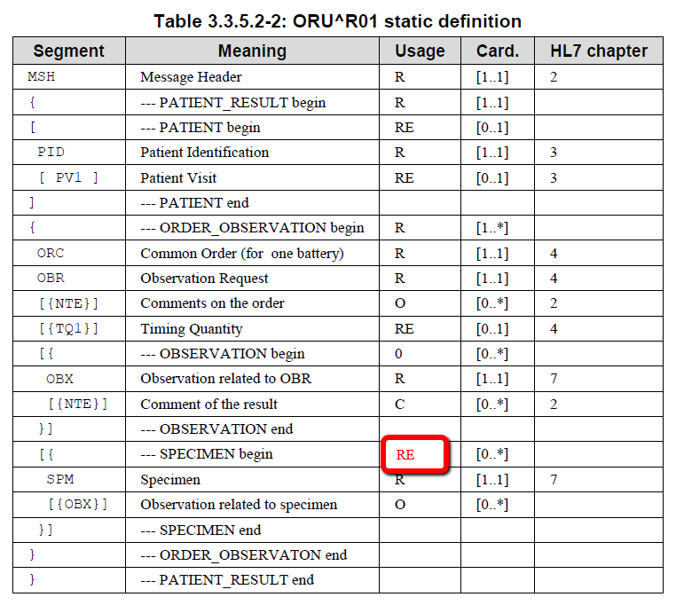

In Vol 2a: section 3.3.5.2 “ORU^R01 – Static Definition” below the table, No change.
The current text is perfect:
The observations and notes produced to fulfill an order are reported as OBX and NTE segmentsin the OBSERVATION segment group following the ORC/OBR pair representing this order.Each specimen used by this order is described as a SPM segment in an instance of the SPECIMEN segment group following the results of the order.
(…)
Following the ORC/OBR, the Order Filler should systematically transmit in the message, all OBX and SPM segments related to this ORC/OBR. This systematic transmission of all observations linked to an OBR and their respective status may help the Order Result Tracker to recover from error situations.

In Vol 2a: section 3.3.5.4.4 “Segment Group Dedicated to the Report Facsimile” No change.
The current text is perfect:
Message ORU^R01 provides this link in a dedicated ORDER_OBSERVATION segment group, appearing at the bottom of the message. This last ORDER_OBSERVATION segment group, which was requested by the Order Placer when the Order Group was placed, is composed of only 3 segments: ORC, OBR, OBX.

In Vol 2a: section 4.5.2 “Interaction Diagram” for the microbiology example, correct the figure showing the interaction diagram, by changing the event associated with the first OUL message to Order Result Tracker, from “NW” to “SC”:
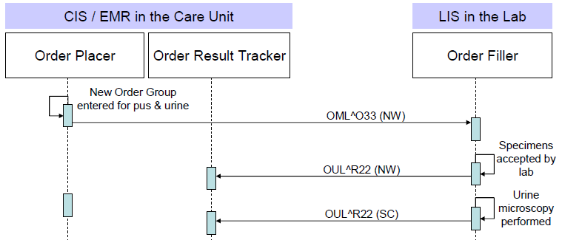

OUL^R22 (NWSC)
In Vol 2a: section 4.5.2 “Interaction Diagram” add the following paragraph below the figure:

This example of microbiology workflow has selected the OUL^R22 message structure to convey the results back to the EMR system, because this specimen-centric message structure is particularly appropriate for microbiology results, which are usually specimen-centric, and for which the provision of specimen data is of key importance to the receiving system.

Nevertheless, ORU^R01 could also have been used instead, providing the same specimen data in a SPECIMEN segment group at the bottom of each ORDER_OBSERVATION segment group, as stated in section 3.3.5.2 “ORU^R01 Static Definition”. Alternative messages using ORU^R01 are shown on the first and last LAB-3 interaction of this use case.

In Vol 2a: section 4.5.3.2 “LAB-3 (OF -> ORT): Message New Order”
Correct the title of the section, the initial sentence, and the content of ORC-1 in the message (in a result message ORC-1 is populated with “SC”, not “NW”).

4.5.3.2 LAB-3 (OF ORT): Message “New Order Status Change”

Day 1 at 8:20 The Order Result Tracker is notified with the creation of the filler order informed that the laboratory has accepted the specimens for a new microbiology order:

MSH|^~\&|OF|Microbiology|ORT||200309060820||OUL^R22^OUL_R22|msgOF12|T|2.5|123||||
USA||EN
PID|1||12345^5^M10^Memphis_Hosp^PI||EVERYMAN^ADAM^^JR^^^L|19800101|M
PV1|1|O|Ward|||||||||||||||12345
SPM|1|123456791^Emergency||MSU^Mid Stream Urine^L|||||||P||||||200309060800|200309060818||Y|…
OBR|1|12345679^Emergency|MSU0309922^Micro|87086^Urine Microscopy and Culture^C4||||||| |||||222222^PHYSICIAN^^^^DR||||||||||I
ORC|SC|12345679^Emergency||777^Emergency|IP||||200309060818||||||||||||
Emergency Ward^^^^^^FI^^^EW00
SPM|2|123456701^Emergency||PUS||||TOE|LEFT||P||||||200309060805|200309060818||Y|…
OBR|1|12345670^Emergency|PUS0300666^Micro|87040^Microscopy and Culture^C4||||||222221^NURSE^NANCY ||||||222222^PHYSICIAN^^^^DR||||||||||I
ORC|NWSC|12345670^Emergency||777^Emergency|IP||||200309060818||||||||||||
Emergency Ward^^^^^^FI^^^EW00

The related acknowledgement message isn’t shown.

The same content could also be provided using this ORU^R01 message:

MSH|^~\&|OF|Microbiology|ORT||200309060820||ORU^R01^ORU_R01|msgOF12|T|2.5|123||||
USA||EN
PID|1||12345^5^M10^Memphis_Hosp^PI||EVERYMAN^ADAM^^JR^^^L|19800101|M
PV1|1|O|Ward|||||||||||||||12345
ORC|SC|12345679^Emergency||777^Emergency|IP||||200309060818||||||||||||
Emergency Ward^^^^^^FI^^^EW00
OBR|1|12345679^Emergency|MSU0309922^Micro|87086^Urine Microscopy and Culture^C4|||||||
|||||222222^PHYSICIAN^^^^DR||||||||||I
SPM|1|123456791^Emergency||MSU^Mid Stream
Urine^L|||||||P||||||200309060800|200309060818||Y|…
ORC|SC|12345670^Emergency||777^Emergency|IP||||200309060818||||||||||||
Emergency Ward^^^^^^FI^^^EW00
OBR|1|12345670^Emergency|PUS0300666^Micro|87040^Microscopy and
Culture^C4||||||222221^NURSE^NANCY ||||||222222^PHYSICIAN^^^^DR||||||||||I

SPM|1|123456701^Emergency||PUS||||TOE|LEFT||P||||||200309060805|200309060818||Y|…

In Vol 2a: section 4.5.3.8 “LAB-3 (OF → ORT): Message “Status Changed”
Replace the content of this section with the following content, which adds an alternative ORU^R01 with the same content of this final results, and corrects some typos of the OUL message :

Day 3 at 11:32 Mike ROSCOP has performed the clinical validation at 11h30. Final results are transmitted.
Note: This message is conforming to the requirements given in section 3.11 “Microbiology Reporting Rules”. In particular: Grouping of the results per microorganism using Observation Sub-ID (OBX-4), and association of antimicrobial sensitivity and microorganism identified, based on the parent/child mechanism: Parent Result (OBR-26) & Parent (OBR-29). Classification of the results (OBX) below an OBR per microorganism.

MSH|^~\&|OF|Microbiology|ORT||200309081132||OUL^R22^OUL_R22|msgOF21|T|2.5| 123||||USA||EN
PID|1||12345^5^M10^Memphis_Hosp^PI||EVERYMAN^ADAM^^JR^^^L|19800101|M
PV1|1|O|Ward|||||||||||||||12345
SPM|1|123456791^Emergency||MSU^Mid Stream Urine^L|||||||P||||||200309060800|200309060818||Y|…
OBR|1|12345679^Emergency|MSU0309922^Micro|87086^Urine Microscopy and Culture^C4||||||| |||||222222^PHYSICIAN^^^^DR||||||||MB|F|||||||444642&ROSCOP&Mike^200309081130
ORC|SC|12345679^Emergency||777^Emergency|CM||||200309060818||||||||||||Emergency Ward^^^^^^FI^^^EW00

TQ1|||||||||R

OBX|1|CE|20453-7^Epithelial Cells^LN||value|||N|||F|||200309061445| |333231^BACK^TERRY
OBX|2|NM|20455-2^Leukocytes^LN||value|/ml||N|||F|||200309061445|…
OBX|3|NM|32776-7^Erythrocytes^LN||value|/ml||N|||F|||200309061445|…
OBX|4|CE|24124-0^Casts^LN||value|||N|||F|||200309061445||333231^BACK^TERRY
OBX|5|NM|699-9^Organism Count^LN||value|/ml||N|||F|||200309061445|…
OBX|6|CE|20430-5^Culture^LN||2ORG^Two Organisms^L|||N|||F|||200309070935|…
OBR|2|12345681^Emergency|MSU03099221^Micro|87088^Organism Identification^C4||||||| ||||| ||||||||MB|F|||||||444642&ROSCOP&Mike^200309081130
ORC|SC|12345681^Emergency||777^Emergency|CM||||200309070938|333231^BACK^TERRY|||||||||||Emergency Ward^^^^^^FI^^^EW00
OBX|1|ST|11475-1^Micro organism identified^LN|1|E. Coli|||N|||F|||…
OBX|2|ST|11475-1^Micro organism identified^LN|2|Strepto D|||N|||F|||…
OBR|3|12345682^Emergency|MSU03099222^Micro|87186^Antibiotic Susceptibility^C4 ||||||||||||||||||||MB|F|11475-1&Micro organism identified&LN^1^E. Coli||| 12345681&Emergency^MSU03099221&Micro|||444642&ROSCOP&Mike^200309081130
ORC|SC|12345682^Emergency||777^Emergency|CM||||200309070938|333231^BACK^TERRY|||||||||||Emergency Ward^^^^^^FI^^^EW00
OBX|1|SN|18861-5^Amoxicillin^LN|1|>=^0.512|µg/ml||R|||F|||200309081107|…
OBX|2|SN|18864-9^Ampicillin^LN|1|<^0.128|µg/ml||I|||F|||200309081107|…
OBX|3|SN|18952-2^Nalidixate^LN|1|>=^2.0|µg/ml||R|||F|||200309081107|…
OBX|4|SN|18956-3^Norfloxacin^LN|1|value|µg/ml||I|||F|||200309081107|…
OBX|5|SN|18928-2^Gentamicin^LN|1|<^0.032|µg/ml||S|||F|||200309081107|…
OBX|6|SN|25596-8^Fosfomycine^LN|1|<^0.1|µg/ml||S|||F|||200309081107|…
OBX|7|SN|18955-5^Nitrofuranton^LN|1|<^0.25|µg/ml||S|||F|||200309081107|…
OBR|4|12345683^Emergency|MSU03099223^Micro|87186^Antibiotic Susceptibility^C4 ||||||||||||||||||||MB|F|11475-1&Micro organism identified&LN^2^Strepto D||| 12345681&Emergency^MSU03099221&Micro |||444642&ROSCOP&Mike^200309081130
ORC|SC|12345683^Emergency||777^Emergency|CM||||200309070938|333231^BACK^TERRY|||||||||||Emergency Ward^^^^^^FI^^^EW00
OBX|8|SN|18965-4^Penicillin G^LN|2|<^0.5|µg/ml||S|||F|||200309081107|…
OBX|9|SN|18861-5^Amoxicillin^LN|2|value|µg/ml||S|||F|||200309081107|…
OBX|10|SN|18864-9^Ampicillin^LN|2|value|µg/ml||S|||F|||200309081107|…
OBX|11|SN|18928-2^Gentamicin^LN|2|value|µg/ml||R|||F|||200309081107|…
OBX|12|SN|18917-5^Doxycycline^LN|2|value|µg/ml||R|||F|||200309081107|…
OBX|13|SN|18919-1^Erythromycin^LN|2|value|µg/ml||R|||F|||200309081107|…
OBX|14|SN|18974-6^Rifampicin^LN|2|value|µg/ml||S|||F|||200309081107|…
OBX|15|SN|18938-1^Lincomycin^LN|2|value|µg/ml||R|||F|||200309081107|…
SPM|2|123456701^Emergency||PUS||||TOE|LEFT||P||||||200309060805|200309060818||Y|…
OBR|1|12345670^Emergency|PUS0300666^Micro|87040^Microscopy and Culture^C4||||||222221^NURSE^NANCY ||||||222222^PHYSICIAN^^^^DR||||||||MB|F|||||||444642&ROSCOP&Mike^200309081130
ORC|SC|12345670^Emergency||777^Emergency|CM||||200309060818||||||||||||Emergency Ward^^^^^^FI^^^EW00
OBX|1|CE|32761-9^Leukocytes^LN||value|||N|||F|||200309060830
OBX|2|CE|32762-7^Epithelial Cells^LN||value|||N|||F|||200309060830| |333231^BACK^TERRY
OBX|3|CE|20430-5^Culture^LN||POS^Positive^L|||N|||F|||200309070935|… |333231^BACK^TERRY
OBR|2|12345685^Emergency|PUS03006661^Micro|87072^Organism Identification^C4|||||||||||| ||||||||MB|F|||||||444642&ROSCOP&Mike^200309081130
ORC|SC|12345685^Emergency||777^Emergency|CM||||200309070941|333231^BACK^TERRY|||||||||||Emergency Ward^^^^^^FI^^^EW00
OBX|1|ST|21020-3^Micro organism identified^LN|1|Staph Aureus|||N|||F| ||200309080830|…
OBR|3|12345686^Emergency|PUS03006662^Micro|87186^Antibiotic Susceptibility^C4|||||||||||| ||||||||MB|F|21020-3&Micro organism identified&LN^1^Staph Aureus||| 12345685&Emergency^PUS03006661&Micro|||444642&ROSCOP&Mike^200309081130
ORC|SC|12345686^Emergency||777^Emergency|CM||||200309070938|333231^BACK^TERRY|||||||||||Emergency Ward^^^^^^FI^^^EW00
OBX|1|SN|18928-2^Gentamicin^LN|1|value|µg/ml||S|||F|||200309080830|…
OBX|2|SN|18996-9^Tobramycin^LN|1|value|µg/ml||R|||F|||200309080830|…
OBX|3|SN|18954-8^Netilmicin^LN|1|value|µg/ml||S|||F|||200309080830|…
OBX|4|SN|18959-7^Ofloxacin^LN|1|value|µg/ml||S|||F|||200309080830|…
OBX|5|SN|18917-5^Doxycycline^LN|1|value|µg/ml||S|||F|||200309080830|…
OBX|6|SN|19000-9^Vancomycin^LN|1|value|µg/ml||S|||F|||200309080830|…
OBX|7|SN|18974-6^Rifampicin^LN|1|value|µg/ml||S|||F|||200309080830|…
OBX|8|SN|25596-8^Fosfomycine^LN|1|value|µg/ml||S|||F|||200309080830|…

The related acknowledgement message isn’t shown.

The same content could also be provided using this ORU^R01 message:

MSH|^~\&|OF|Microbiology|ORT||200309081132||ORU^R01^ORU_R01|msgOF21|T|2.5| 123||||USA||EN
PID|1||12345^5^M10^Memphis_Hosp^PI||EVERYMAN^ADAM^^JR^^^L|19800101|M
PV1|1|O|Ward|||||||||||||||12345
ORC|SC|12345679^Emergency||777^Emergency|CM||||200309060818||||||||||||Emergency Ward^^^^^^FI^^^EW00
OBR|1|12345679^Emergency|MSU0309922^Micro|87086^Urine Microscopy and Culture^C4||||||| |||||222222^PHYSICIAN^^^^DR||||||||MB|F|||||||444642&ROSCOP&Mike^200309081130

TQ1|||||||||R

OBX|1|CE|20453-7^Epithelial Cells^LN||value|||N|||F|||200309061445| |333231^BACK^TERRY
OBX|2|NM|20455-2^Leukocytes^LN||value|/ml||N|||F|||200309061445|…
OBX|3|NM|32776-7^Erythrocytes^LN||value|/ml||N|||F|||200309061445|…
OBX|4|CE|24124-0^Casts^LN||value|||N|||F|||200309061445||333231^BACK^TERRY
OBX|5|NM|699-9^Organism Count^LN||value|/ml||N|||F|||200309061445|…
OBX|6|CE|20430-5^Culture^LN||2ORG^Two Organisms^L|||N|||F|||200309070935|…
SPM|1|123456791^Emergency||MSU^Mid Stream Urine^L|||||||P||||||200309060800|200309060818||Y|…
ORC|SC|12345681^Emergency||777^Emergency|CM||||200309070938|333231^BACK^TERRY|||||||||||Emergency Ward^^^^^^FI^^^EW00
OBR|2|12345681^Emergency|MSU03099221^Micro|87088^Organism Identification^C4||||||| ||||| ||||||||MB|F|||||||444642&ROSCOP&Mike^200309081130
OBX|1|ST|11475-1^Micro organism identified^LN|1|E. Coli|||N|||F|||…
OBX|2|ST|11475-1^Micro organism identified^LN|2|Strepto D|||N|||F|||…
SPM|1|123456791^Emergency||MSU^Mid Stream Urine^L|||||||P||||||200309060800|200309060818||Y|…
ORC|SC|12345682^Emergency||777^Emergency|CM||||200309070938|333231^BACK^TERRY|||||||||||Emergency Ward^^^^^^FI^^^EW00
OBR|3|12345682^Emergency|MSU03099222^Micro|87186^Antibiotic Susceptibility^C4 ||||||||||||||||||||MB|F|11475-1&Micro organism identified&LN^1^E. Coli||| 12345681&Emergency^MSU03099221&Micro|||444642&ROSCOP&Mike^200309081130
OBX|1|SN|18861-5^Amoxicillin^LN|1|>=^0.512|µg/ml||R|||F|||200309081107|…
OBX|2|SN|18864-9^Ampicillin^LN|1|<^0.128|µg/ml||I|||F|||200309081107|…
OBX|3|SN|18952-2^Nalidixate^LN|1|>=^2.0|µg/ml||R|||F|||200309081107|…
OBX|4|SN|18956-3^Norfloxacin^LN|1|value|µg/ml||I|||F|||200309081107|…
OBX|5|SN|18928-2^Gentamicin^LN|1|<^0.032|µg/ml||S|||F|||200309081107|…
OBX|6|SN|25596-8^Fosfomycine^LN|1|<^0.1|µg/ml||S|||F|||200309081107|…
OBX|7|SN|18955-5^Nitrofuranton^LN|1|<^0.25|µg/ml||S|||F|||200309081107|…
SPM|1|123456791^Emergency||MSU^Mid Stream Urine^L|||||||P||||||200309060800|200309060818||Y|…
ORC|SC|12345683^Emergency||777^Emergency|CM||||200309070938|333231^BACK^TERRY|||||||||||Emergency Ward^^^^^^FI^^^EW00
OBR|4|12345683^Emergency|MSU03099223^Micro|87186^Antibiotic Susceptibility^C4 ||||||||||||||||||||MB|F|11475-1&Micro organism identified&LN^2^Strepto D||| 12345681&Emergency^MSU03099221&Micro |||444642&ROSCOP&Mike^200309081130
OBX|8|SN|18965-4^Penicillin G^LN|2|<^0.5|µg/ml||S|||F|||200309081107|…
OBX|9|SN|18861-5^Amoxicillin^LN|2|value|µg/ml||S|||F|||200309081107|…
OBX|10|SN|18864-9^Ampicillin^LN|2|value|µg/ml||S|||F|||200309081107|…
OBX|11|SN|18928-2^Gentamicin^LN|2|value|µg/ml||R|||F|||200309081107|…
OBX|12|SN|18917-5^Doxycycline^LN|2|value|µg/ml||R|||F|||200309081107|…
OBX|13|SN|18919-1^Erythromycin^LN|2|value|µg/ml||R|||F|||200309081107|…
OBX|14|SN|18974-6^Rifampicin^LN|2|value|µg/ml||S|||F|||200309081107|…
OBX|15|SN|18938-1^Lincomycin^LN|2|value|µg/ml||R|||F|||200309081107|…
SPM|1|123456791^Emergency||MSU^Mid Stream Urine^L|||||||P||||||200309060800|200309060818||Y|…
ORC|SC|12345670^Emergency||777^Emergency|CM||||200309060818||||||||||||Emergency Ward^^^^^^FI^^^EW00
OBR|1|12345670^Emergency|PUS0300666^Micro|87040^Microscopy and Culture^C4||||||222221^NURSE^NANCY ||||||222222^PHYSICIAN^^^^DR||||||||MB|F|||||||444642&ROSCOP&Mike^200309081130
OBX|1|CE|32761-9^Leukocytes^LN||value|||N|||F|||200309060830
OBX|2|CE|32762-7^Epithelial Cells^LN||value|||N|||F|||200309060830| |333231^BACK^TERRY
OBX|3|CE|20430-5^Culture^LN||POS^Positive^L|||N|||F|||200309070935|… |333231^BACK^TERRY
SPM|2|123456701^Emergency||PUS||||TOE|LEFT||P||||||200309060805|200309060818||Y|…
ORC|SC|12345685^Emergency||777^Emergency|CM||||200309070941|333231^BACK^TERRY|||||||||||Emergency Ward^^^^^^FI^^^EW00
OBR|2|12345685^Emergency|PUS03006661^Micro|87072^Organism Identification^C4|||||||||||| ||||||||MB|F|||||||444642&ROSCOP&Mike^200309081130
OBX|1|ST|21020-3^Micro organism identified^LN|1|Staph Aureus|||N|||F| ||200309080830|…
SPM|2|123456701^Emergency||PUS||||TOE|LEFT||P||||||200309060805|200309060818||Y|…
ORC|SC|12345686^Emergency||777^Emergency|CM||||200309070938|333231^BACK^TERRY|||||||||||Emergency Ward^^^^^^FI^^^EW00
OBR|3|12345686^Emergency|PUS03006662^Micro|87186^Antibiotic Susceptibility^C4|||||||||||| ||||||||MB|F|21020-3&Micro organism identified&LN^1^Staph Aureus||| 12345685&Emergency^PUS03006661&Micro|||444642&ROSCOP&Mike^200309081130
OBX|1|SN|18928-2^Gentamicin^LN|1|value|µg/ml||S|||F|||200309080830|…
OBX|2|SN|18996-9^Tobramycin^LN|1|value|µg/ml||R|||F|||200309080830|…
OBX|3|SN|18954-8^Netilmicin^LN|1|value|µg/ml||S|||F|||200309080830|…
OBX|4|SN|18959-7^Ofloxacin^LN|1|value|µg/ml||S|||F|||200309080830|…
OBX|5|SN|18917-5^Doxycycline^LN|1|value|µg/ml||S|||F|||200309080830|…
OBX|6|SN|19000-9^Vancomycin^LN|1|value|µg/ml||S|||F|||200309080830|…
OBX|7|SN|18974-6^Rifampicin^LN|1|value|µg/ml||S|||F|||200309080830|…
OBX|8|SN|25596-8^Fosfomycine^LN|1|value|µg/ml||S|||F|||200309080830|…
SPM|2|123456701^Emergency||PUS||||TOE|LEFT||P||||||200309060805|200309060818||Y|…

In Vol 2a: section 4.2.3.4 “LAB-3 (OF -> ORT): Message New Order”
Correct the title of the sectionand the initial sentence.

4.2.3.4 LAB-3 (OF->ORT): Message “New OrderStatus Change”
The Order Result Tracker is notified of the creation of the filler order by means of a result

Messageinformed that a new order is being performed:

In Vol 2a: section 4.3.2 “Interaction Diagram”
Correct the first LAB-3 message on the figure.
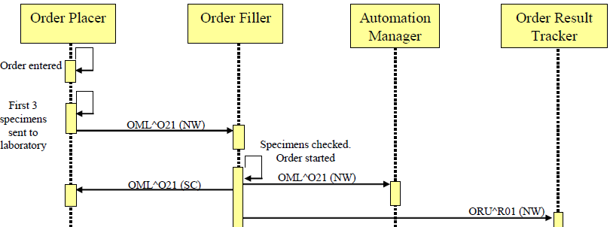

ORU^R01 (NWSC)

In Vol 2a: section 4.3.3.4 “LAB-3 (OF ORT) …”
Correct the title of the section and the initial sentence

4.3.3.4 LAB-3 (OF ORT): Message “New order” with the first 3 Specimens

The Order Result Tracker is notified with the creation of the filler informed that a new order is in process. The observation related to the 3rd specimen (unavailable) is canceled.

In Vol 2a: section 4.4.2 “Interaction Diagram”
Correct the first LAB-3 message on the figure.
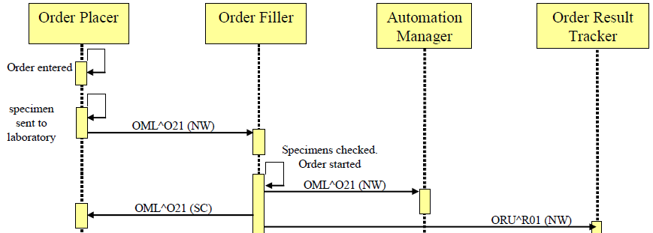

ORU^R01 (NWSC)

In Vol 2a: section 4.3.3.4 “LAB-3 (OF ORT) …”
Correct the title of the section and the initial sentence

4.4.3.4 LAB-3 (OF->ORT): Message “New OrderStatus Change”

The Order Result Tracker is notified with the creation of the filler orderinformed that a new order is being processed:

In volume 2x, section C.11 “Microbiology Reporting Rules”, complement the initial sentence:
This section explains how messages carrying microbiology results shall be structured in

transactions LAB-3, LAB-5 and LAB-23 of this IHE Laboratory Technical Framework. Complete examples of microbiology result messages, compliant with these requirements are shown in section 4.5 of Volume 2a.

In volume 2x, delete the entire section C.11.2.2 “An Example”

C.11.2.2 An Example

