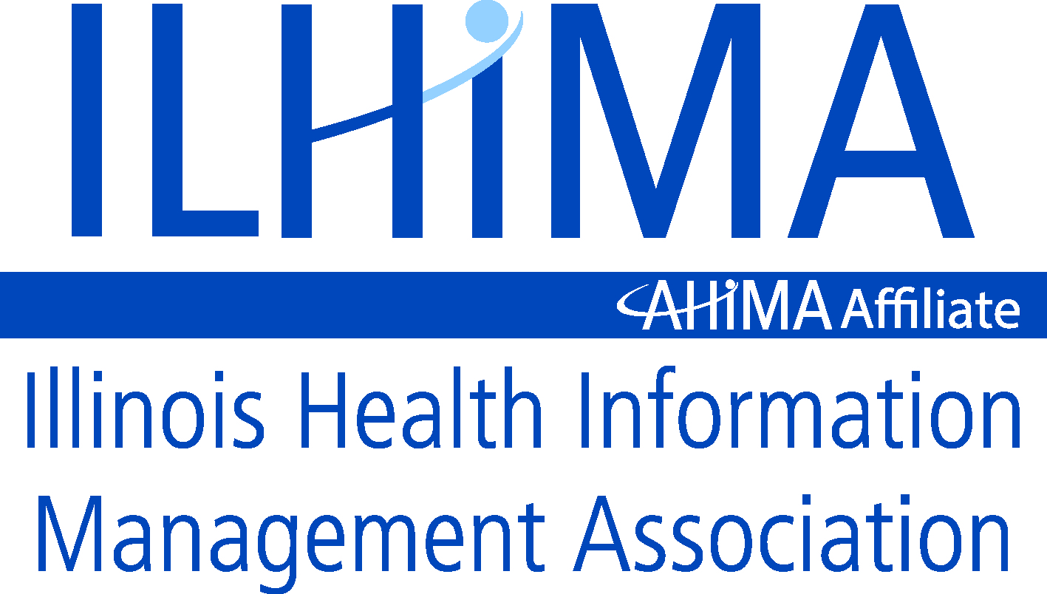
September 17, 2015
AHIMA
233 N Michigan Avenue
Chicago IL 60601

Dear Carolyn,
Theresa Jones formed an ILHIMA Task Force to address Information Governance initiatives. The task force focused on Documentation and Data Integrity. The taskforce created the attached proposal and the ILHIMA Board supports this proposal for referral to AHIMA.
The proposal sites the current problems with data integrity that, to a large extent, have resulted from electronic documentation systems and processes. Additional attachments provide examples of documentation data integrity problems and suggested letters to CIOs and vendors to request their help in resolving these data integrity issues.
The proposal requests:
- Creation of a taskforce to study the issues
- Revision of position statements and practice standards
- Creation of a tool kit for use by all involved disciplines
- Promotion of AHIMA HIM Professionals as experts and leaders in determining standards and providing audits for document and data integrity for paper and electronic health record
- Ongoing discussion and monitoring for further interventions as needed.
The ILHIMA Documentation and Data Integrity Taskforce and the ILHIMA Board would like to meet with AHIMA representatives to review the proposal, address any questions and discuss next steps. We have members in the Chicago area that are available to meet in person and others that can participate remotely. Ideally, we would like the proposal to be discussed at the House of Delegates meeting in New Orleans. If the timing is too short, we suggest a follow-up meeting with the HOD specifically to address this proposal.
We believe this should be our primary advocacy effort in working with the HIM professionals, providers and other healthcare practitioners, CIOs and other healthcare executives, vendors and legislators. Now that ICD-10 is soon to be a reality, we are ready to take on this documentation and data integrity problem as the experts in health information management.
We will anxiously await your reply. Thank you for your time and assistance with this important initiative.
Sincerely,
Teri Phillips
Teri Phillips, MBA, RHIA
ILHIMA Past President
ILHIMA Taskforce to Promote Document and Data Integrity in the Electronic and Legal Health Record

Background:
Based on feedback from ILHIMA members and other AHIMA CSA HIM professionals throughout the country, via published surveys, audits, discussion and direct observation, there is an escalating concern that a stronger and more urgent advocacy effort is needed on the part of AHIMA to address document and data integrity in the electronic health record. The serious issues of proliferation of inaccurate and careless documentation, the large volume of repetitive, non-relevant, non-reliable information within the records, and the use of technologies that are allowing inappropriate use or display of data in the electronic health record are concerning from a patient safety as well as medico-legal, and health information management workflow perspective.
There is growing evidence that the documentation in many cases has lost the ability to adequately ‘tell the story of the patient’ in a reliable and relevant manner and there appears to be a rapidly evolving deterioration in the quality and sustainability of the content of the documentation that is being archived as the legal health record. This post discharge record has traditionally been relied upon as a trustworthy “permanent” historical business evidentiary document for health care providers.
This concerning trend seems to be accelerating post Meaningful Use incentive based system implementations on electronic health record systems over the past several years. HCPro’s annual Medical Records Briefing EHR Survey (due to be published in the October 2015 issue), consistent with 2014, showed that over 60% of the respondents believe that the EHR is causing quality of documentation issues to stay the same or have gotten worse. Members have expressed concern in that these systems may have been rushed to installation prior to software being mature enough, or lack of solutions delivering what was promised, as evidenced by anecdotal information received from members. In addition, many HIM professionals report a lack of involvement in the system selection, design, or implementation process. There have also been reports of issues discovered during objective auditing activities conducted by third party consulting groups.
Additional anecdotal reports by AHIMA members identify deterioration of the quality of the documentation and the record itself include:
- Growing volumes of patients requesting corrections to records after reading and identifying errors in content, many of which are related to use of copy and paste or pull forward of information from previous findings, problem lists, notes, and medication lists
- Increasing numbers of legal inquiries and complaints about readability of records.
- Escalating numbers of insurance or outside reviewer complaints, rejections, and denials for payment of cases on records with poor and out of sequence documentation
- Increasing volumes of ‘pages’ (whether electronic or printed) causing decreases in productivity, particularly in the coding area and increased cost of paper, supplies, postage, and general release of information expenses being passed on to requestors
- Growing dissatisfaction of clinicians of EHR template and order entry use due to erroneous auto-population of documentation that is recurring
- Uncontrolled texting of clinical information as an undocumented communication vehicle
- Increasing use of dictation/transcription (reported by several transcription companies as well), causing some delays in information availability.

An independent contractor recently conducted several hundred individual retrospective and concurrent detailed medical record reviews identifying trends in document and data integrity including sites of an Academic University Adult and Pediatric hospital, a Long Term Acute Care Facility, an Acute Care mid-size hospital, and a Critical Access Hospital.
Results of those findings, most of which were viewed as being a direct result of the use of copy and paste or incorrect auto-population of data within the EHR were as follows:
- One hundred percent of the records in facilities that used copy and paste functionality--contained problematic documentation (wrong demographic information such as dates/times/note labeling, erroneous or poor note content, mis-represented information, repetitive/redundant information within multiple notes, etc.)
- Increased identification of query opportunities due to presence of conflicting information or errors in information
- Multiple examples of mis-used abbreviations, poor syntax, poor grammar, and other textual problems
- Lack of identifying data on printed records, and in some cases multiple patients’ data overlaid into a single record causing confusion as to identity of patient.
- Lack of author signature, date, time, or heading of documents causing sequential orientation and point of reference confusion.
- Decreased case mix due to coders ‘skipping’ through voluminous notes due to concern about productivity.
- Inability to identify modified changes or historical / resolved conditions, medications, or test results from one entry to next when copy and paste is used.
Finally, there is growing concern that not all EHRs are capable of providing a locked down episodic record that reflects unique (vs. longitudinal) data integrity for a specific visit within a hospital entity unless there is a use of a Level 3 Electronic Document Management System.
Intent:
Therefore, a taskforce was formed by the Illinois Health Information Management Association as an Information Governance initiative to propose some recommendations to ILHIMA members, other AHIMA CSA members, and AHIMA as an advocacy outreach. This team acknowledged that AHIMA recognizes Document and Data Integrity as a concern based on its various work previously done which results in such practice briefs, position statements, and articles such as:
AHIMA. "Assessing and Improving EHR Data Quality (Updated)."Journal of AHIMA 86, no.5 (May 2015): 58-64.
AHIMA. "Integrity of the Healthcare Record: Best Practices for EHR Documentation." Journal of AHIMA 84, no.8 (August 2013): 58-62.
AHIMA “Copy and Paste Position Statement” http://library.ahima.org/xpedio/groups/public/documents/ahima/bok1_050621.pdf
Nelson, Michael L. "The ‘Keys’ to Help Solve Patient Data Matching. "Journal of AHIMA 86, no.8 (August 2015): 28-30.
AHIMA. "The Implementation and Management of Patient Portals."Journal of AHIMA 86, no.4 (April 2015): 50-55.
However, the ILHIMA taskforce believes that in light of the growing concerns, lack of vendors addressing problem design flaws, and urgency of the issue, that AHIMA should:
- Designate a work group to address this issue
- Take a stronger position on limiting use of copy and paste and cloning (auto populate) technologies used in the EHR
- Take a stronger position advocating use of a post-discharge locked down record through a Level 3 electronic documentation management system if a complete locked down record is not available upon discharge.
- Unite existing practice briefs, articles, and position papers into a single revised EHR Document and Data Integrity Best Practice Toolkit
- Provide the toolkit to all CSA’s to benefit use of the Toolkit to educate vendors and providers
The growing concern over document and data integrity is not just a concern recognized by AHIMA members. On March 31, 2015, the Joint Commission addressed the Safe Use of Health Information Technology in their issuing of Sentinel Event 54 as a serious concern for patient safety. Along with this, the OIG has been issuing continuous warnings of potential fraudulent billing due to copy and paste initiatives which were highlighted in JAHIMA in a July 27, 2015 interview of Felicia Heimer of the OIG by Mary Butler at AHIMA.

The ILHIMA Taskforce on Document and Data Integrity recognizes the importance of clear, complete, compliant, concurrent, and chronologic documentation in the electronic (pre-discharge) health record as well as the electronic (post-discharge) legal health record. For purposes of this discussion, the active portion of the electronic health record is defined as a health information system composed of data that is created as part of documentation processes and displayed to the user of the record through dynamic templates and reports utilized during active care.

Also for purposes of this discussion, the legal health record refers to the post-discharge, workflow based accumulation of final documentation and any associated electronic signature, addenda or amendments to the record that occur post discharge, remains persistent as the final recorded data for an episode of care which is able to be archived and purged as a complete and single record.
An accurate legal health record, whether in paper or electronic format, may be considered the most important resource in a healthcare setting because it provides the core data upon which all clinical care, administrative, and financial decisions are based upon for the patient and serves as the business evidentiary record for the health care provider and organization based on the point of registration into the system. “Accurate patient data matching is a critical patient safety issue. Overlays that comingle the medical information of two or more people may lead to disastrous adverse medical events and duplicate medical records, which may be fragmented and incomplete and can limit the effectiveness of treatment plans, resulting in less than optimal outcomes.”
The active electronic and post-discharge legal health record play distinct and separate roles at different points in the documentation life cycle, therefore it is important that the design of and systems used to create, manage, and maintain medical records across the continuum of care, must support the specific and unique functionality needed in order to maintain the appropriate workflow necessary for accurate and efficient record processing.
The document and data integrity of electronic and legal health records play a significant support role in communication and support of quality patient care and safety as well as reimbursement and risk mitigation. Without adequate functionality in place to maintain a stable legal health record environment post-discharge, there is a risk of loss of the ability of the medical record to defend itself as the business evidentiary record and provide trustworthy, relevant, and reliable permanent health record information for ongoing reference and use.

Maintaining principles of document and data integrity within the health and legal health records is a core responsibility of the health information management professional as part of information governance and as the custodian of the legal health record. In addition, disruption in the workflow, and the growing volume of problematic documentation is having a negative impact on productivity and the quality of the work performance, particularly in the coding, abstracting, and release of information functions for health information professionals and may contribute to a lowered case mix due to poor documentation trends. With the upcoming implementation of ICD-10-CM and ICD-10-PCS, the importance of clear, concise, compliant, complete, and current/chronologic documentation for each patient visit is essential. With data repositories, data warehouses, and the need for interoperability of data increasing in importance, clear documentation is an essential starting point for advancement in data analytics.

ILHMA Request to AHIMA:

ILHIMA volunteers for a leadership role in this area and asks AHIMA for advocacy support in the following Documentation and Data Integrity activities:
- Creation/Commission of a formal workgroup/taskforce to study:
- The problematic documentation and data integrity issues being experienced as a result of the use of poorly designed electronic health records and inappropriate technology application which impact the accuracy of the information and create potential safety hazards to patients and potential liability to the health care providers.
- The extensive workflow problems being experienced will impact the HIM professional’s ability to manage the legal, post-discharge health record occurring with the use of electronic health records as well as to use the documentation to support coding, data abstracting, release of information and other core activities critical to patient continuity of care and revenue cycle processes.

- Revision and combination of fragmented or piecemeal position statements regarding document and data integrity through creation of stronger AHIMA professional practice standard which provides guidance to members and to the industry:
  - Disallow copy and paste of any information from a previous visit into a current visit’s documentation without appropriate labeling of reference date and source and identification of any modifications or additions within such documentation, visible to the reader of the documentation, as well as differentiation from any newly created data and documentation.
  - Disallow automatic template population of any data without appropriate labeling of reference date and source and identification of any modifications of additions within such documentation, visible to the reader of the document, as well as differentiation from any newly created data and documentation.
  - Promote use of the electronic document management system with workflow (Level 3) as the appropriate platform for long term archival health record management as opposed to the active dynamic record within the EHR.

- Creation of a formal communications toolkit for CSA and other usage and assertive and funded marketing campaign to educate AHIMA members, other professional association members, provider organizations, clinicians, government agencies, accrediting organizations, electronic health record vendors, and the industry at large about the importance of:
  - Applying such practice standards as described above.
  - Supporting the use of appropriate technologies (i.e. stable, non-dynamic Level 3 electronic document management systems and/or fully locked down post-discharge electronic records) for maintenance of the official legal health record which will be the long term archived episodic business evidentiary record for the health care facility.

- Actively promote AHIMA HIM professionals as the primary experts in determining standards for and developing and conducting audits for document and data integrity for paper and electronic health records.

- Continued discussion and monitoring of the document and data integrity issues related to the adoption of electronic health records through field research, observation, audit, and survey funded by AHIMA and reported to members on a regular basis.

Attached are 2 sample letters which are examples of what could be provided for members to send to their CIOs and to their EHR vendors.

Sincerely,

ILHIMA Documentation and Data Integrity Taskforce Members
Theresa Jones, MSEd, RHIA
Darice Grzybowski, MA, RHIA, FAHIMA
DeShawna Hill-Burns, RHIA, CHIS-CP
Christine Cain, RHIA
Reginald Stith, RHIA

ILHIMA Board of Directors

ILHIMA Delegates

Attachment 1 Sample Letter to Chief Information Officers

Attachment 2 Sample Letter to Electronic Health Record System Vendors

Attachment 3 Examples of Poor Documentation

ATTACHMENT 1 (Sample Letter to CIO)
Dear Chief Information Officer:
As the legal custodian of the medical record which is the business evidentiary record for our facility, I am writing you about the importance of assuring key principles of document and data integrity of the Electronic Health Records in both the active (pre-discharge) and legal (post-discharge) archival records.
In the active record, we recommend the following steps be taken to reduce redundancy:
- Strictly limiting the use of any copy and paste functionality (each note and entry must stand on its own.)
- Elimination of any pull forward (cloning or auto –population) of data from previous entries, including history, lab values, problem lists, or medication lists. All entries should refer to or display historical reference; never duplicate into a note as if the actions or results were newly discovered or completed.
- Strict identification of any content which is displayed on the electronic or printed health record from a previous encounter by labeling content with an accurate date, time, author, and heading information.
We also support the use of a locked down, post discharge record which can be achieved by implementing a Level 3 Electronic Document Management Solution in order to promote, maintain and defend the integrity of our legal health record. This Level 3 model is illustrated by the diagram on page 3 of this document and differentiates from our current environment in that it maintains the integrity of the record by ensuring that 100% of the legal record is maintained in a persistent and stable environment that is locked down post-discharge. Any authentication or amendments added to the record are visible on a single view (vs. in versions that are not visible in a single printed record output) and represent the record in its entirety for each distinct episode of care.
The persistent and unique episode of care within the legal health record is distinguished from the active or working and input based electronic health record in that it:
- Does not contain data which has been carried forward or copy and pasted from other episodes of care (different admission, discharge date, or outpatient encounter)
- Does not reflect data (such as on a medication or problem list) which has been updated or changed in a future episode of care.
- Is accessible to only those individuals that have a right and need to know or are listed as a clinician of record.
- Can be reproduced or released more than one time (electronically or in paper) and have identical content except for an indicator which should be used to identify that the reproduction is a copy of the original record.
- Is document based, not template based in such that it does not pull and push data into and out of blank templates which can be modified at a future point in time.
- Can be archived, purged, locked, and destroyed according to retention laws and guidelines.
- Can be read chronologically and in an organized fashion throughout workflow applications including record completion, clinical documentation improvement, coding, abstracting, Master Patient Index maintenance, and other health information management functions.
- Can be transferred electronically, and with ease into another separate software system (for connection or replacement purposes) using document interoperability principles.
- Is locked down post-discharge without alteration, unless such alteration is a formal amendment or addendum to the record which is visible upon view or print.
I am asking your support as part of our Information Governance strategy in promoting document and data integrity in the legal health record by adjusting policies and technologies, and implementing an electronic document management system or similar functionalities to maintain the long term legal health record for the facility. I am happy to assist you in this critical information governance activity as a key component of our core patient communication and business evidentiary record. Thank you.

Sincerely,

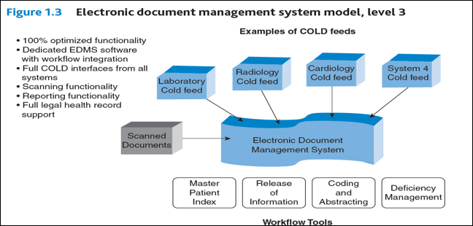

Attachment 2 (Sample Letter to Vendor)
Dear ______________________________:
As the legal custodian of the medical record which is the business evidentiary record for our facility, I am in support of revisions of designs which are impacting the integrity of our electronic and legal health records.
In the active record, we recommend the following steps be taken to reduce redundancy:
- Elimination of any copy and paste functionality (each note and entry must stand on its own.)
- Elimination of any pull forward (cloning or auto –population) of data from previous entries, including history, lab values, problem lists, or medication lists. All entries should refer to or display historical reference; never duplicate into a note as if the actions or results were newly discovered or completed.
- Strict identification of any content which is displayed on the electronic or printed health record from a previous encounter by labeling content with an accurate date, time, author, and heading information.
We also support the use of a locked down, post discharge record which can be achieved by implementing a Level 3 Electronic Document Management Solution in order to promote, maintain and defend the integrity of our legal health record. This Level 3 model is illustrated by the diagram on page 3 of this document and differentiates from our current environment in that it maintains the integrity of the record by ensuring that 100% of the legal record is maintained in a persistent and stable environment that is locked down post-discharge. Any authentication or amendments added to the record are visible on a single view (vs. in versions that are not visible in a single printed record output) and represent the record in its entirety for each distinct episode of care.
The persistent and unique episode of care within the legal health record is distinguished from the active or working and input based electronic health record in that it:
- Does not contain data which has been carried forward or copy and pasted from other episodes of care (different admission, discharge date, or outpatient encounter)
- Does not reflect data (such as on a medication or problem list) which has been updated or changed in a future episode of care.
- Is accessible to only those individuals that have a right and need to know or are listed as a clinician of record.
- Can be reproduced or released more than one time (electronically or in paper) and have identical content except for an indicator which should be used to identify that the reproduction is a copy of the original record.
- Is document based, not template based in such that it does not pull and push data into and out of blank templates which can be modified at a future point in time.
- Can be archived, purged, locked, and destroyed according to retention laws and guidelines.
- Can be read chronologically and in an organized fashion throughout workflow applications including record completion, clinical documentation improvement, coding, abstracting, Master Patient Index maintenance, and other health information management functions.
- Can be transferred electronically, and with ease into another separate software system (for connection or replacement purposes) using document interoperability principles.
- Is locked down post-discharge without alteration, unless such alteration is a formal amendment or addendum to the record which is visible upon view or print.
In addition, we believe at point of discharge, the complete interface or integration of the clinical and demographic information and all content from the active EHR be available in the EDMS making it the system legal health record (LHR). In implementing a Level 3 Electronic Document Management Solution it can be used to promote, maintain, and defend the integrity of our legal health record while providing for the most risk mitigation.
We are asking you, our electronic health records vendor of our dynamic and patient centered active health record documentation and information system to help support all interfaces and integration with our chosen electronic documentation system (EDMS).
The EDMS maintains the following characteristics and is not ‘just’ a scanning solution vendor. Simply ‘pointing’ to scanned documents does not create a fully unified legal health record and is inadequate for maintaining the workflow necessary to support reliable, relevant record that is compliant with good documentation standards.
As part of our Information Governance plan, we are asking for your support in eliminating any barriers in getting output created in your software product as part of patient care documentation creation, and integrating it into the post-discharge legal health record so that the record may be completed post-discharge, used, referred to, maintained, released, and eventually archived and purged as part of retention of the legal health record.
Sincerely,

xxxxxxxxxxxxxx
Attachment 3 Problem Documentation Examples
Examples of Dangers of Copy and Paste, Auto-Population of Template Data, and ‘Pull Forward” Information into reports:
All of these examples can: a) cause a medical error to occur which can endanger patient safety, b) cause confusion or conflict amongst providers causing delays or errors in care to occur, c) increase risk of legal malpractice and negligence due to documentation not matching actual care provided, d) cause a decrease in reimbursement or a delay in reimbursement from third party payers due to inability to ascertain correct documentation for coding, e) cause slowdown in productivity for anyone required to read through redundant chart documentation, f) cause an unnecessary volume increase in the printed record resulting in extreme cost to requestors of the paper medical record.

Copy and Paste Abuse:
-Makes activities or observations appear to have occurred that did not really occur (i.e. full review of systems, repeat of lab tests, appearance of patient, etc.)
-Pulls old, non-relevant historical data forward into current note that can cause error in judgement or ordering of wrong test. (i.e. reporting an Hgb value of 6.0 on discharge, when admitting lab values are repeatedly copied through to discharge, even though that is not the latest lab value.)
-Provides evidence that review of documentation did not occur when erroneous statements, abbreviations, or spelling errors occur and then are repeated.
-Creates out of sequence / non-chronologic documentation causing other providers not to trust or use documentation, thus possibly skipping a vital note, change or instruction.
Auto-Template Fill In and “Pull Forward” data
-All of the same problems with copy and paste above occur, with the added problem that there may not be the opportunity for any modification, nor any identification of source of information or original date, thus reference point is lost: (i.e. note on admission says “patient had dialysis 2 days ago”, then this note is copied the next day and it again says “patient had dialysis 2 day ago”—which is now really 3 days ago).
-When copying content – headers may not flow causing interpretation problems and assumptions (i.e. “Positive history of breast cancer” may be documented on a report under the FAMILY HISTORY section; but now pulls forward as “Positive history of breast cancer” in a progress note for the patient (not the FAMILY), and a wrong assumption and treatment may occur.
-Problem lists and Medication Lists may be pulled forward, even though conditions are resolved, and medications are discontinued. This may populate, in error, across multiple visits in a longitudinal record. All medications and problems should be specific only to the current episode of care and validated each time.
Other:
There is evidence of rapid proliferation of inappropriate abbreviations use, ‘text’ talk, poor grammar, misspellings, format, and syntax errors through the records showing lack of proofing and formatting.

Grzybowski, Darice “Strategies for Electronic Document and Health Record Management, AHIMA, 2014, p.9
http://www.jointcommission.org/assets/1/18/SEA_54.pdf
http://journal.ahima.org/2015/07/27/preventing-fraud-and-abuse-in-clinical-documentation/
Nelson, Michael L. "The ‘Keys’ to Help Solve Patient Data Matching."Journal of AHIMA 86, no.8 (August 2015): 28-30
Darice Grzybowski, MA, RHIA, FAHIMA H.I.Mentors, LLC Copyright
Grzybowski, Darice “Strategies for Electronic Document and Health Record Management, AHIMA, 2014, p.9
Grzybowski, Darice “Strategies for Electronic Document and Health Record Management, AHIMA, 2014, p.9
Grzybowski, Darice “Strategies for Electronic Document and Health Record Management, AHIMA, 2014, p.9

