IHE Face 2 Face meeting Chicago October 1st, 2010
Author : Filip Migom (<ongoing version 0.1>)
Oct. 1, 2010 | 0.1 | Draft setup of a discussion item on possible sample identifications by Specimen, Container or position Published on the wiki.ihe.net on Saturday October 2nd, 2010 9h00 | Filip Migom
Oct. 2, 2010 | 0.2 | Added some images | Filip Migom

Action : Documentation for ID specimen container position time.

Introduction.
Identification of a “Sample” on an instrument may vary upon different use-scenario and is related to the different parameters available during the analytical work process. Within HL7 2.x, we have seen different solution to identify a sample as a Specimen ID, container Identifier or by its position on a specific carrier or Tray.
<image to make>
Different scenarios are best seen in use-cases per laboratory discipline and type of instrument.
Hematology may work on EDTA Blood Samples which are directly sampled from the patient. The EDTA Blood Sample receives a unique identifier which we may call a Specimen ID or Container Identifier.
<image of EDTA>
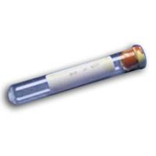
Biochemistry may work on aliquot serum samples derived after centrifuged Blood samples. The Blood Sample receives a unique identifier. Each aliquot may receive its own unique identifier and remembers the relation to its root sample and the original identification. When an analyzer is working on a Specimen, it does physically not necessarily know this sample is an aliquot or a root sample. Again the identifier can be a Specimen ID or a Container identifier
<Image of Blood Sample into Aliquots>
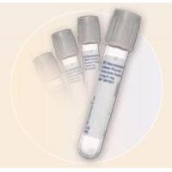
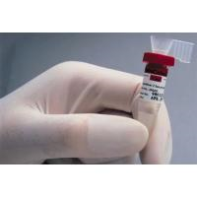
Microbiology may work on different human body sampling like smear, urine, ... . There are various techniques for sampling and carriers for the samples like ear stick, urine pot. We can call this the root material to be sampled as a start of the microbiology process, the content of the sample will be cultivated. The resulting micro-organism cultivation will become a new sample for further examination on the analyzer.
<Image of urine -> cultivated on a plate -> Resulting in a micro-organism>
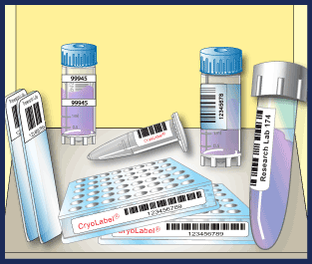
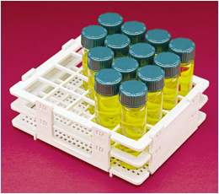
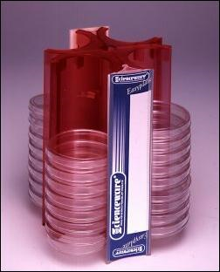

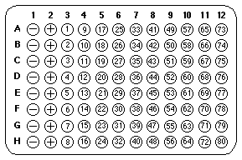
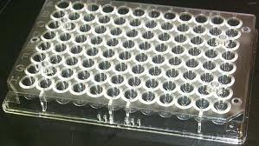
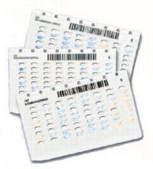
Having an understanding of the various samples, we can now think on how those samples are to be identified.
The size of an EDTA tube allows easily an identification with a Barcode label
The size of an aliquote may already have some trouble using a Barcode. Some will be identified with a smaller label containing a barcode identifier which is unique for a period of time.
Alternative identification can be performed by assigning the aliquot a position in an identified rack
Micro-organisms can be dropped on a spot on an identified rack
By this introduction, we see that a Sample on an instrument can be identified by :
- Specimen ID
- Carrier ID
- Rack ID and Rack position

Which identifier is to be used during a Simple Query Mode ?
By understanding the various scenarios in different disciplines on different instruments, we have seen that a sample can be identified by different parameters: Root Specimen ID, Aliqouted Carrier ID or the position on a Rack.

What is available in HL7 2.x and documented in IHE TF-2

SPM – Specimen Segment
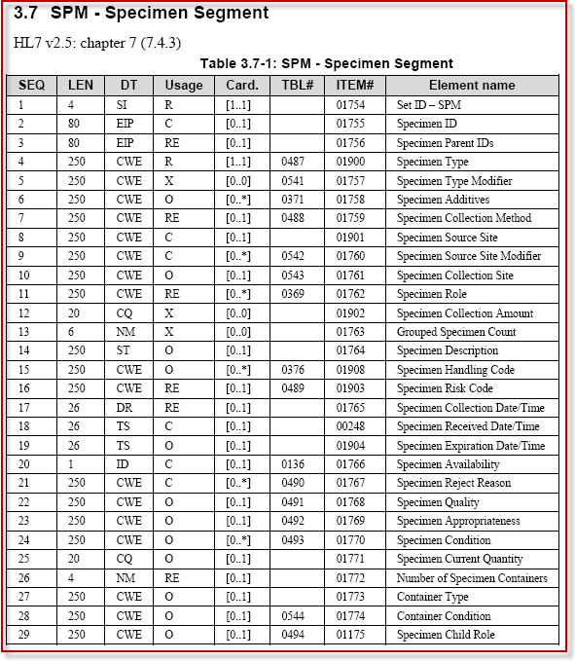
SPM-2 Specimen ID (EIP), conditional.
This field contains a unique identifier or pair of unique identifiers for the specimen, enterprisewide.
Condition predicate: This field shall be populated in OML messages of transaction LAB-1, in the
context of the use case "Externally placed order with identified specimens" defined in volume 1. This field is required in OML messages of the LAB-2 transaction. It may also be used in
transaction LAB-3. This field is required if known (RE) in transactions LAB-4 and LAB-5. Refer
to section 2.4.6.1 for the details of the data type.
SPM-3 Specimen Parent ID (EIP), required if available.
This field contains the identifier for the parent specimen, from which the specimen described by
the segment instance has been extracted. Please refer to section 2.4.6.1 for the details of the data type.
The IHE Laboratory Technical Framework does not admit pooling of specimens; therefore the
maximum cardinality for the parent specimen is 1.

SAC Container Detail Segment
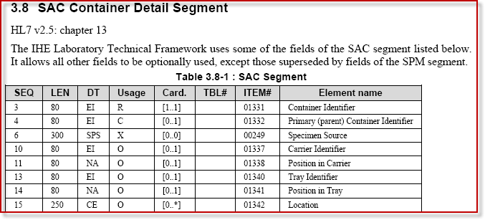
SAC-3 – Container Identifier (EI), required.
SAC-3 field identifies the container. This field is the container's identifier assigned by the
corresponding equipment. A container may contain the primary (original) specimen or an
aliquot (secondary sample) of that specimen. For primary sample this field contains Primary
Container ID; for bar-coded aliquot samples this field contains Aliquot Container ID.
SAC-4 – Primary (parent) Container Identifier (EI), conditional.
Condition predicate: This field is used only in transactions LAB-4 and LAB-5, LAB-21, LAB-
22, LAB-23, LAB-26, LAB-61 and LAB-62 when dealing with an aliquoted specimen. In that
case, SAC-3 and SAC-4 are used simultaneously as described below:
If SAC-4 field is filled in, it identifies the primary container from which this specimen came.
For primary samples this field is empty; for aliquot samples this field should contain the
identifier of primary container.

Rack ID and Rack position
SAC-10 – Carrier Identifier (EI), optional.
HL7 definition: This field identifies the carrier. It is the ID (e.g., number or bar code) of the
carrier where the container (e.g., tube) is located.
The IHE Laboratory Technical Framework has not constrained the usage of this field yet.
SAC-11 – Position in Carrier (NA), optional.
Components: <Value1 (NM)> ^ <Value2 (NM)> ^ <Value3 (NM)> ^ <Value4 (NM)> ^ < ()>
HL7 definition: This field identifies the position of the container in the carrier (e.g., 1…3…).
The sub-components allow, if necessary, to transfer multiple axis information, e.g., 2-
dimensional carrier (X^Y).
The IHE Laboratory Technical Framework has not constrained the usage of this field yet.
SAC-13 – Tray Identifier (EI), optional
HL7 definition: This field identifies the tray identifier (e.g., a number of a tray or a bar code
on the tray), where the container carrier is located.
The IHE Laboratory Technical Framework has not constrained the usage of this field yet.
SAC-14 – Position in Tray (NA), optional.
Components: <Value1 (NM)> ^ <Value2 (NM)> ^ <Value3 (NM)> ^ <Value4 (NM)> ^ < ()>
HL7 definition: This field identifies the position of the carrier in the tray. The sub-components
allow, if necessary, to transfer multiple axis information, e.g., 2-dimensional tray (X^Y).
The IHE Laboratory Technical Framework has not constrained the usage of this field yet.

SAC-15 – Location (CE), optional.
HL7 definition: This field is the physical location that the specimen was at the time that the
transaction was initiated. The location description can vary with the LAS. For example, it can
be an X,Y,Z coordinate in a storage system; a refrigerator number and drawer number where
the container-carrier-tray is located; or it can be the name of the institution and the laboratory
which owns the container currently. The repeating of this field allows for hierarchical
representation of location (lowest level first), e.g., shelf number, refrigerator storage id, lab name, institution name, etc.
The IHE Laboratory Technical Framework has not constrained the usage of this field yet.

Appendix.

Reference IHE LAB Technical FrameWork Version 2 : vol 2
HL7 Component Table - EIP – Entity Identifier Pair
SEQ LEN DT Usage CARD TBL# COMPONENT NAME
1 427 EI C [0..1] Placer Assigned Identifier
2 427 EI C [0..1] Filler Assigned Identifier
The IHE LAB-TF uses this data type for identifying specimens (see SPM-2 and SPM-3 in SPM
segment static definition).

