Integrating the Healthcare Enterprise



IHE Anatomic Pathology

Technical Framework Supplement

Anatomic Pathology Reporting to Public Health Repositories

(ARPH)

Public Comment

Date: <June XX, 2009>
Authors: Christel Daniel, Wendy Scharber, …, François Macary
Email: < >
This is a supplement to the IHE Anatomic Pathology Technical Framework V1.2
It is submitted for Public Comment between <June xx, 2009 and July xx, 2009>.
Comments shall be submitted within that period to http://forums.rsna.org:
- Select the “IHE” forum
- Select Anatomic Pathology Technical Framework
- Select 2009-2010 Supplements for Public Comment
- Select ARPH
Please use the Public Comment Template provided there when starting your New Thread.

Details about IHE may be found at: www.ihe.net

Details about the IHE <Domain Name> may be found at: http://www.ihe.net/Domains/index.cfm

Details about the structure of IHE Technical Frameworks and Supplements may be found at: http://www.ihe.net/About/process.cfm and http://www.ihe.net/profiles/index.cfm

The current version of the IHE <Domain Name> Technical Framework may be found at:. http://www.ihe.net/Technical_Framework/index.cfm

These ”boxed” instructions are for the author to indicate to the Volume Editor how to integrate the relevant section(s) into the overall Technical Framework
Replace Section X.X by the following:
TABLE OF CONTENTS
Introduction 3
Profile Abstract 3
Open Issues and Questions 3
Closed Issues 3
Volume 1 – Integration Profiles 4
Glossary 4
1.7 History of Annual Changes 4
2.1 Dependencies among Integration Profiles 5
2.2.X <Profile Name> Integration Profile 5
X <Profile Name> Integration Profile 5
X.1 Actors/ Transactions 8
X.2 <Profile Name> Integration Profile Options 9
X.3 <Profile Name> Process Flow 9
X.4 <Profile Name> Security Considerations 10
<Appendix A> Actor Summary Definitions 10
<Appendix B> Transaction Summary Definitions 11
Volume 2 - Transactions 12
3.Y <Transaction Name> 12
3.Y.1 Scope 12
3.Y.2 Use Case Roles 12
3.Y.3 Referenced Standard 12
3.Y.4 Interaction Diagram 12
<Appendix letter> Appendix_Name 14

Introduction
<provide a brief overview of the volumes/ sections of the Technical Framework that get changed/ added by this profile>
The Anatomic Pathology Reporting to Public Health repositories (ARPH) integration profile is based on the North American Association of Central Cancer Registries (NAACCR) draft E-Path Reporting Process document developed in March 2005 and Pathology Laboratory Electronic Reporting (Vol. V). The latter is an implementation guide including specifications for carrying data from anatomic pathology labs to cancer registries based on V2.3.1. The NAACCR e-Path Working Group is updating this guide to include specifications for V2.5.1. The HL7 AP work group will monitor and review this work to ensure consistency with the HL7 standards. The NAACCR/HL7 implementation guide will also influence cancer surveillance reporting in Canada through the Cancer Care Ontario and Canadian Partnership Against Cancer organizations. Any changes/additions needed to the V2.5.1. specifications will be sent for balloting from the HL7 AP work group.

Profile Abstract
<200 words or less describing this profile – goes in Executive Summary document>
Public Health agencies collect data on the occurrence of diseases diagnosed in anatomic pathology laboratories such as cancers.
The ARPH profile defines the actors and transactions involved in the standardized collection of anatomic pathology report data for public health agencies and the way these agencies will develop methods to electronically receive and process reports from anatomic pathology laboratories.
This integration profile will make it easier for anatomic pathology laboratories, public health agencies, and software vendors to adopt a uniform method for report transmission and processing. It will facilitate international electronic reporting of anatomic pathology reports in public health domain.

Open Issues and Questions
All Open issues are expecting feedback (especially from the NAACCR E-Path working group)
- Does ARPH study a mechanism for selecting AP report (relevant for a given Public Health Agency according to eligibility criteria) and filtering data (from the AP report)? (cf D-MIM Public Health HL7 Domain)
- Does ARPH provide a general structure of the AP report with a list of predefined sections (such as Diagnosis Field; Gross/Macroscopic Description; Microscopic Description [Goldsmith08]) as well as a minimal list of structured observations (findings) extracted from checklists or synoptic reports (e.g body site, subsite, surgical procedure, tumor size, distance between tumor and the closest margin, state of the clinically important surgical margins, diagnostic codes (SNOMED, ICD-O), TNM, pTNM)? (see section X.5). Does the “CAP Cancer Checklist – Implementation Guide Questions and Answers” document (see section 2.12) maintained by the NAACCR Pathology Data Work Group provide some practical guidelines for implementing Synoptic Reporting transmissions using the HL7?
- Does ARPH profile address the requirements to protect the confidentiality of patient data: anonymization, patient consent, and encryption? (knowing that regulations vary between public health organisms and countries)

Closed Issues
- ARPH profile doesn’t address the issue of updating coding systems among AP laboratories and public health organisms
- ARPH profile doesn’t address the issue of the registration of an AP laboratory in order to allow it to send data to the Public Health agency. This registration is prerequisite to the use of the ARPH profile.
- ARPH profile doesn’t address the issue of Anatomic Pathology reporting for care coordination (multidisciplinary meeting, healthcare networks, etc)

Volume 1 – Integration Profiles

Glossary
Add the following terms to the Glossary:
<any glossary additions associated with the profile draft go here>

1.7 History of Annual Changes
<Brief overview of “what’s new” in the given year of the Technical Framework.>
Add the following bullet to the end of the bullet list in section 1.7
The Anatomic pathology Reporting to Public Health repositories (ARPH) Profile extends the scope of the Anatomic Pathology Technical Framework to reporting and investigation (depending on Open issue 1) in the public health context. The ARPH Profile extends the reporting workflow of the AP TF and establishes the continuity and integrity of basic pathology examination data exchanged between the systems of the Anatomic Pathology laboratory and public health agencies such as cancer registries, centers of disease control, etc.

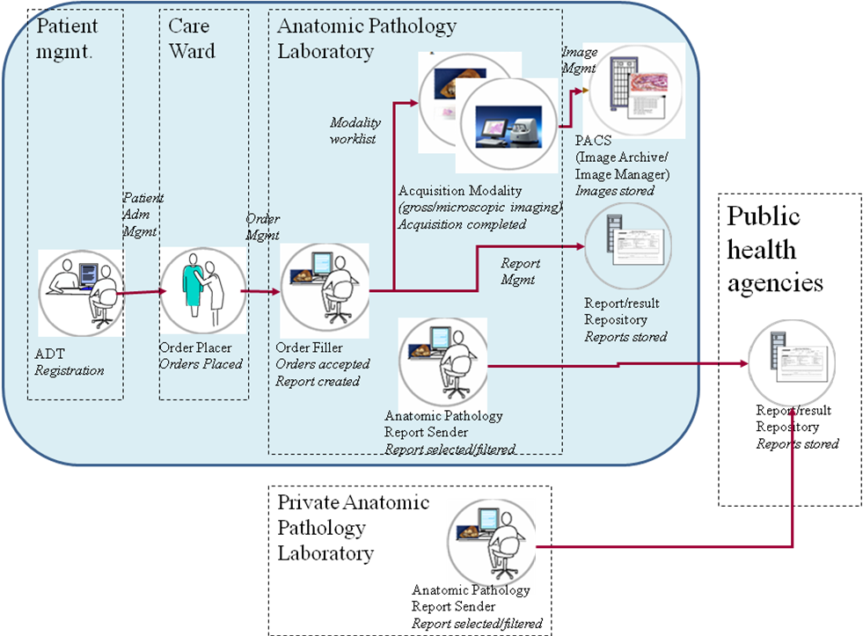

2.1 Dependencies among Integration Profiles
Add the following to Table 2-1

<Profile Name> | <?> | <?> | <->

Add the following section to section 2.2

2.2.X ARPH Integration Profile
<One paragraph description/ overview of Integration Profile>
Public Health agencies collect data on the occurrence of diseases diagnosed in anatomic pathology laboratories such as cancers.
The ARPH profile defines the actors and transactions involved in the standardized collection of anatomic pathology report data for public health agencies and the way these agencies will develop methods to electronically receive and process reports from anatomic pathology laboratories.
This integration profile will make it easier for anatomic pathology laboratories, public health agencies, and software vendors to adopt a uniform method for report transmission and processing. It will facilitate international electronic reporting of anatomic pathology reports in public health domain.

Add Section X

X ARPH Integration Profile
<Introductory Description/ overview of Integration Profile. May be the same as 2.2.X if that’s all it takes.>
The purpose of this integration profile is to describe electronic pathology reporting from an anatomic pathology laboratory to a public health agency (cancer registry, center of disease control, etc).

Public Health agencies collect data on the occurrence of diseases diagnosed in anatomic pathology laboratories such as cancers.
Cancer registries, for example, collect the type, extent, and location of the cancer; and the type of initial treatment. In each registry, medical facilities (including hospitals, physicians' offices, therapeutic radiation facilities, freestanding surgical centers, and anatomic pathology laboratories) report these data to the state central cancer registry. The cancer information gathered is critical for Public Health to have the ability to report Cancer Statistics. Cancer registry data is used to provide information on cancer trends, survival, treatment standards, access to healthcare and serves as a resource for research.
Historically, cancer registries have received paper reports from anatomic pathology laboratories (if received at all) and the registries are required to send cancer registrars into anatomic pathology laboratories to manually identify reportable cases and abstract pertinent information into an electronic form. This type of case ascertainment and data collection for the cancer registry is very resource intensive, time consuming, and prone to error in transcription and in missed cases. The process could benefit greatly from the implementation of standards reporting pathology information directly to the central cancer registry.
This integration profile will make it easier for anatomic pathology laboratories, public health agencies, and software vendors to adopt a uniform method for report transmission and processing. It will facilitate international electronic reporting of anatomic pathology reports in public health domain.
This integration profile defines the actors and transactions involved in the standardized collection of anatomic pathology report data for public health agencies and the way these agencies will develop methods to electronically receive and process reports from anatomic pathology laboratories.

X.1 Use cases (to be completed)

X.1.1 Extracting a collection of reports
The pathologist selects relevant reports to be sent to the Public Health organism. He/she complements and reorganizes the existing anatomic pathology reports as needed and send the collection to the Public Health repository.

X.1.1 Sending reports in real time one-by-one
Whenever a new completed report is relevant for Public Health the pathologist complements and reorganizes this report as needed and sends it to the Public Health repository.

X.2 Actors/ Transactions
<Actor/ Transaction diagram and Actor/ Transaction table. >
Figure X.1-1 shows the actors directly involved in the “AnatomicPathology Reporting to Public Health Repositories” Integration Profile (ARPH) and the relevant transactions between them. Other actors that may be indirectly involved due to their participation in <other related profiles>, etc. are not necessarily shown.
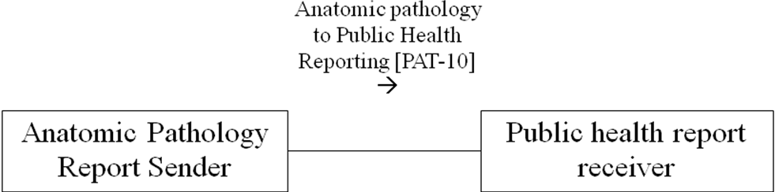

Figure X.1-1. ARPH Actor Diagram
Table X.1-1 lists the transactions for each actor directly involved in the <Profile Name> Profile. In order to claim support of this Integration Profile, an implementation must perform the required transactions (labeled “R”). Transactions labeled “O” are optional. A complete list of options defined by this Integration Profile and that implementations may choose to support is listed in Volume I, Section X.2.

Table X.1-1. <Profile Name> Integration Profile - Actors and Transactions
Actors | Transactions | Optionality | Section in Vol. 2
Anatomic Pathology Report Sender | Anatomic pathology to Public Health Reporting | R | Z.1
Public Health Report Receiver | Anatomic pathology to Public Health Reporting | R | Z.1

X.3 <Profile Name> Integration Profile Options
<Table describing the options available for this integration profile and references to all sections that state requirements for compliance to the Option.>
Options that may be selected for this Integration Profile are listed in the table X.2-1 along with the Actors to which they apply. Dependencies between options when applicable are specified in notes.
Table X.2-1 <Profile Name> - Actors and Options
Actor | Options | Vol & Section
Actor A | No options defined | - -
Actor F | No options defined | - -

X.4 <Profile Name> Process Flow
<Description of the process flow(s) and sequence diagram(s) covered by this profile in order to satisfy the use cases. This often will include a brief description of the use cases as well. If there are detailed behavioral rules that apply to a specific process flow or multiple process flows or descriptions then an appendix may be added as needed>

Figure X.2-1. Basic Process Flow in <Profile Name> Profile

X.5 ARPH: content structuring & coding rules
This section provides rules in order to guide the structuration and coding of a minimal medical content of the Anatomic Pathology report for Public Health. These rules are based on the “Reporting Guidelines for Clinical Laboratory reports in Surgical Pathology” (Arch pathol Lab Med)

X.5.1 Required sections
- Diagnosis Field
- Gross/Macroscopic Description
- Microscopic Description

X.5.1 Required structured observations (findings)
The minimal list of structured observations (findings) extracted from checklists or synoptic reports consists in:
For each specimen:
- Body site, subsite
- Surgical procedure
- Tumor size
- Distance between tumor and the closest margin
- State of the clinically important surgical margins
- Diagnostic codes (SNOMED, ICD-O)
For the case
- TNM
- pTNM

X.6 <Profile Name> Security Considerations
<Description of the Profile specific security considerations. This should include the outcomes of a risk assessment. This likely will include profile groupings, and residual risks that need to be assigned to the product design, system administration, or policy.>
<Appendix A> Actor Summary Definitions
<add any actor definitions for new actors defined specifically for this profile>
<Appendix B> Transaction Summary Definitions
<add any transaction definitions for new transactions defined specifically for this profile>

Volume 2 - Transactions
Add section 3.Y

3.Y <Transaction Name>
This section corresponds to Transaction Y of the IHE Technical Framework. Transaction Y is used by the <ABC> and <DEF> actors.

3.Y.1 Scope

3.Y.2 Use Case Roles

Actor:
Role:
Actor:
Role:
Actor:
Role: .

3.Y.3 Referenced Standard
<e.g., HL7 2.3.1 Chapters 2, 3>
<e.g. DICOM 2008 PS 3.3: A.35.8 X-Ray Radiation Dose SR IOD>

3.Y.4 Interaction Diagram
<the interaction diagram shows the detailed standards-based message exchange that makes up the IHE transaction>

3.Y.4.1 <Message_1 Name>
<One or two sentence description of the first message of the above interaction diagram, typically relating the message to the relevant standard>

3.Y.4.1.1 Trigger Events
<description of the real world events that cause the initiation of the first message>

3.Y.4.1.2 Message Semantics
<detailed description of the meaning, structure and contents of the first message including any IHE specific clarifications of the message format, attributes, etc.>

3.Y.4.1.3 Expected Actions
<description of the actions expected to be taken as a result of sending or receiving this message>

3.Y.4.2 <Message_2 Name>
<One or two sentence description of the the next message in the above interaction diagram, typically relating the message to the relevant standard. Note, repeat this section as necessary based on the number of messages in the interaction diagram>

3.Y.4.2.1 Trigger Events
<description of the real world events that cause the initiation of the next message>

3.Y.4.2.2 Message Semantics
<detailed description of the meaning, structure and contents of the next message including any IHE specific clarifications of the message format, attributes, etc.>

3.Y.4.2.3 Expected Actions
<description of the actions expected to be taken as a result of sending or receiving this message>

3.Y.5 Security Considerations
<description of the transaction specific security consideration. Such as use of security profiles. >

3.Y.5.1 Security Audit Considerations
<This section should specifiy any specific ATNA security audit event that is associated with this transaction and requirements on the encoding of that audit event. >

3.Y.5.1.(z) Actor Specific Security Considerations
<This section should specifiy any specific security considerations on an Actor by Actor basis.>
<Appendix letter> Appendix_Name
<Detailed cross transaction relationships or mapping details are described in an appendix in Volume 2>

