IHE Pharmacy / HL7 Pharmacy

Medication Management

Related Concepts and Definitions

Contents
Scope & purpose of this document 4
General Process 5
Data Elements relevant to Medication management 7
Prescription Data 7
Dispense Data 8
Medication Administration Data 8
Medication Statement Data 9
Health Concern Observation Data 9
Potential Contra-indications 10
Specific lab results 10
Drug and alcohol usage 10
Process steps 11
The act of gathering data 11
The act of making sense from the data 11
The act of verification of the data 12
The act of adding data to the collection 13
The acts of carrying out the therapy and evaluating the outcome 13
Definitions of Medication management 15
Medication Lists 16
Unreconciled Medication List 17
Reconciled Medication List 17
Aggregated Medication List 18
Medication Profile 19
Medication Management Profile 20
Medication Management 21
External references to terms used 22
Medication Reconciliation 22
Medication Review 23
Types of Medication Review 24
Appendix 25
Table of figures 25

Scope & purpose of this document

The purpose of this document is to define the various concepts and terminologie used in the pharmacy domain. IHE pharmacy, HL7 Pharmacy and ISO TC215 workgroup 6 have been convening frequently and noticed that each person had a different interpretation of the terms used. As SDO’s where communication of medication information is the core purpose of these organization it is of course vital to understand what a noun means, so that all persons have common ground of the words used.. Terms that have composite ingredients are to a certain extent arbitrarily defined, but this document contain the definitions that are agreed on by HL7 pharmacy, IHE Pharmacy and ISO TC215 workgroup 6.

The scope in the first stage will be on the definitions of composite information, such as lists. This will be set against the workflow and process in medication therapy.

Communicating information by means of IT can be separated into four layers:
- The conceptual meaning of terms
- The content and characteristics of terms
- The packaging of terms.
- The logistical transfer of information.

The first layer is also called the semantic layer. This document focuses on this layer. The intention is to understand the concept of a term. The result should be, that when a term as unreconciled medication list is used, that all readers should interpret the term in the same manner..

The second layer is also called the syntax layer. It defines the content of a term. Some of these elements in the content will be optional. In the context of this document the term syntax refers to the rules governing the composition of meaningful elements. As an example if we use the term location we could have chosen the geographical coordinates ( i.e. N 54 .W) as the syntax for a location, but rather we would prefer a more logical address, such as street, number, postal code and city. This document is not intended to dive into the syntax of the medication terms.

The third layer defines how the content is formatted so that senders and receivers can recognize the elements of the content. Examples are CDA documents, HL7v3 or HL7v2 messages. This document is not intended to go into this matter.

The fourth layer is the physical distribution of the information, such as pull or push mechanism’s. The logistical aspects are not in the scope of this document, nor is the method or required infrastructure to obtain the information part of this document.

Approach of this document
The approach of this document is first to explain the logical steps in a medication therapy of a patient and to state which data elements are required at that step and what is done with the data. We then searched for the best definition that would fit at that stage of medication therapy..

We noticed that if we had simply made a listing of definitions that the interpretations of the various terms led to endless discussion of the meaning of the terms.

General Process

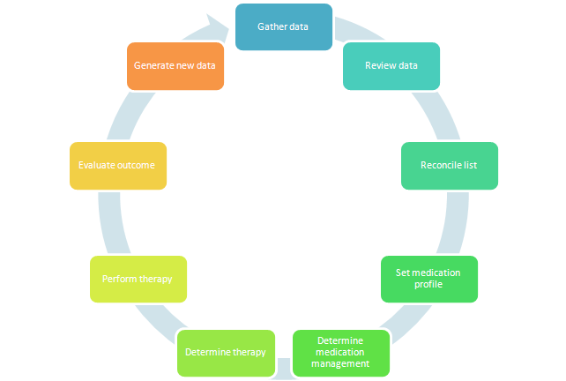

The medication process is actually a recurring cycle. This is often not recognized by care providers, because the care providers are frequently replaced, or the patient is transferred from one institution to another, but certainly from the point of view of the patient the events of the medication therapy are a recurring loop.
The loop does not have always have a smooth constant flow. While “gather data” is the logical starting point in the medication management process diagram, it is not uncommon for the process to start at a different step/point in the diagram. Events could happen all the time that could make intervention necessary. For example, admission of patient into hospital ER and later into the clinical units triggers review of patient’s existing medication list and then medication profile. As the condition of the patient changes (deteriorates or improves) or new lab results of the patients neral functions requires adjustments of the dosage. This all affects the medication management and provides short cuts in the loop.

These steps in the flow of the medication management of the patient result into different kinds of lists, profiles of medication of the patient. The purpose and the status of each type of list must not only be understood by the author, but also by other care professionals who share the information with the original source. The intent of this document is to distinguish the different steps in medication management and which type of document belongs to which process part.

The sequence on which we will explain the definitions are to:
- identify the basic data elements relevant to medication management.
- define the possible process steps and the variations in the processes
- name the various report types that can be linked to that part of the process.

Data Elements relevant to Medication management

Effective medication therapy management requires the inputs of relevant historic and current information including medication and related clinical information. This section provides an overview of the information important for medication therapy management planning and review processes. Details of information requirement (including data elements, data types and terminology constraints) for each of these data components are out-of-scope for this whitepaper and will be addressed in detail in a separate technical/discussion paper.

The collection of data elements must be seen as a list of possible data elements. It became evident, that it was not possible to make a compulsory list of ingredients. It would be magnificent to know everything, but there is a cost of effort of registration that is required to put the information in a system. That effort might not always be worthwhile. Tradition, but certainly also a level of computerisation, accessibility of that information and the differences in workflow are factors that influence the availability of data.

Prescription Data
A prescription is a treatment order (usually written) by a qualified practitioner such as medical practitioner, dentist, nurse practitioner (and in some jurisdictions, pharmacist).
A treatment order can cover medications, nutritions, procedures (e.g. dialysis, dressing, operations, etc), therapies
Prescription medications are drugs that can only be made available to patients by an order (usually written and signed) of a qualified practitioner.

It is important to recognize that a prescription order is a combined order that contains two distinct elements:
- A therapy agreement that the prescriber makes with the patient
- An logistical order to supply tangible goods, most commonly the medication.
In certain settings these elements might be seen as separate entities. An order to stop medication can be seen an example of an order where there is a therapy agreement to stop using the medication and where the supply is left void.

Depending on the constituency and the type of process the prescriber might leave the level of detail of the order open for others to fill in. In many cases the medication on the prescription would be prescribed on a more generic level while the dispense is most certainly a tangible product.

Prescription (together with dispense and administration) data are key components of patient’s medication list, medication profile. This data is very important for safe and effective management of patient’s medication therapy and is an integral component of the patient’s medication management plan.

The most common source for prescription data are the prescribing systems.

Dispense Data
Dispense of medication includes the act of preparing and supplying medications.
Medication dispense data capture details about (prescribed) medication dispensed for use by patient. Dispense information are usually originated by pharmacists and collected from pharmacy systems.

In the institutional setting the administration of medication to a patient might be from the ward stock and the dispense itself could be a supply from the pharmacy stock to the ward, which might not be a patient’s name. In the view of medication management we only focus on dispense that is tied to patient. This is common in the community setting and the dispense of rare and expensive medication in institutional setting.

Certain systems define the medication as dispensed as soon as the order is ready for dispatch ( i.e. ready to be picked up by the patient). In the view of medication management we define medication as dispensed, if it is in the possession of the patient. This is to exclude medication that is not picked up as a valid dispense.

In the community setting, medication dispense data provide “partial closing the loop” information on prescription. The presence of medication dispense data against a prescription gives certain confidence that the patient is more likely to comply with medication management plan. The dispense should be matched with a prescription via a reference to the prescription id.

In many cases a listing of dispense will give a more complete view of the total medication consumption, because pharmacies will have a more complete registration, including paper prescriptions and the OTC (over the counter) supplies by the pharmacy. Moreover the dispense is likely to give more detail, because it will contain a product that can be dispensed in comparison with a more generic product code from a prescription. The dispenser might also have added dates ( or time interval), which the prescriber might have left open. This will influence the appearance of medication in a list.

Medication Administration Data
Medication administration data captures details about (prescribed and non prescribed) medications administered to or taken by the patient.
Each medication administration record/entry is an account of one administration event, which may be a point in time event (representing a dose of medication), or may be an occurrence over a time interval (e.g. intravenous administration of antibiotic over duration of 30 minutes)
Medication administration data differs from medication statement, which represents an assertion of known use of medication in general.

It is unusual for medication administration records to be kept in the community setting. But if such information is available, for example for trombosis patients, it completes the medication prescription-dispense-administration loop.
The presence of medication administration data in community setting allows more accurate assessment of patient compliance profile.
Medication administration data provide important information for safe and effective management of patient’s medication program.
Medication administration data originate from nurses, patient or relatives, home care aids or even administration machines and have various sources ranging from EHR to telemedicine systems.

Medication Statement Data
“A Medication Statement is a declaration of medication actually used, known to be used, as well as intended to be used by the patient in the future. A medication statement refers to exactly one medication. This information might be procured as a result of the process of medication review and reconciliation (e.g. by interviewing the patient or by querying and review trustworthy data sources).”
Medication statement captures information that are not formally captured in prescription, dispense and administration repositories. It provides important additional information that add to the completeness of a patient’s medication list or medication profile, and is one of the important information source to facilitate safe and effective patient medication management.

Statements from the patient about the OTC medication or herbal concoctions can be captured in the medication statements. This could even be extended to the registration of recreational drug use or alcohol consumption. The source of the information could be the patient, relatives or even the interviewing care provider. The information could originate from any system varying from an EHR to a PHR.
The reliability of the statement is just as reliable as the source. Assertion is acceptable.
Note that the identification of the medication might not be exact. (foreign medication, herbal mixtures etc.)

Health Concern Observation Data
Patient’s health concern data include data that reflect the assessment of the patient’s health. They include:
- gender, age
- body weight
- genetic profile
- health risks (including risks associated with family history)
- issues/problems (including compliance issues)
- diagnosis
- health status (including diagnostic test findings)
- potential contraindications (including existing conditions and/or predispositions, e.g. pregnancy, allergies and intolerances)
- other relevant vital signs

The latest and historic patient health concern assessment information will always influence a clinician’s decision in planning a patient’s treatment (medication management included)

Potential Contra-indications
Medication is prescribed as a remedy against a certain health issue. Potential contra-indications are other health issues of the patient which might give reason not to prescribe this medication, or at least take consideration of before prescribing the medication to the patient. This could range from an allergy to the medication, or other conditions ( for example hypertension) that could worsen when the medication is used. Not all health issues of the patient are relevant for each case. It depends on the circumstances and the medication prescribed. Therefore they are called potential contra-indications.

Specific lab results
Certain organs play an important role in the medication therapy. Care providers take a special interest in the liver and neral functions when it comes to medication management.
Medication can also be disruptive for patients who have to watch their blood thickness. Sometimes this information is also encapsulated in the medication profile.

Drug and alcohol usage
Abusive use of drugs and alcohol have their effect on medication usage. Certain countries have a requirement to register the use of drugs or alcohol abuse on the medication profile of certain patients.

Process steps

The act of gathering data

Gathering data is usually necessary when an unfamiliar patient appears for the first time to an institution or at least when no medication data can be found in the IT system. Sometimes the patient might have brought along a listing of medication on paper and it is not unusual that they their pills along in a plastic bag to show them to a care provider.
The goal of this paper is to abandon these archaic methods of gathering and focus on modern techniques of data retrieval.
There could be multiple sources for the data and the methods to retrieve data might be different. The data might originate from document repositories or databases from various sources such as pharmacy systems, GP systems, hospital pharmacy systems, laboratories, EHR systems from hospitals, regional or national database, PHR-systems. The method to retrieve the data is not described in this document, but can be found in other IHE profiles.

Gathering data is also required when a patient returns to the institution after treatment elsewhere. The patient might already have medication data in the system, but the data is most likely to be outdated. An update of the medication data is required to have a valid and recent file.

The result of gathering data might be a collection of raw data.

A typical product that comes of this phase is:
- unreconciled medication list
For further elaboration see chapter 6.

The act of making sense from the data
The raw acquired material might not be useful to be able to draw conclusions on what the patient is using at the moment. The volume of retrieved information might be too large to be able to make a sensible report. The various types of cleaning up the mess are generally:
- removing old outdated data, for example medication that has long been stopped.
- removing duplicates. In retrieving data from different external sources particular dispenses that might have been copied across might appear twice.
- aggregating similar data to singular grouped data, daily dispenses for a repetitive prescription.
- removing insignificant data such as bandages or diapers that are dispensed through a pharmacy.
A part of this cleaning process can be done automatically on the basis of filtering rules, such as checking on identities, part numbers and dates, but in the end human interpretation is required to draw the final conclusions of what should be in the list.

Particular remark has to be placed with the aggregation of the components prescription, dispense and the administration or medication statements from the patient. Presciptions are normally based on the generic medication code, while dispense would mention a specific trade product with a distinct part-number. Grouping the prescription and dispense data together is therefore done by matching the prescription-id, but this might not always be present. This is even more the case with medication statements, where a prescription-id might be unknown to the informer.

What we need to distinguish in the cleaning up process is the concept of static and dynamic method. In a static clean up the cleaning up process is done permanently in the collection of data and stored as such. Once an element has been deleted or aggregated it cannot be undone. The advantage is that the cleaning up is only done once. The disadvantage is that the filtering rules have less flexibility. You cannot ask detail information any more once you have aggregated the data into one element.

In a dynamic filtering the cleaning up process is only done temporarily on the run and needs to repeated every time this report is required. The dynamic filtering could be ticking a checkbox in a parameter screen before the starting the display of a list. The advantage is that the filtering rules can be changed depending on the need of that moment. The disadvantage is, that rework has to be done every time. In the example of detailed dispenses, the dispenses are aggregated every time a report is run.

There is no exact rule where to put the boundary for static or dynamic clean up. This is very much a choice of the IT vendors and their users.

The sequence in which a report is shown, is usually done dynamically. Computers are fast enough to sort long list of medication on the fly, whether you want to sort it by medication code, date or health concern.

A typical product that comes out of this step is:
- Aggregated medication list
For further elaboration see chapter 6.

The act of verification of the data
It is not unusual to verify the list with ( a relative of) the patient or an intermediate of the patient, such as a nurse or a primary care provider. Human interaction is involved in the act of verification. This could be the care provider acting alone or in conjunction with the patient. The patient might deny that certain medication is still used and add other medication products that are relevant for the medication list. Examples are over the counter medication that the patient has bought in a drugstore.

The verification of data is not only limited to medication, but to all types of information relevant for the medication safety as described in the previous chapter, such as allergies and contra-indications.

As a result data elements may be refined, corrected, added or removed.

The result of this process step is having a collection of data, that the care provider regard as correct and relevant for the further treatment of the patient as described in the next paragraph. A snapshot of the collection of data is stored on a system.

A typical product that comes out of this step is called:
- Reconciled medication list
For further elaboration see chapter 6.

The act of adding data to the collection

The next step in the treatment is usually where the care provider draws conclusions from the existing collection of data and sets up a new treatment plan. This could be orders for additional analysis or a medication therapy plan.
This collection of data i.e. tidied up and verified data together with a new treatment plan form an up to date profile for the patient. At this point in time the care provider and the patient know what has occurred in the past and what they set up to do for the future.

Taking new measures by the care provider is generally regarded as an act of managing the treatment of the patient. This would add the word management to this process step.

A typical product that comes out of this step is called:
- medication ( management) profile.
For further elaboration see chapter 6.

The acts of carrying out the therapy and evaluating the outcome
Eventually the medication therapy is carried out and the outcome of the therapy is evaluated. In the ambulatory setting the outcome might be regarded successful unless the patient comes back.

In the institutional setting the outcome is monitored and reviewed by the care providers. Evaluation might be added. This in itself generates new input and data or new data is generated by partners in the healthcare, such as the community pharmacy.
Other results such as lab results or observations, that are relevant for the therapy have to be considered and are added to the collection. This is actually new raw data. The circle in the process has returned at it’s starting point and the process steps will repeat again.

Definitions of Medication management

Reflecting to the process steps that are described in chapter 5 we now sort the various types of medication management lists according to their acts in an overall overview. This results in the following diagram.

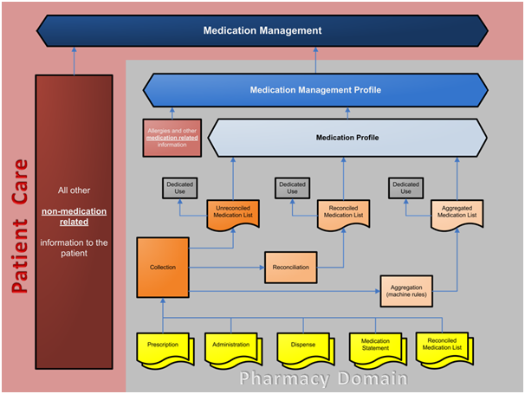
Figure 1 Overview of terms

Figure 1 reflects the overall overview and the relationship between the various terms used in the medication management. In the following chapters we will discuss the various topics of this overall concept.

Medication Lists

In practice the process steps do not run nicely in order and certain domains would have procedures that might differ from other healthcare guidelines. Therefore no exact definition can be made on the various types of medication lists and people use the names through each other. The following chapters contain an ennumeration of various medication lists with which most products can be classified with.

In general a medication list is a collection of information, organised in the format of a list, describing the drug therapy/regime that the patient is or has been taking. It can be presented as an electronic view from query to the EMR/EHR repository; or as printout which the patient carries.

The medication list may contain:
- prescriptions
- dispenses
- medication administration
- medication statements
- input from existing ( older) medication lists.

Some definitions also mention intolerances and allergies, but that is not a general rule. The medication list could be listed in various ways. It's entry point is usually the product over time.

An example of a definition is:

“The medication list should include all medications (prescriptions, over-the-counter, herbals, supplements, etc.) with dose, frequency, route, and reason for taking it”
[Source: Institute for Healthcare Improvement]
http://www.ihi.org/knowledge/Pages/Changes/ReconcileMedicationsinOutpatientSettings.aspx

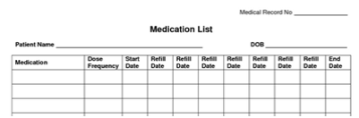

Figure 2: Example of Patient Medication List printed on paper

Going down the hierarchy the medication list can be divided into the various subsorts.

Unreconciled Medication List

An Unreconciled Medication List is a list of medications of the raw data, usually ordered by date of occurrence. The list could consists of various elements ( prescriptions, dispense, administrations) often depending on the accessibility of the systems and sources available. A stand alone GP system would for example contain prescriptions as the main ingredient of the unreconciled medication list.
The list is not processed or changed in terms of clearing, removing duplicates, grouping of medications, etc. The unreconciled medication list is usually the result of act. 5.1 ( gathering data).

The unreconciled medication list is usually generated prior to consultation with the patient and is the result of querying one or multiple systems.

Reconciled Medication List

A collection/set of patient’s known medications at a point in time obtained from various sources, organised and presented in a list format. The contents of the procured medication list have gone through the process of clinical verification. Any discrepancies identified by the reviewer are discussed with the prescriber and/or patient and reasons for changes to therapy then documented.

The reconciled medication list is in most cases the next step after gathering information in an unreconciled medication list. This is described as act 5.: verification of data. Human interaction is involved in the act of reconciling the medication list.

An example of an explanation of a reconciled medication list is:

“The medication list should include all medications (prescriptions, over-the-counter, herbals, supplements, etc.) with dose, frequency, route, and reason for taking it. It is also important to verify whether the patient is actually taking the medication as prescribed or instructed, as sometimes this is not the case”
[Source: Institute for Healthcare Improvement]
http://www.ihi.org/knowledge/Pages/Changes/ReconcileMedicationsinOutpatientSettings.aspx

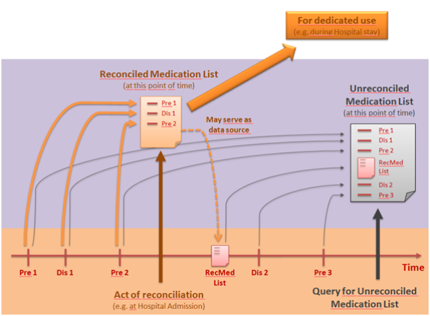
Figure 3: Reconciled-/Unreconciled Medication list

Aggregated Medication List

An Aggregated Medication List is a list of medications at a higher complexity level derived by the process of Medication Aggregation (with some kind of machine pre-processing of the data e.g. combining same medications, clearing duplicates, etc.).
Data structure: The data structure differs from the original data-structure of the data source elements. It contains additional information e.g. in the case of the combination of same medications the date-range a patient was on that medication.

No human interaction is required in the process of aggregating the medication list.

Medication Profile
A Medication Profile is a general term for a collection of medication information. Raw data as well as all three types of Medication lists (Unreconciled, Reconciled, Aggregated) may be part of that collection.

An example of a definition of a medication profile:

“A complete and comprehensive summary of all regular medications taken by a patient. The profile includes key details about the consumer/patient, the issuing pharmacy, and details of each medication such as active ingredient and brand names, strength and form, dose and directions for use, and other supplementary information (e.g. route of administration, indication, special directions.”
Information about the consumer [patient] includes patterns and reasons of non-adherence, adverse reaction history and contra-indications.
[Source: Medication Profiling Service, Pharmaceutical Society of Australia, October 2007]
http://beta.guild.org.au/uploadedfiles/Professional_Pharmacy_Services/The_Patient_Medication_Profile_Program/PMP%20Promo%20Pack%20GP%20Info%20hi-res.pdf
http://www.psa.org.au/download/standards/medication-profiling-service.pdf

Medication Management Profile
The medication management profile should provide the care provider with all necessary information to be able to perform medication management.

A proper medication management profile should be patient centric. This means that the patient characteristics would be the starting point of display of information. The health concerns or problem concerns of the patient would be the initial view and would state what (medication) therapies have been applied throughout the timeline, rather than the medication lines would state for which purpose they were prescribed.

The medication management profile is an extension of the medication profile and contains other relevant health concern data such as:
- generic patient data
- gender, age, body weight
- potential contra-indications
- intolerances and allergies
- relevant lab results.
A Medication Management Profile is the final basis for doing medication management.

The medication management profile would also contain not only the actual medication profile, but also past history and experiences of the patient with regards to medication therapies. For example variations in dosage, reasons for stopping, adverse drug events.

Figure 2 example of medication management profile screen

Medication Management

Medication Management is the act of managing the medication therapy of a patient. Medication management is usually performed by prescribers, but in some cases the (hospital) pharmacists also play an important role in the management of the medication therapy.

External references to terms used
The following texts are a collection of definitions from various organizations. These definitions might differ from the previous praragraphs, where we have tried to explain the definitions in comparison to each other.

Medication Reconciliation
“Medication reconciliation is the formal process of obtaining and [clinically] verifying a complete and accurate list of each patient's current medicines, matching the medicines the patient should be prescribed to those they are actually prescribed. Any discrepancies are discussed with the prescriber and reasons for changes to therapy then documented.”
[Source: Office of Safety & Quality of Healthcare, Department of Health, Western Australia]
http://www.safetyandquality.health.wa.gov.au/medication/medication_reconciliation.cfm
[Source: Australian Commission on Safety & Quality in Healthcare]
http://www.safetyandquality.gov.au/our-work/medication-safety/medication-reconciliation/

“Medication reconciliation is a formal process in which healthcare providers work together with patients, families and care providers to ensure accurate and comprehensive medication information is communicated consistently across transitions of care. Medication reconciliation requires a systematic and comprehensive review of all the medications a patient is taking (known as a BPMH) to ensure that medications being added, changed or discontinued are carefully evaluated.”
[Source: Institute for Safe Medication Practices Canada]
http://www.ismp-canada.org/medrec/

“Medication reconciliation is the process of comparing a patient's medication orders to all of the medications that the patient has been taking. This reconciliation is done to avoid medication errors such as omissions, duplications, dosing errors, or drug interactions.”
[Source: The joint Commission]
http://www.jointcommission.org/assets/1/18/SEA_35.PDF

“Medication reconciliation is the process of creating the most accurate list possible of all medications a patient is taking — including drug name, dosage, frequency, and route — and comparing that list against the admission, transfer, and/or discharge orders. The goal is to ensure that all correct medications are to the patient and to prevent unintended changes or omissions of medications at all transition points”
[Source: Institute for Healthcare Improvement]
http://www.ihi.org/knowledge/Pages/Changes/ReconcileMedicationsatAllTransitionPoints.aspx

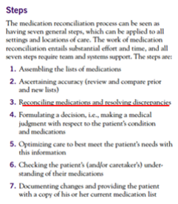
Figure 4: Medication Reconciliation Process
[Source: The Physician’s Role in Medication Reconciliation, American Medical Association, 2007]
http://www.ama-assn.org/resources/doc/cqi/med-rec-monograph.pdf

Medication Review

“As defined by the Royal Australian College of General Practitioners (RACGP), a medication review is a critical clinical review of all prescribed, over-the-counter and complementary medications undertaken to optimise therapy and minimise medication-related problems. Medication reviews may be undertaken in the surgery, or home or institution”
[Source: Department of VA, Australian Government]
http://www.dva.gov.au/service_providers/pharmacy/Pages/medrevu.aspx

A process of systematic evaluation of a person’s complete medication regimen and management of the medications
[Source = Guidelines for Pharmacist Providing Residential Medication Management Review and Quality Use of Medicine Services, Pharmaceutical Society of Australia, 2011, October]
http://www.psa.org.au/download/practice-guidelines/rmmr-and-qum-services.pdf
Includes careful clinical evaluation of aspects of the patient’s medication regime (a specific medication or all known medications) such as indications, uses, dosage, frequencies, effects and side effects, max cumulated dose, contraindications; and making appropriate medication management recommendations and/or decisions.

Types of Medication Review
Medication order review – a clinical evaluation of medication order/prescription to identify any issues related to the medication order and making recommendations or decisions to resolve the problems.
Medication therapy review – “The medication therapy review is a systematic process of collecting patient-specific information, assessing medication therapies to identify medication-related problems, developing a prioritized list of medication-related problems, and creating a plan to resolve them. Medication therapy reviews are one of the five Medication Therapy Management Core Elements Service Model Version 2.0 1 these reviews can be comprehensive or targeted to an actual or potential medication problem. Whether comprehensive or targeted, the individual patient’s medications are evaluated in the context of the patient as a whole, taking into consideration all of the patient’s conditions and medication therapies”
[Source: American Pharmacists Association]
http://www.pharmacist.com/medication-therapy-management-services
Medication profile review – a clinical evaluation of patient’s medication profile

Appendix

Table of figures

Figure 1: Concepts related to the Medication Management process. 5
Figure 2: Examples of Patient Medication List printed on paper. 7
Figure 3: Reconciled-/Unreconciled Medication list. 8
Figure 4: Medication Reconciliation Process. 11
Figure 5: Medication Lists, Profiles and Process flow.. 13

