Monday, February 6, 2017
Call to order
Present: Fabio Buti (involved in Radiology early on), Charles Parisot, Amit Popit, Thierry Darwan, Andrea Fouquet, George Cole, Thom Kuhn; Emma Jones; Denise Downing
Phone: Brian Reinhold, Vassil, Chris Melo, Dr. Stephen Beller, Hans Buitendijk, Holly Miller, MD, Kwakour Quaynor
Agenda reviewed – Joint meeting Tuesday with Pharmacy, may need to add time for CPs due to FHIR based profiles and it moving to DSTU3

Patient Centric Data Element Location Services (QED on FHIR)
Overall review done, identified issues, discussion over the issues performed, granularity at both the document and data element level course grain and fine grain data, HL7v3 makes it difficult, want to move towards a mobile system, open issue the data may not be available in one of the documents in the diagram below.
PDLS - thought is to introduce a fine grain access to health data in addition to the course based access to health data - document. Document sharing - XDS/XCA/MHD based. QED was based on the HL7v3 standard but it’s too complex.

PDLS simplify for Document level granularity will keep as is
For data element level granularity will use QED on FHIR.

Existing XDS deployment asking for general direction on access to data

Discussed the below diagram to place the document inside the care setting, the orange dots represent the data elements,
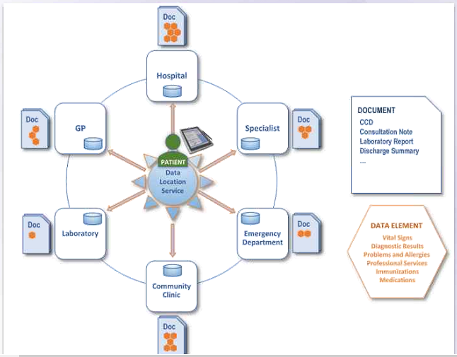

mQED (Query for Existing Data for Mobile) fine grain data is depicted with the orange box, the profile will provide the context about how to find the fine grain data in a consistent way, going from the document registry/repository going to the fine grained resource there will be some reconciliation that will need to take place,
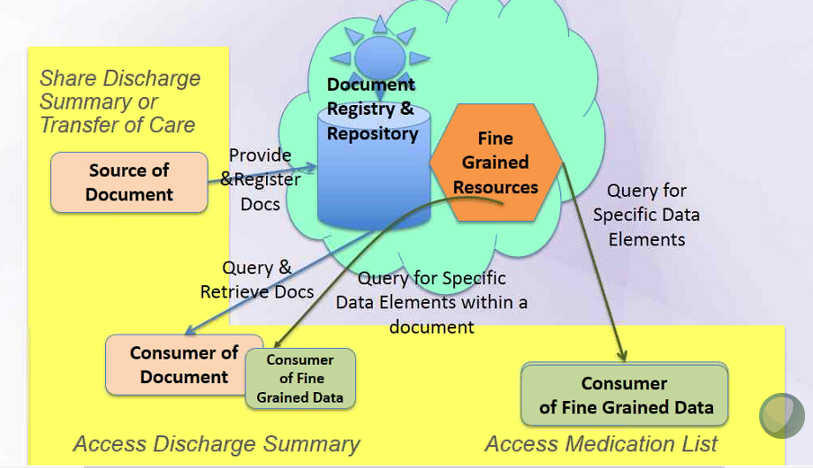

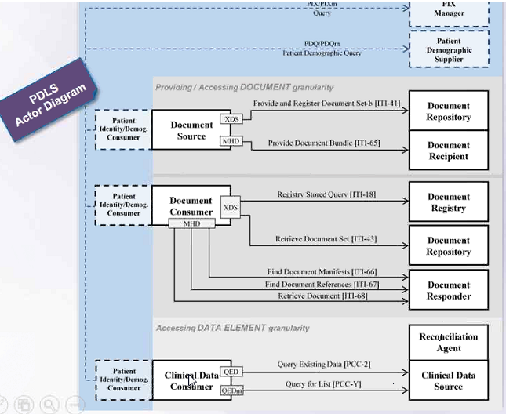

PCC will keep mQED, the agreement was Yes that PDLS will stay in PCC and PCC will own it, this profile will produce 2 works one for ITI and one for PCC, the profile may improve RECON so there may be CPs to RECON
Issue with QED, QED alone is not enough for document sharing, users are now understanding what they can do with sharing documents and how to exchange it, a query with HL7v is difficult, on demand document viewing has been successful
Open Issues:
Location and span of RECON, when asking for fine grain data from Fine Grain Resource you may get returned different data, do you implement a relay proxy, the profile will not address the relay proxy, but need to have a few Use Cases about the proxy, this will be in an Appendix and it will give you the information about this issue, but it will not be an implementation guide with details

Do we do RECON? Yes, once collected the data repository can partially RECON it then RECON it again, if you have a proxy the RECON would occur in the proxy,

Set of documents query and select the document in the query, but we don’t get the document only the data elements, would supply a directory of resources in the document registry of the document and the metadata would be the URL of resources, the open issue below needs further discussion and will be talked about tomorrow

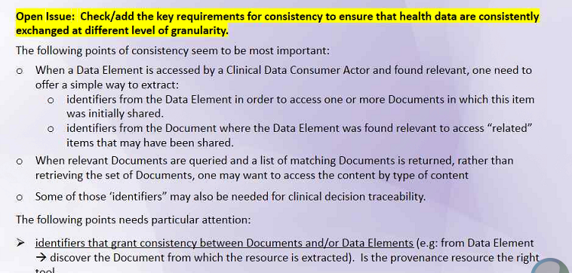

Remote Patient Monitoring (RPM)
Present: Amit Popit, Thierry Darwan, Andrea Fourquet, George Cole, Thom Kuhn
Phone: Diana Warner, Kwekour Quaynor

Update to an existing profile, add a transaction, back-end server wasn’t required to dispatch data, observation upload replacement of data model to send the data instead of v2 messaging and replace PCD-01 with a FHIR bundle, both are present, transaction that can go to the IHE profiles, RESTFUL upload, the profile isn’t interested in GET,

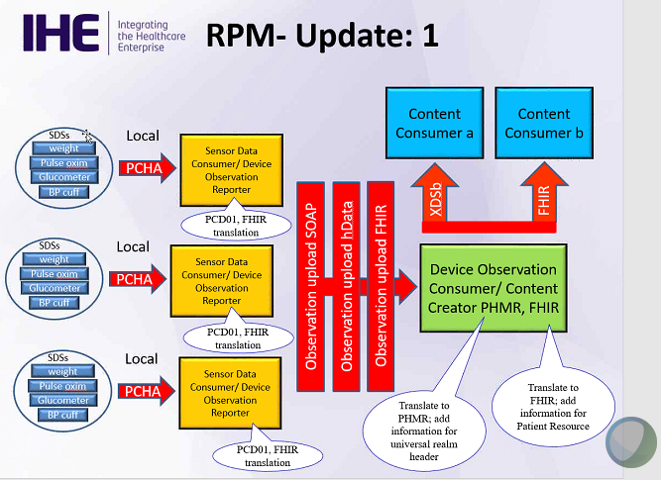

This update is not going to store the PHD has uploaded, there some tools to filter, there are some FHIR resources to help avoid duplicate data, conditional creates can send the upload with a conditional create, the FHIR servers receives it, it looks for the resource and if it finds it based on a set of criteria-identifier that is guaranteed it is the resource and it will return the resource
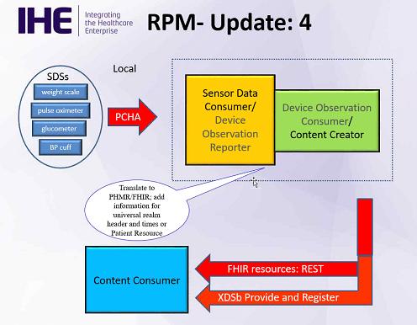

A PHD (i.e., pedometer) can have a lot of data to report (i.e., steps, calorie consumed the activity involved in, etc.), it can be considered a session, if the same data is uploaded from different devices you need to use a conditional-criteria to avoid the sending of duplicate data, not as simple as doing a PUT, the profile will build into it the ability to avoid duplication

Pt Registration Content

Present: Amit Popit, Thierry Darwan, Andrea Fourquet, George Cole, Thom Kuhn, Tone Southerland
Phone: Diana Warner, Kwekour Quaynor

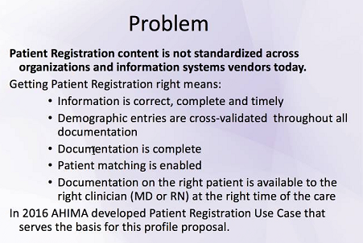

Content profile defining a more constrained view, new transactions and adding two additional segments that PAM Profile (ITI-30)

New transaction – profile will be able to send CDA based documents that includes Pt registration data, no new Actors using existing Actors

Use Cases – 2 main ones, but maybe 3 Use Cases, walk-in pt. to ED, registration conducted by clinician, 3rd Use Case pt. is being transferred to another provider and pt. registration information has been tracked on, with the 3rd Use Case may need to update the section of existing profiles

360 x Profile
Present: Amit Popit, Thierry Darwan, Andrea Fourquet, George Cole, Thom Kuhn, Emma Jones, Denise Downing
Phone: Vassil , Brian Rhienholt, Dr. Stephen Beller, Hans Buitendijk, Chris Melo, Holly Miller MD

2 Use Cases – PCP to Specialist and Public Health to Specialist (coordination with EHDI)

Care Team Management Profile
Present: Amit Popit, Thierry Darwan, Andrea Fourquet, George Cole, Thom Kuhn, Lori Fourquet
Phone: Hans Buitendijk, Chris Melo

Aligning with ONC and Domain Analysis Model work, examples and definitions are coordinating with that works definition

Two Questions to Discuss this Week:
Determining what is trying to achieve
Care Coordination Functional Model – part of HL7 work which can drive implementation work, which part of CCS is the profile trying to meet? Should try to say what is the Care Team, let the systems know if the systems exist and if any changes have been made to the team, get to the list of Care Teams that the pt has or is associated with, this is part of the Membership capabilities 5.2 Care Team Member Capabilities, we need to see if the Use Case supports the need for sections 5.2.1. or 5.2.2 leaving those two sections out of the workflow, the profile will not go into messaging or negotiations or scheduling

Reworked the Introduction sentences, for tomorrow need to define List and Discovery,

Open Issues List:
Need to determine a FHIR version DSTU3, use v3
Future updates will be dealt with by CPs

HPD, did not reference to Care Teams, it referenced to providers, there is HPD on FHIR work going on, check to see if that work will utilize the Care Team Resource, HPD+ got rolled back into ITI, Emma will check on the FHIR website or with others to see about HPD on FHIR

Volume 2 issues – how Care Team Members will be removed from the Care Team and how will updates occur (need to describe in volume 2) real-time or published subscription? Use the Subscription resource

Review #5 and on tomorrow.

EMS (DET) Profile
Present: Amit Popit, Thierry Darwan, Andrea Fourquet, George Cole, Thom Kuhn, Lori Fourquet
Phone: Hans Buitendijk, Chris Melo

Open Issue: Need a Name for the Profile because EMS is only a US term

Query transaction, this profile is using a FHIR resource and a document sharing, using existing XDS document, may add the ability to add it via FHIR (MHD), do we make a new transaction?? This is the question, don’t use MHD or use MHD and FHIR

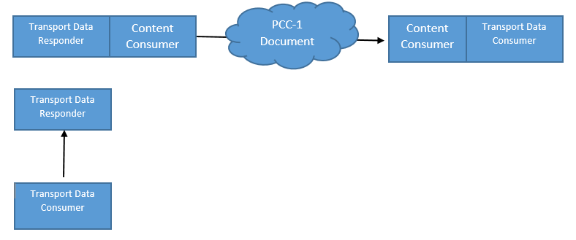

Approach for profiling FHIR the Transactions of PCC will expand, can we reuse transactions as is QEDm

Make it an option to support both FHIR and CDA document, query options EMS capabilities should include the number of queries to perform

PMDT - Presented by Denise downing.
Need to clean up diagrams. Discussion about the need to use IHE profile template for the diagrams rather than a commercial tool.

Tuesday, February 7, 2017
Joint with ITI - QED on FHIR
List of issues to discuss
Revised the general overview

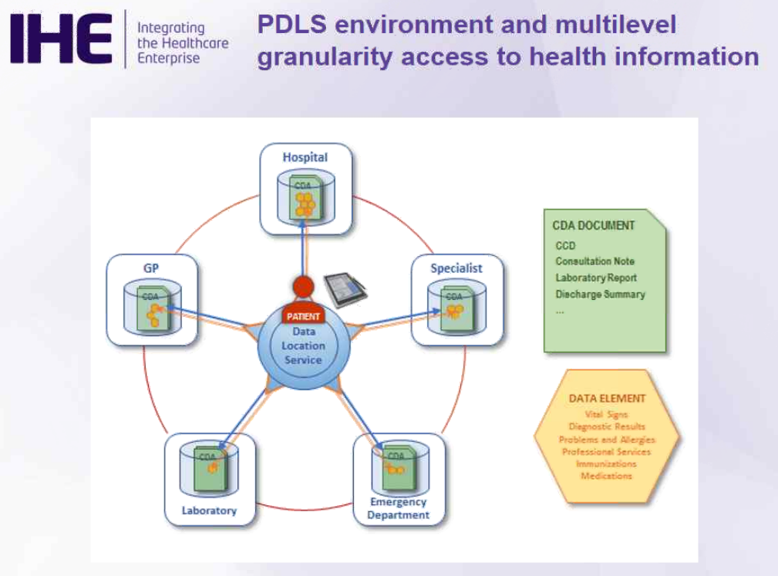

Want to add a tablet to demonstrate use of mobile devices

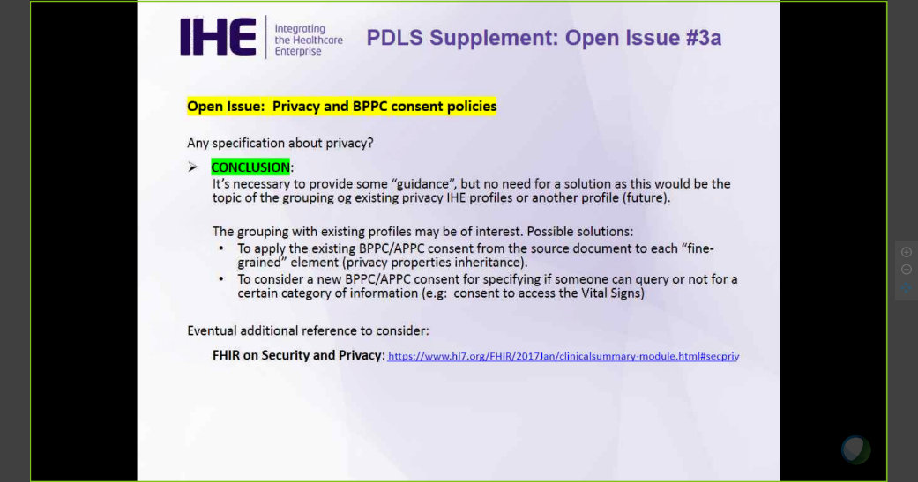
Privacy - need to take a consistent approach
Issue with text elements in a document - extracting of text is not possible
Need to discuss further
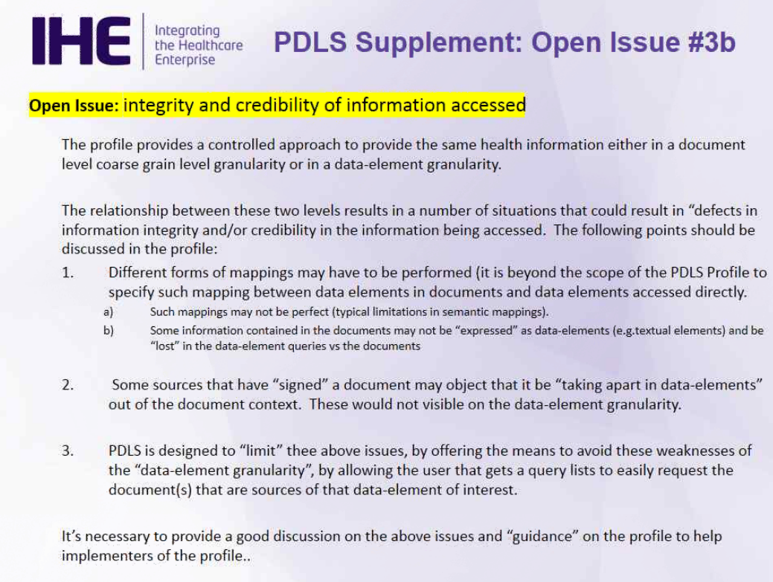

Discussion about use of provenance as an option

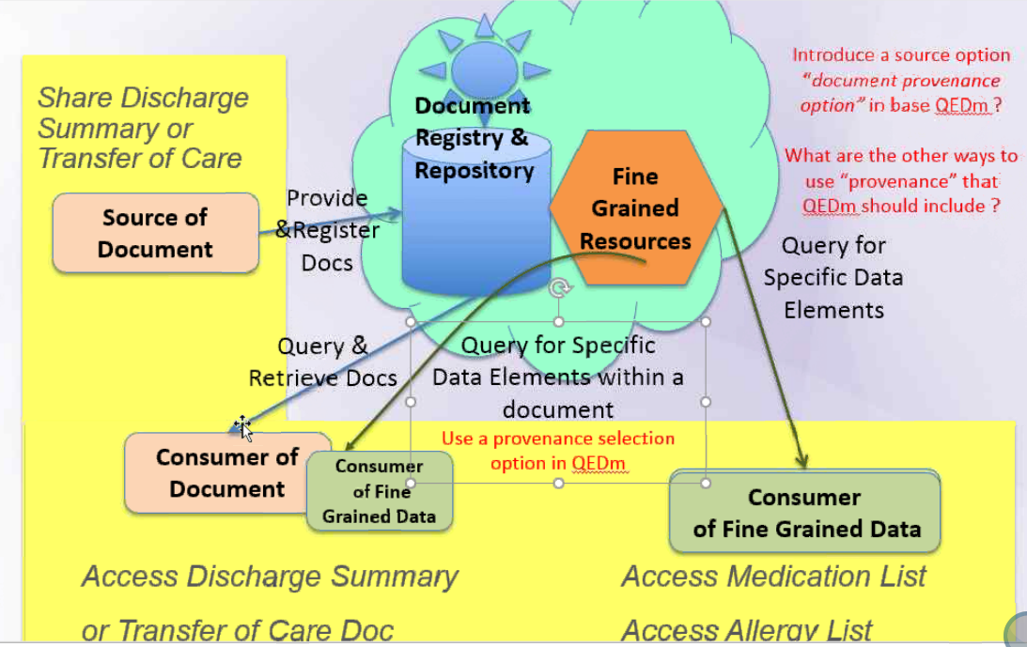

What happens when systems go beyond this profile and return data that did not come from documents?

This is an open question: can we get data element that is not coming from documents

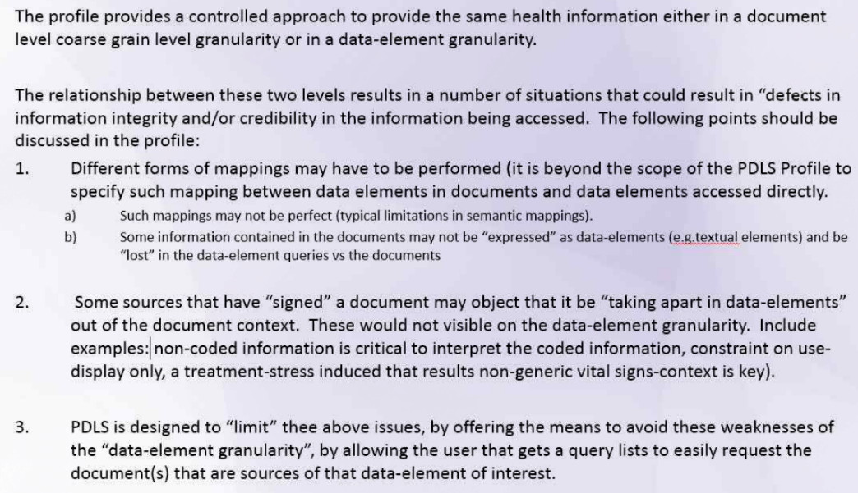

RPM on FHIR
Brian - need the correct names for the transactions (provided)
Need to know of an ITI transaction that makes sense already exists - will ask John Moehrke

360X
Present: Amit Popit, Thierry Darwan, Andrea Fourquet, George Cole, Thom Kuhn, Emma Jones, Denise Downing
Phone: Vassil , Brian Rhienholt, Dr. Stephen Beller, Hans Buitendijk, Chris Melo, Holly Miller MD, Rob Rose

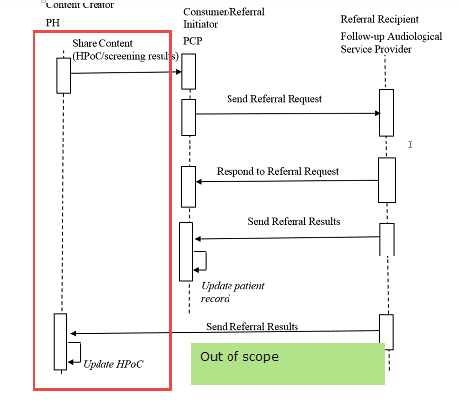
Security consideration will follow the direct trust

National Extension Vs Profile

Have to be national extension because of Direct trust and the use of CCDA
Proposal to use volume 1 as a profile + the national extensional - what are we basing the national extension on? Suggestion to make volume 2.x work which will be TBD. Knowing there is work tbd to create the volume 2.

RIPT: Note profile name changed
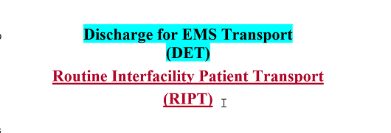

.
Discussion about content - FHIR and CCDA - data mapping to NHCS transport forms

Wednesday, February 8, 2017

Joint Meeting:
DCC engagement on how to connect IHE regional deployments so we can better understand which profiles are in use, which can be deprecated, and how to organize the IHE "architecture"

Pharmacy
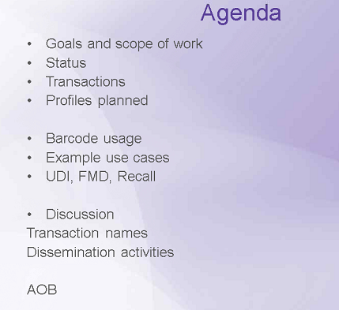

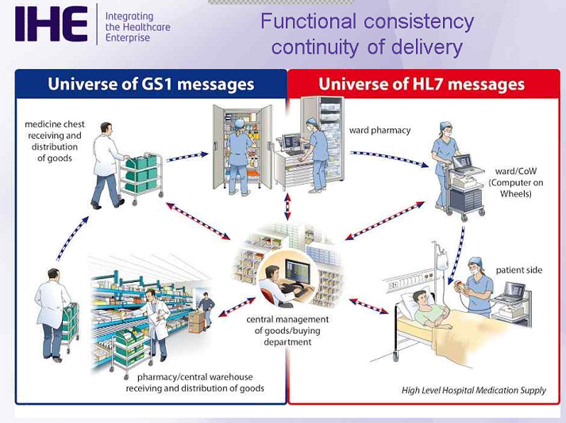

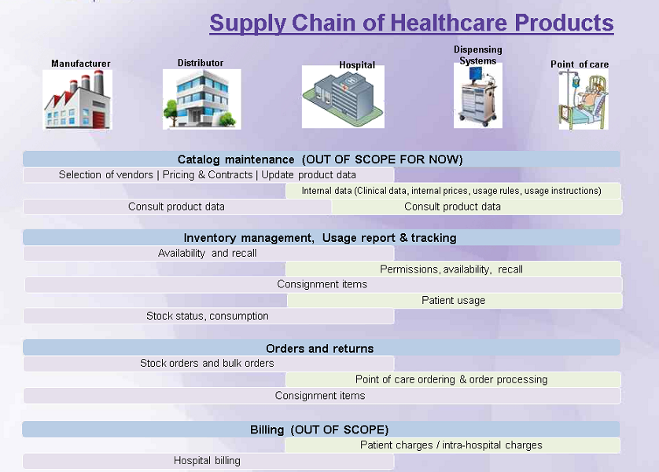
Adding layer of inventory and distribution

Bar Coding
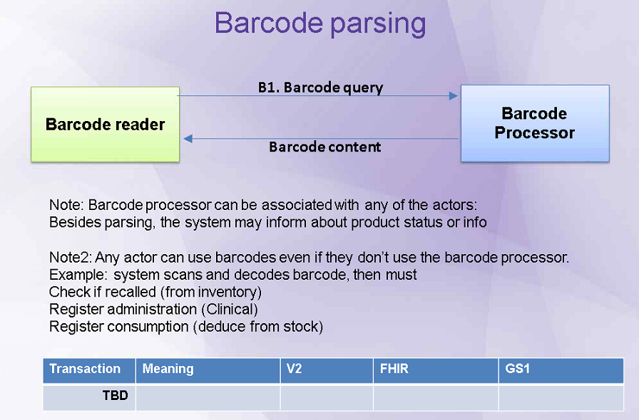

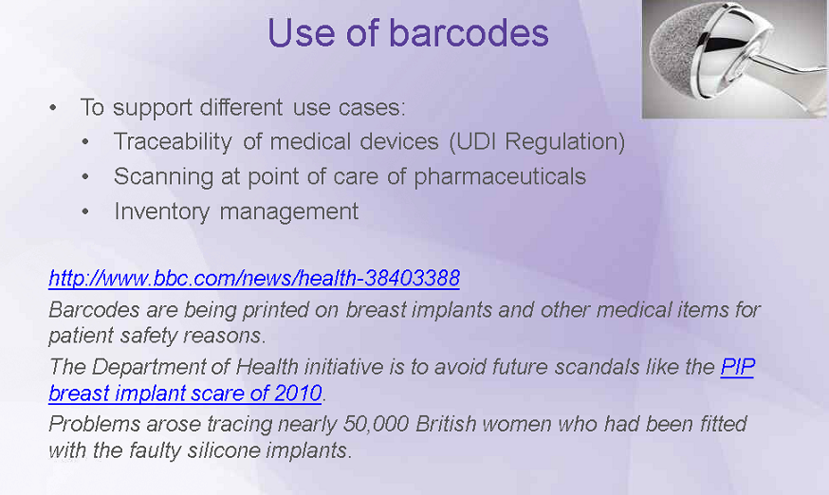

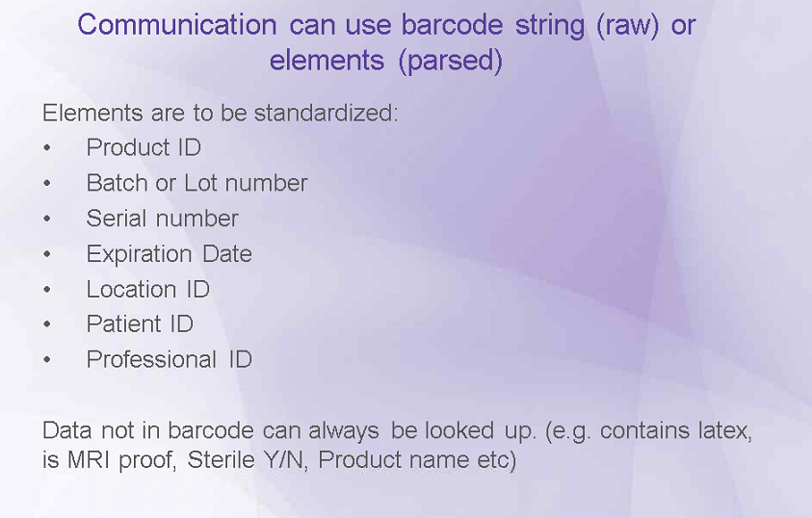

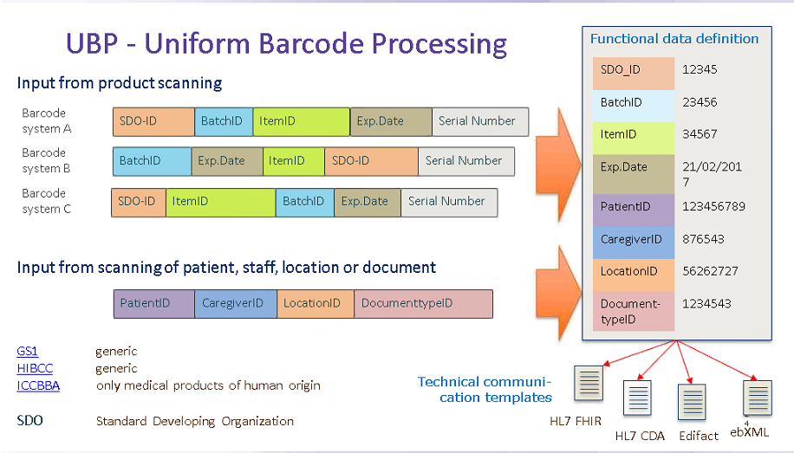

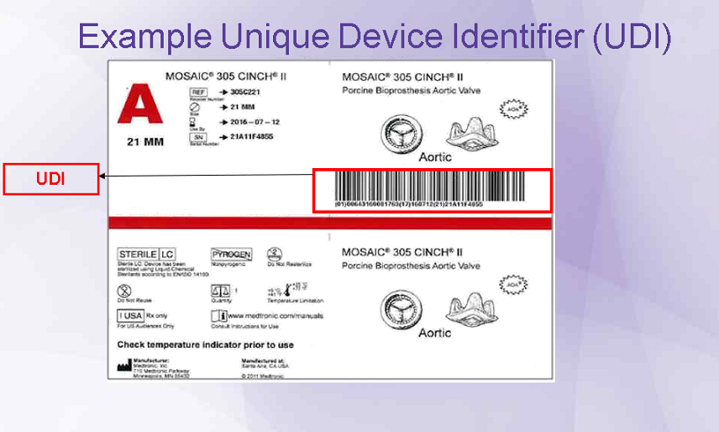

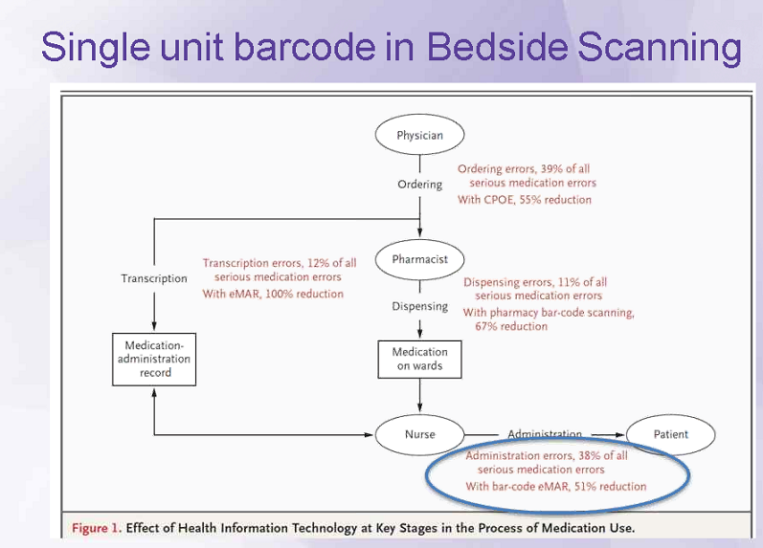

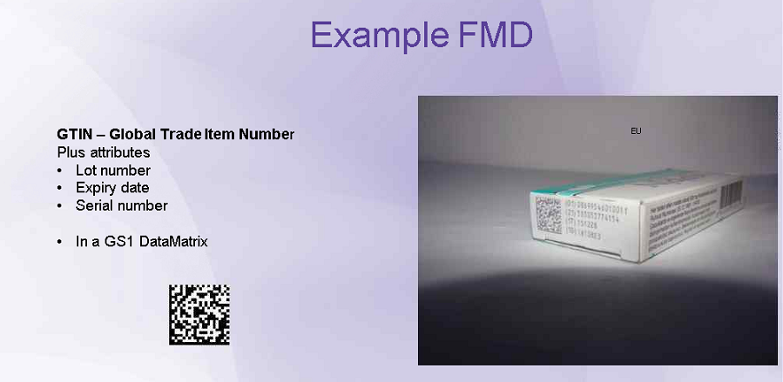

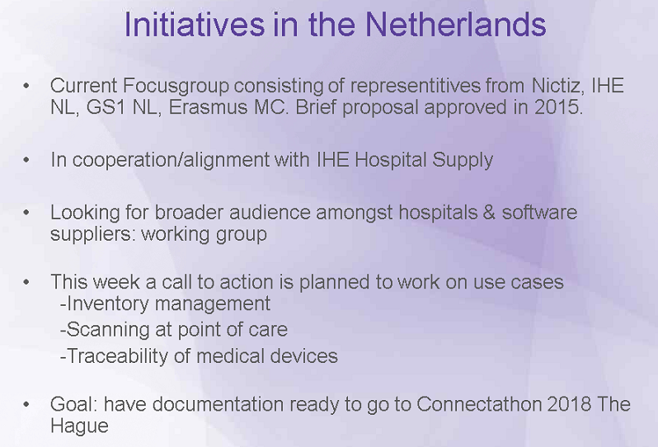

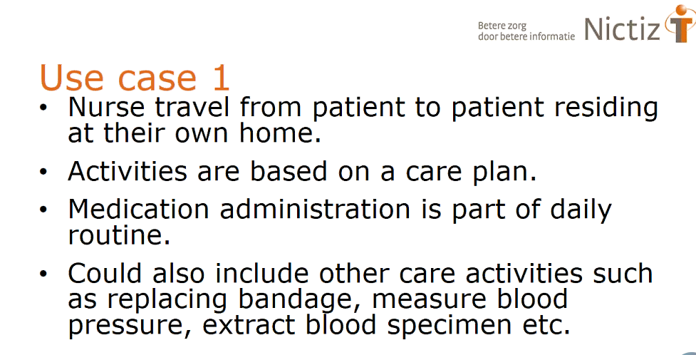

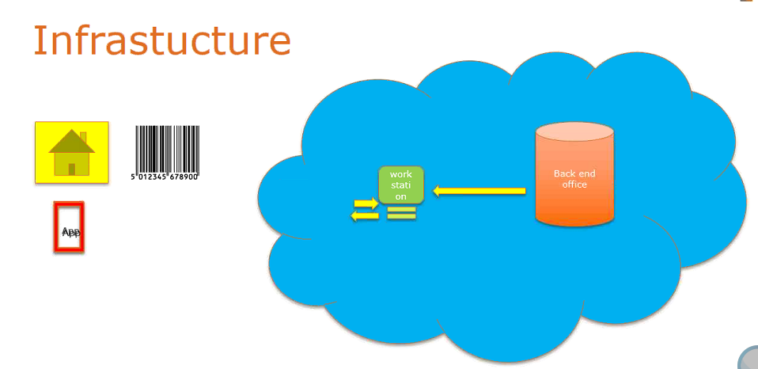

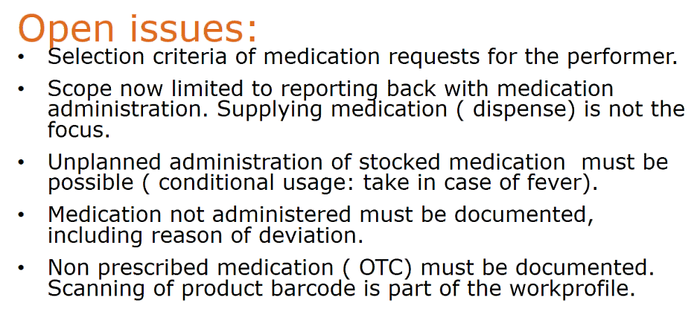
Discussion about use of FHIR resources that are not fully baked.

QED on FHIR (PDLS & QEDm)
Present: Thierry Dart, Andrea Fourquet, Thom Kuhn, George Cole, Tone Southerland, Charles Parisot, Fabio Buti
Phone: Brian Rienholdt, Amit Popit

PDLS Potential Deployment Models
When you deploy XDS there may be multiple repositories, for the Clinical Data Source where can it be? Develop a Document Repository

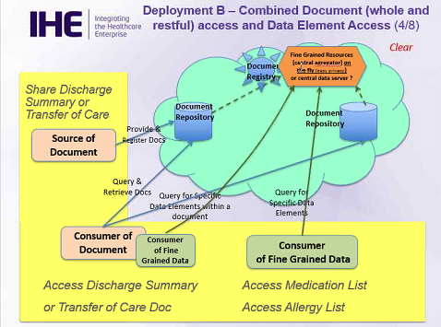

This deployment can handle reconciliation, REST transaction via FHIR will need to wait for this transaction to occur, PULL model, will place all 5 deployment models in the Appendix

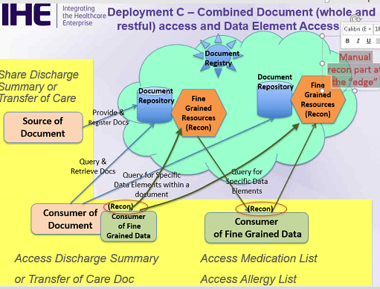

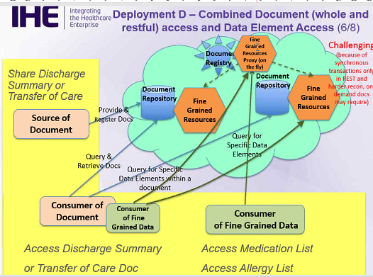
QEDm

Requirements:
What and how to query,
From Original QED
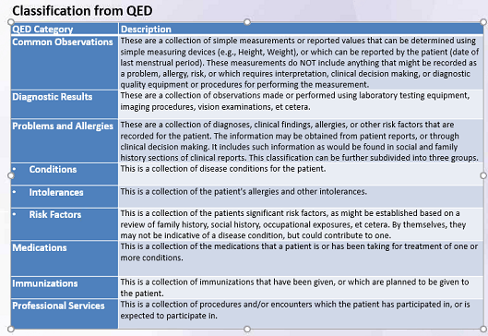

Argonaut looked at MU and Clinical Data Set using FHIR Resource
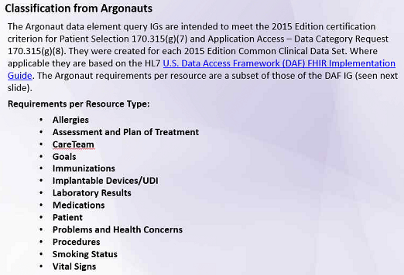

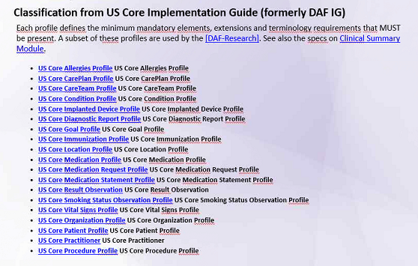

QEDm will look at the following content:

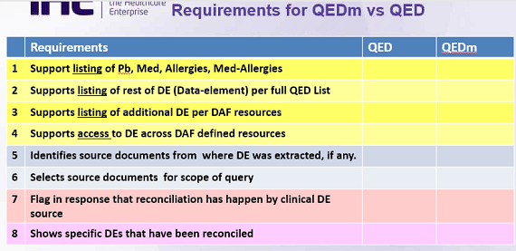

#7 & #8 are for reconciliation, this function should not be considered reconciliation, and it is a deduplication of data elements not comparing lists to make one.

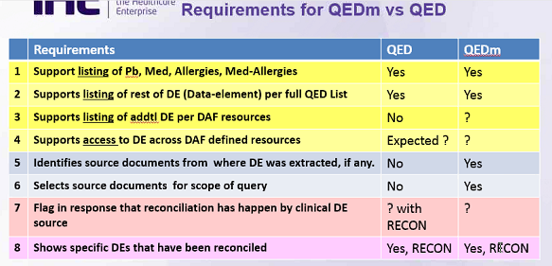

360x
Security considerations and other profiles section reviewed
Profiles moved forward

Point of Care Medical Device Tracking
Reviewed Security section
Device security - look at FDA device

Dynamic Care Team Management
Reviewed volume 1 updates. Profile posted for editorial review

RPM
Present: Andrea Fourquet, George Cole, Tone Southerland
Updated transaction numbers based on CP-222, gave new transaction numbers for FHIR transaction

Pt Registration
Present: Amit Popit, Thierry Dart, Andrea Fourquet, George Cole, Tone Southerland, John Moehrke
Phone: Kwekour Quaynor, Chris Melo, Thom Kuhn, Anna Arlova

Transaction profile with constraints to PAM, is the constraints US realm needs, what is driving the constraint, AHIMA is trying to improve the quality of data, new section in ITI PAM section 4, PCC will do the content-data elements, this will add segments to PAM where PAM was silent this will add constraints and need to verify the PAM did not forbid the constraints the section, new to the Profile is making a CDA document which wasn’t in the original profile proposal

All the data elements will be constrained as a v2 PAM message and submit a CDA document that includes all the data, it is expanding the scope of the Profile

Anna will send us the list of data elements, we will send EMLA information to Anna

EMS
Present: Amit Popit, Thierry Dart, Andrea Fourquet, George Cole, Tone Southerland, John Moehrke
Phone: Chris Melo, Thom Kuhn

Need a Transaction #, looking for NEMSIS copyright information, template ID?? Updated the Actor Diagrams, discussed which transaction profiles to use for the CDA format, but the profile is focused on FHIR, use the Security Considerations from PDQm is generic FHIR based security information

Change Proposals
Reviewed current list of CP. Assigned and completed the ones that are ready for ballot. Discussed plans for updating PCC FHIR based profiles to STU3. Will create CPs when STU 3 is made available.

Thursday, February 9, 2017

Profiles updates reviewed.

DCTM
- Volume 1 need FHIR reference and other reference links updated when HL7 site is finalized.
- Will continue every other week t-cons (Monday’s 4pm EST) for volume 2+ work
QED
- Per Charles, need 4 t-cons scheduled for transactions. Will need 3PCC members and SME to attend (Keith Boone and Arganaut folks). Will send email to Jeremiah
RIPT (EMS)
- Will set up T-Cons with Jeremiah
RPM on FHIR
- Will set up T-Cons with Jeremiah
Pt Registration
- Need more volume 1 work. Will set up t-Cons to review and also need to discuss plans for volume 2+
PMDT
- Will continue with current T-Con schedule – Every other Monday at 2PM EST
360X
- Will schedule t-Cons

Friday, February 10, 2017
Profile Editors continue profile work and plans for Volume 2

