1300 North 17th Street, Suite 1752
Arlington, VA 22209, USA
+1-703- 841-3281
http://dicom.nema.org
dicom@medicalimaging.org

Meeting Notes

Patient Positioning & Workflow Subgroup of
DICOM Working Group Seven
(Radiation Therapy)
June 15-19, 2015
Hotel Sol Principe
Torremolinos (Málaga), Spain
Present: Representing
Bari, Sanjay Elekta, Inc.
Beunk, Harold ICT
Busch, Uli Varian Medical Systems
Schadt, Christof Brainlab AG
Schwere, Thomas Varian Medical Systems
Vierlinck, Olivier IBA Particle Therapy
Vonach, Martin Brainlab AG
Wikler, David IBA Particle Therapy
Presiding Officer: Thomas Schwere, Chair
1. Opening

The meeting was called to order on 2015-06-15 at 09.00. Participants identified themselves and their employers. The Agenda was approved.
- Monday, June 15 2015
Thomas provided a status update of the DPDW profile together with a high-level walk through of the main scenarios.
Notes from this session:
- 3rd combination of the sub profiles (DPDW 1, DPDW 4) is actually not needed. (To be removed.)
- RO-DPD-200: How does TSM know what actors to notify? Configuration vs. Subscription.
- There might be more than one instance of a certain actor (e.g. two PPAS: room based and gantry based)
- PPCRS: The intention of this actor always raises questions as it cannot be determined by its name. We need a new term for this actor. Reconciliation to be replaced by something more appropriate (see further below).
- Objects could be retrieved from an actor's local storage instead of always retrieving them from the OST (optional performance optimization that doesn't need to be spelled out in more detail in the profile).
- RO-DPD-202: This seems to be a candidate for removal. The correction can be implicitly triggered after the final update of the Correction Reconciliation UPS.
- RO-DPD-223: We need a new UPS code for Positioning Correction Reconciliation.
- Both Position Correction Reconciliation and Position Correction UPS shall be pre-scheduled in TMS.
- UI interaction to drive/control the workflow through a session should all be in TSM.
- RO-DPD-216: Ready for monitoring could also be a generic "Ready for Tx" signal.
- Is there also an instruction about gating in Supplement 160?
  - This is part of the monitoring instruction.
  - Gating is specified through the Additional Monitoring Action Sequence.
- Re-positioning could be automatically done by PPMS. Do we have a scenario for that?
  - There is no scenario for that. Use Case #3 is about automatic repositioning triggered by PPMS with the interaction through TSM. Fully automated repositioning without TSM interaction is not foreseen (yet).
- Termination of an interrupted Tx should be possible through user interaction in TSM as well.
- Who identifies the patient? This shall be done in TSM.
- Consider to combine all positioning actors (PPAS, PPRS, PPCRS, PPD) into one positioning actor as a black box. Define a sub profile defining the interactions between TSM, this combined PP (Patient Positioning) and PPMS.
- We need a scenario where monitoring is already started prior initial positioning.
- TSM knows about the capabilities of the actors on the level of supported procedure codes.
- If something different should be performed than initially scheduled, TSM is in charge to issue the change. I.e. cancel the scheduled UPS and issue a new UPS according to the configured capabilities. Details (e.g. instruction) might be missing and need to be filled in (using default values) by the performing actor.
- To notify the actor to start a UPS, TSM could issue an N-CREATE on the actor. The actor would act as a SCP in this case. Is it always possible to tight the creation of a UPS always to its immediate execution? (Probably not…)
- "Notify Device to Start UPS" RO-DPD-217 and its subsequent "Query worklist for..." shall use the following principle (technical details not sorted out though):
  - TSM pushes the request to start UPS to the actor including a specific UPS instance UID (e.g. N-EVENT-REPORT).
  - The actor pulls the specific UPS instance from the TSM (e.g. N-GET).
- Transaction for patient setup is missing.
- Pre-requisite for the patient positioning is the alignment of the patient (e.g. based on laser).
- Why do we have the workitem code both in the UPS and in the acquisition instruction? UPS can be deleted after the execution (N object) while the instruction remains persisted (C object).
- Harold raised the concern that we have a very generic acquisition instruction IOD. Maybe it would help to split into multiple more specific acquisition instructions for example along the acquisition technique.
- There is no need to specify the minimum required attributes for the Supplement 160 instructions in the profile. This should go along the type definition of the attributes (1, 2, 3, C).
- Tuesday, June 16 2015
The group started working on RO-DPD-200. The content of the session was extended to cover the three phases of DPDW 2.
Notes:
- How can it be guaranteed that the couch is not moved between RO-DPD-201 and the actual acquisition of the positioning information? Do we need transactions to lock/unlock the couch? (See also further below.)
- Consider replacing RO-DPD-204 "Store RT Patient Repositioning Results" by RO-22. How to specify an extension to a transaction from a base profile in a derived profile? IHE seems to have an approach for that. For example how to restrict the content in a derived profile/transaction?
- Position information in positioning acquisition result object should be required (e.g. mandatory for RT and CT Images).
- Consider renaming of RO-20 from "Retrieve Dynamic Treatment Delivery Input Objects from TMS" to "Retrieve Dynamic Input Objects from TMS" (to be more generic).
- RO-20 and RO-DPD-200 should be unified/generalized (query for positioning acquisition and retrieving of dynamic treatment objects).
- Registration instruction:
  - Can only be created once the acquired objects are available (prior to that the acquired objects are specified as placeholders only). TSM will create a new registration instruction using the original one as base.
  - How to annotate reference vs. acquired objects? Added Clinical Process Role Sequence to the registration instruction module in Supplement 160.
  - How to handle the registration UPS? Acquired objects shall be added to the input sequence by the TSM after the acquisition step was completed.
- RO-23 Store Position Registration Results:
  - Only standard SRO shall be allowed in both IPDW and DPDW.
  - Could we use the MMRO-III transaction for that? (No)
  - To be renamed to "Store Spatial Registration Results".
- RO-227 to be replaced by the generic final update transaction. That transaction was introduced to specify the adding of the acquisition results to the registration step in TSM. This should rather be specified in the worklist query for registration where the expected data is defined.
- Couch locking:
  - RO-DPD-201 could implicitly lock the couch until the user explicitly intends to move the couch away.
  - General feeling is that this cannot be solved by the profile.
  - The group concluded to add a note in the profile that either couch is locked or the user has to make sure that the couch does not move during this process.
- Add a loop in DPDW 2 Phase 1 for re-acquisition of positioning information.
- RO-DPD-204: Spell out that device position information shall be annotated in the acquired objects.
- RO-DPD-201:
  - Make optional and state that there might be other means to get this information.
  - The device position information is to be conveyed by the RT Device State IOD.
- The group decided on a new name for the PPCRS actor: PPDS "Patient Position Definition System".
- To improve performance when retrieving data created in a previous step, the output sequence could contain multiple AE titles where to retrieve the input data from:
  - AE titles need to be configured anyhow.
  - One of the AE titles should be marked as the permanent one while the other is the one to be used to improve performance.
  - To support this, the producers of data have to act as Q/R SCP.
  - If the producers act as Q/R SCP, the final update/completion can actually happen before the store to the OST was completed.
- Wednesday, June 17 2015
The group decided to continue working in the big group instead of having break-out sessions in smaller groups.
Notes:
- In DICOM 2nd gen position information is expressed using transformation matrices (between fixed room and table top) instead of the six axes representation used in 1st gen.
- 2nd gen BDI will contain transformation matrices as well (instead of the six axes).
- Within one and the same treatment session there shall only be one type of representation for position information (matrix vs. six axes).
- What is the output of the PDS:
  - Indication if a correction shall be applied (e.g. by using the performed parameters).
  - The Correction Instruction.
- The question was raised why not doing all positioning stuff ad-hoc during the treatment session. Upfront scheduling in TMS is needed for guidance and efficiency!
- Should the TSM look into instructions at all when driving the workflow? The group decided on the following principle: Whenever possible the workflow should be based on the content of the UPS only. The content of the instructions shall only be analyzed in TSM when really needed.
- Application of the patient position correction following RO-DPD-217:
  - What shall happen if the PPD cannot drive to the target position as requested by the Correction Instruction (e.g. out of machine limits)?
  - There might be some explicit user overrides in PPD.
  - The status of the correction UPS shall include the whole process including potential user interaction.
  - Completion in the correction UPS means to continue with the workflow.
  - We might need dedicated final update transactions where certain semantics could be described in the Expected Action section. (E.g. Override might be needed, User accepted the incomplete correction, …)
- TDD and PPD are combined actors in most cases.
- There was a long discussion about one or multiple BDIs per fraction triggered by the question how to cover the in-between imaging (or more general, how to model something that should happen in between two beams). During this session the group concluded to have one BDI per isocenter/couch rotation. The idea was to have a common workflow for all scenarios: Positioning/Delivery for first isocenter, Positioning/Delivery for second isocenter and so on. From TMS there would still be one BDI, TSM would then split up according to the rule as specified above. (This conclusion was rejected again on Friday, see further below.)
- Thursday, June 18 2015
The group decided to continue working in the big group instead of having break-out sessions in smaller groups.
Notes:
- Continuation of monitoring after a re-positioning scenario: Re-use of monitoring UPS vs. New monitoring UPS?
- There are a lot of variations in the monitoring scenarios (e.g. monitoring is stopped during repositioning vs. monitoring runs through). Is it possible at all to define something in the profile that is applicable in real world scenarios? How should we tackle this? The group decided that in a first approach the scenarios should be simplified to cope with the overall complexity: For example let the monitoring run through while the repositioning is happening.
- It looks as "Resume Tx" is missing in some of the scenarios.
- Automatic re-positioning:
  - This is actually a combination of PPMS, PPRS and PPDS actors.
  - Should we introduce a new actor for that?
  - Ideally this should be handled identical to the re-acquisition case.
  - The combined actor could respond with "Oh, I already did that".
- Position information in Tx Records: How does TDD know the position information if actors are really discrete? Spell out in the transaction that it's assumed that TDD can get this information by some existing means.

Notifications between actors:
- The group discussed the proposal of Harold (from a previous TCon) about how dynamic information could be conveyed. In summary: Introduce Progress Information Parameter Sequence attribute (Type 3) in Progress Information Sequence (0074,1002) using Content Item Macro. This can be used to notify about more dynamic information such as Radiation On. For example the following transactions could make use of that: RO-DPD-206 (Notify on Radiation Delivery Status Change) or RO-DPD-209 (Notify on Radiation State):

- N-SET from TDD to TSM
- N-EVENT-REPORT from TSM to subscribed actors

Coded Progress Information Parameter for Radiation Delivery Status Changed:
EV("121xxx", DCM, "Radiation Delivery Status", "ON"|"OFF")

- Subscription of TMS to TSM is missing: Should we add this to the profile?
- Input Readiness state could be used as a trigger to start the execution of a UPS.
- Global subscription has the disadvantage to get overwhelmed with a lot of notifications which are not of any interest for a particular actor.
- Implicit global subscription to TSM:
  - TSM anyhow has the knowledge about everything and could do selective N-EVENT-REPORTs.
  - N-SET (Progress Information "Paused") to TSM.
  - N-EVENT-REPORT (Resume) from TSM to actor.
- The group came up with the following preliminary notification mechanisms:
Transaction | Used Notification Mechanism
RO-DPD-206: Notify on Radiation Delivery Status Change | Progress Parameter
RO-DPD-208: Subscribe / Unsubscribe to Treat UPS Status | Standard UPS services
RO-DPD-209: Notify on Radiation State | Progress Parameter
RO-DPD-216: Indicate Ready for Monitoring | Progress Parameter
RO-DPD-217: Notify Device to start UPS | using Input Readiness State/Dynamic Input Objects, N-EVENT-REPORT to the specific actor/AE title
RO-DPD-220: Notify Treatment Session Actors on Starting Session | Not defined yet
RO-DPD-221: Notify Device to stop UPS | Cancel Request through N-EVENT-REPORT, providing a cancelation reason
RO-DPD-225: Notify Device to resume UPS | Not defined yet

- Friday, June 19 2015
The group re-discussed the split up of the BDI as decided on Wednesday:
- What could be the criteria for splitting up the BDI? Uli raised the concern that there are no waterproof criteria for this. Furthermore if we would strictly split up the BDI for everything that could happen in between two beams, we would also have to split up the actual BDI if the user does some ad-hoc imaging. This is not feasible at all. With other words this means that we anyway have to be able to suspend a BDI, callout to something different and resume the BDI where it was stopped before.
- In the current version of the profile TDD loops over the beams. This actually makes the in-between imaging impossible. Instead of having that loop in TDD, TSM should actually drive the beams on TDD (TSM requests TDD to treat beam x). This heavily simplifies the in-between imaging as TSM can check after each beam how to proceed.
- The group now tends towards not splitting up the BDI and let the TSM do the orchestration over the beams (i.e. Treat UPS/BDI shall span the full plan).

Interaction between 1st and 2nd gen DICOM:
- Uli presented an approach how Supplement 160 could deal with 1st and 2nd gen at the same time (very preliminary):

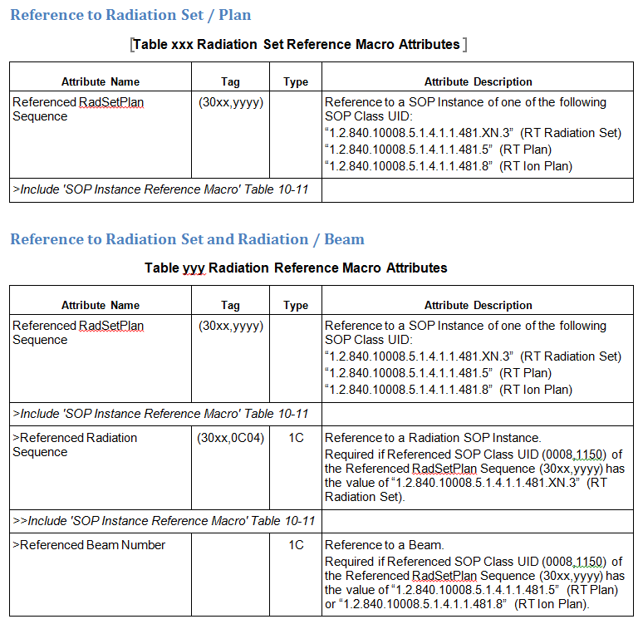

The group discussed the possible combinations of actors:
- It was not clear if the combined actor has to expose the transactions of the individual actors as specified in the DPDW profile.
- Optimizing a combined actor would actually not be possible if the individual transactions had to be exposed.
- A follow up discussion in one of the next TCons is needed.
- Wrap-up, Next Steps
The meeting showed that there are still some basic concepts to be sorted out (such as orchestration of beam delivery, in-between imaging or notification protocols). During the next TCons these issues have to be sorted out with highest priority.
- Homework Assignments
- Thomas:
  - Provide sequence diagrams for the two alternative approaches (split up of BDI vs. beam orchestration in TSM). To be discussed in one of the next TCons.
  - Incorporate changes as discussed in this meeting into the working version of the DPDW profile.
- Adjournment
The meeting was adjourned at 12.30 on June 19, 2015.
Reported by: Thomas Schwere
2015-07-24

