Integrating the Healthcare Enterprise



IHE Quality Research and Public Health
Technical Framework Supplement

Retrieve Protocol for Execution
(RPE)

Public Comment

Date: April 22, 2009
Author: Daemon Whittenburg
Email: ihe@himss.org

This is a supplement to the IHE Quality Research Public Health.

It is submitted for Public Comment between June 01, 2009 and July 01, 2009.
Comments shall be submitted within that period to http://forums.rsna.org:
Select the “IHE” forum
Select QRPH
Select 2009-2010 Supplements for Public Comment
Select Supplement Name
Please use the Public Comment Template provided there when starting your New Thread.

Details about IHE may be found at: www.ihe.net

Details about the IHE QRPH may be found at: http://www.ihe.net/Domains/index.cfm

Details about the structure of IHE Technical Frameworks and Supplements may be found at: http://www.ihe.net/About/process.cfm and http://www.ihe.net/profiles/index.cfm

The current version of the IHE QRPH Technical Framework may be found at: http://www.ihe.net/Technical_Framework/index.cfm

Table of Contents
Introduction 6
Profile Abstract 7
Open Issues and Questions 7
Closed Issues 7
Volume 1 – Integration Profiles 8
Glossary 8
1.7 History of Annual Changes 8
2.1 Dependencies among Integration Profiles 8
2.2.X Retrieve Protocol for Execution Integration Profile 8
X Retrieve Protocol for Execution Integration Profile 9
X.1 Actors/ Transactions 9
X.1.1 RPE Actors 10
X.1.1.1 ProtocolDefManager 10
X.1.1.2 ProtocolExecutor 10
X.1.1.3 ProtocolStateManager 10
X.1.2 RPE Transactions 11
X.1.2.1 RetrieveProtocolDef 11
X.1.2.2 EnterPatientRequest 11
X.1.2.3 PatientScreeningVisitsScheduled 11
X.1.2.4 RecordPatientScreeningVisit 11
X.1.2.5 EnrollPatientRequest 11
X.1.2.6 PatientStudyVisitsScheduled 11
X.1.2.7 RecordPatientStudyVisit 11
X.1.2.8 AmendProtocolDef 12
X.1.2.9 AlertProtocolState 12
X.2 Retrieve Protocol for Execution Integration Profile Options 12
X.3 Retrieve Protocol for Execution Process Flow 12
X.4 RPE Security Considerations 13
<Appendix A> Actor Summary Definitions 14
<Appendix B> Transaction Summary Definitions 15
Volume 2 - Transactions 17
3 IHE Transactions 17
3.Y1 RetrieveProtocolDef transaction 17
3.Y1.1 Scope 17
3.Y1.2 Use Case Roles 17
3.Y1.3 Referenced Standards 17
3.Y1.4 Interaction Diagram 18
3.Y1.5 Security Considerations 19
3.Y1.6 Protocol Requirements 20
3.Y1.6.1 Sample SOAP Messages 20
3.Y1.6.2 Sample RetrieveProtocolDef SOAP Request 21
3.Y1.6.3 Sample RetireveProtocolDef SOAP Response 21
3.Y2 EnterPatientRequest transaction 21
3.Y2.1 Scope 22
3.Y2.2 Use Case Roles 22
3.Y2.3 Referenced Standards 22
3.Y2.4 Interaction Diagram 22
3.Y2.6 Protocol Requirements 24
3.Y2.6.1 Sample SOAP Messages 25
3.Y2.6.2 Sample EnterPatientRequest SOAP Request 25
3.Y2.6.3 Sample EnterPatientRequest SOAP Response 25
3.Y3 PatientScreeningVisitsScheduled transaction 25
3.Y3.1 Scope 25
3.Y3.2 Use Case Roles 26
3.Y3.3 Referenced Standards 26
3.Y3.4 Interaction Diagram 26
3.Y3.6 Protocol Requirements 28
3.Y3.6.1 Sample SOAP Messages 29
3.Y3.6.2 Sample PatientScreeningVisitsScheduled SOAP Request 29
3.Y3.6.3 Sample PatientScreeningVisitsScheduled SOAP Response 29
3.Y4 RecordPatientScreeningVisit transaction 29
3.Y4.1 Scope 29
3.Y4.2 Use Case Roles 30
3.Y4.3 Referenced Standards 30
3.Y4.4 Interaction Diagram 30
3.Y4.6 Protocol Requirements 32
3.Y4.6.1 Sample SOAP Messages 33
3.Y4.6.2 Sample RecordPatientScreeningVisit SOAP Request 33
3.Y4.6.3 Sample RecordPatientScreeningVisit SOAP Response 33
3.Y5 EnrollPatientRequest transaction 33
3.Y5.1 Scope 33
3.Y5.2 Use Case Roles 34
3.Y5.3 Referenced Standards 34
3.Y5.4 Interaction Diagram 34
3.Y5.6 Protocol Requirements 36
3.Y5.6.1 Sample SOAP Messages 37
3.Y5.6.2 Sample EnrollPatientRequest SOAP Request 37
3.Y5.6.3 Sample EnrollPatientRequest SOAP Response 37
3.Y6 PatientStudyVisitsScheduled transaction 37
3.Y6.1 Scope 38
3.Y6.2 Use Case Roles 38
3.Y6.3 Referenced Standards 38
3.Y6.4 Interaction Diagram 38
3.Y6.6 Protocol Requirements 40
3.Y6.6.1 Sample SOAP Messages 41
3.Y6.6.2 Sample PatientStudyVisitsScheduled SOAP Request 41
3.Y6.6.3 Sample PatientStudyVisitsScheduled SOAP Response 41
3.Y7 RecordPatientStudyVisit transaction 41
3.Y7.1 Scope 41
3.Y7.2 Use Case Roles 42
3.Y7.3 Referenced Standards 42
3.Y7.4 Interaction Diagram 42
3.Y7.6 Protocol Requirements 44
3.Y8 AmendProtocolDef transaction 46
3.Y8.1 Scope 46
3.Y8.2 Use Case Roles 46
3.Y8.3 Referenced Standards 46
3.Y8.4 Interaction Diagram 47
3.Y8.6 Protocol Requirements 49
3.Y9 AlertProtocolState transaction 50
3.Y9.1 Scope 50
3.Y9.2 Use Case Roles 50
3.Y9.3 Referenced Standards 50
3.Y9.4 Interaction Diagram 51
3.Y9.6 Protocol Requirements 53

Introduction
The Retrieve Protocol for Execution Profile (RPE) provides an automated mechanism for an Electronic Health Record (EHR) to retrieve a complex set of clinical research instructions (Protocol Definition) from an Electronic Data Capture (EDC) system to execute within the EHR.

Profile Abstract
The Retrieve Protocol for Execution Profile (RPE) provides an automated mechanism for an Electronic Health Record (EHR) to retrieve a complex set of clinical research instructions (Protocol Definition) from an Electronic Data Capture (EDC) system to execute within the EHR.
Many health care sites supplement their core patient care activities by participating in clinical trials. Currently, the tasks required for clinical research participation are served by EDC systems entirely separate from the site's EHR. The ITI profile Retrieve Form for Data-capture (RFD), along with its complementary content profile Clinical Research Data-capture (CRD) have set a path towards integrating site-based clinical research into the workflow of the EHR. This new profile, RPE, expands the scope of workflow integration between clinical research and an EHR.
A standard protocol document is being developed by the CDISC's Protocol Representation Group (PRG). This protocol representation includes the Trial Design Model (TDM), a standard structure for representing the planned sequence of events and the treatment plan of a trial. This planned sequence of events includes many tasks that could be executed by an EHR's workflow engine. These standards will be used to insert the executable workflow tasks into the EHR without hindering the normal activities of the site.

Open Issues and Questions
Does it make sense for each of the Actors in Table X.1-1 to be required to implement each of the transactions?

Closed Issues
< List of closed issues/ questions with their resolutions that have been addressed prior to publishing of the Technical Framework>

Volume 1 – Integration Profiles

Glossary
Add the following terms to the Glossary:
Clinical Trial Protocol - The ICH (International Conference on Harmonization) GCP (Good Clinical Practice) defines a Clinical Trail Protocol to be "a document that describes the objective(s), design, methodology, statistical considerations, and organization of a clinical trial. The protocol usually also gives the background and reason the trial is being conducted, but these could be provided in other documents referenced in the protocol (such as an Investigator's Brochure)."
ProtocolDef - The protocol definition created by an eClinical Research sponsor that describes a clinical research study. The ProtocolDef will be maintained by the ProtocolManager.
ProtocolState - The protocol state at the point in which a patient is involved in a clinical study.

1.7 History of Annual Changes

2.1 Dependencies among Integration Profiles
Add the following to Table 2-1
RPE is dependent on RFD
<RPE> | <?> | <?> | <->

Add the following section to section 2.2

2.2.X Retrieve Protocol for Execution Integration Profile
The Retrieve Protocol for Execution Profile (RPE) provides an automated mechanism for an Electronic Health Record (EHR) to retrieve a complex set of clinical research instructions (Protocol Definition) from an Electronic Data Capture (EDC) system to execute within the EHR.
Many healthcare sites supplement their core patient care activities by participating in clinical trials. Currently, the tasks required for clinical research participation are served by systems entirely separate from the site's EHR. The ITI profile Retrieve Form for Data-capture (RFD), along with its complementary content profile Clinical Research Data-capture, have set a path towards integrating site-based clinical research workflow into the task manager of an electronic health record. This new profile, Retrieve Protocol for Execution, expands the scope of workflow integration between clinical research and EHR systems.
Add Section X to the QRPH Framework

X Retrieve Protocol for Execution Integration Profile
The Retrieve Protocol for Execution Profile (RPE) provides an automated mechanism for an Electronic Health Record (EHR) to retrieve a complex set of clinical research instructions (Protocol Definition) from an Electronic Data Capture (EDC) system to execute within the EHR.
Many healthcare sites supplement their core patient care activities by participating in clinical trials. Currently, the tasks required for clinical research participation are served by systems entirely separate from the site's EHR. The ITI profile Retrieve Form for Data-capture (RFD), along with its complementary content profile Clinical Research Data-capture, have set a path towards integrating site-based clinical research workflow into the task manager of an electronic health record. This new profile, Retrieve Protocol for Execution, expands the scope of workflow integration between clinical research and EHR systems.
(RFD specification has uses cases as X.1 and Actors/Transactions as X.2…The use cases were not a part of the supplement template. Do they need to be added and where?)

X.1 Actors/ Transactions
Figure X.1-1 shows the actors directly involved in the Retrieve Protocol for Execution Integration Profile and the relevant transactions between them. Other actors that may be indirectly involved due to their participation in other profiles are not necessarily shown.
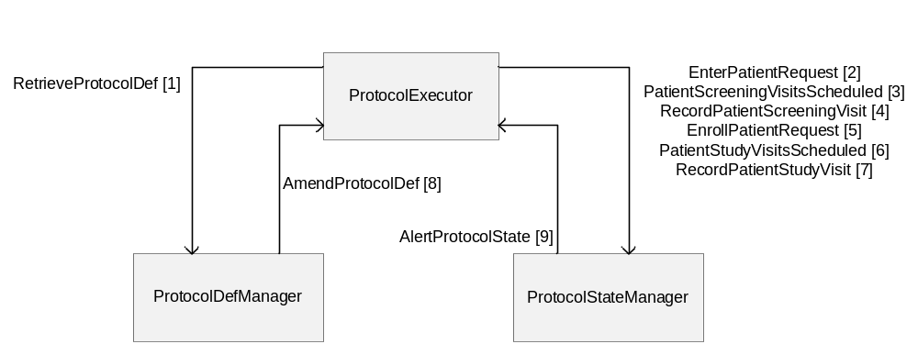
Figure X. 1-1 RPE Actor Diagram

Table X.1-1 lists the transactions for each actor directly involved in the RPE Profile. In order to claim support of this Integration Profile, an implementation must perform the required transactions (labeled “R”). Transactions labeled “O” are optional. A complete list of options defined by this Integration Profile and that implementations may choose to support is listed in Volume I, Section X.2.

Table X.1-1. Retrieve Protocol for Execution Integration Profile - Actors and Transactions
Actors | Transactions | Optionality | Section in Vol. 2
ProtocolDefManager | RetrieveProtocolDef | R | QRPH TF-2:3.Y1
ProtocolDefManager | AmendProtocolDef | R | QRPH TF-2:3.Y8
ProtocolExecutor | RetreiveProtocolDef | R | QRPH TF-2:3.Y1
ProtocolExecutor | EnterPatientRequest | R | QRPH TF-2:3.Y2
ProtocolExecutor | PatientScreeningVisitsScheduled | R | QRPH TF-2:3.Y3
ProtocolExecutor | RecordPatientScreeningVisit | R | QRPH TF-2:3.Y4
ProtocolExecutor | EnrollPatientRequest | R | QRPH TF-2:3.Y5
ProtocolExecutor | PatientStudyVisitsScheduled | R | QRPH TF-2:3.Y6
ProtocolExecutor | RecordPatientStudyVisit | R | QRPH TF-2:3.Y7
ProtocolExecutor | AmendProtocolDef | R | QRPH TF-2:3.Y8
ProtocolExecutor | AlertProtocolState | R | QRPH TF-2:3.Y9
ProtocolStateManager | EnterPatientRequest | R | QRPH TF-2:3.Y2
ProtocolStateManager | PatientScreeningVisitsScheduled | R | QRPH TF-2:3.Y3
ProtocolStateManager | RecordPatientScreeningVisit | R | QRPH TF-2:3.Y4
ProtocolStateManager | EnrollPatientRequest | R | QRPH TF-2:3.Y5
ProtocolStateManager | PatientStudyVisitsScheduled | R | QRPH TF-2:3.Y6
ProtocolStateManager | RecordPatientStudyVisit | R | QRPH TF-2:3.Y7
ProtocolStateManager | AlertProtocolState | R | QRPH TF-2:3.Y9

X.1.1 RPE Actors

X.1.1.1 ProtocolDefManager
The ProtocolDefManager manages clinical research protocol definitions. An example would be an EDC vendor that wishes to allow access to the list of clinical research protocol definitions contained within the EDC system.

X.1.1.2 ProtocolExecutor
The ProtocolExecutor accesses clinical research protocol definitions from an entity that manages clinical research protocol definitions. An example would be an EHR vendor that wants to participate in clinical studies by accessing clinical research protocol definitions. This entity would also consume and execute the protocol definition within the application.

X.1.1.3 ProtocolStateManager
The ProtocolStateManager wants to receive clinical research data from a supplying entity. An example would be an EDC vendor wanting to consume data from an EHR.

X.1.2 RPE Transactions

X.1.2.1 RetrieveProtocolDef
The RetreiveProtocolDef transaction is used to allow a site to retrieve an instance of a protocol definition for a particular study from a manager of protocol definitions. This can be used by a site attempting to retrieve a protocol definition once they have finalized all Prerequisites/Dependencies to execute this transaction. This also can be used by an EDC vendor attempting to retrieve a protocol from a sponsor.

X.1.2.2 EnterPatientRequest
The EnterPatientRequest transaction allows a site to request that a patient be entered into a clinical study of an external system. Prior to executing this transaction, the patient shall meet pre-screening eligibility criteria and sign the consent.

X.1.2.3 PatientScreeningVisitsScheduled
The PatientScreeningVisitsScheduled transaction allows a site to schedule a patient’s screening visits into an external system. Prior to executing this transaction, the patient must have already been entered into the external system.

X.1.2.4 RecordPatientScreeningVisit
The RecordPatientScreeningVisit transaction allows a site to record a patient’s screening visit into an external system. Prior to executing this transaction, the patient must have already been entered into the external system.

X.1.2.5 EnrollPatientRequest
The EnrollPatientRequest transaction allows a site to enroll a patient into a clinical study of an external system. Prior to executing this transaction, the patient must have met all screening objectives as well as all screening eligibility criteria. The reasons for failure of this transaction would be a screen failure, study put on hold or enrollment for the study is complete.

X.1.2.6 PatientStudyVisitsScheduled
The PatientStudyVisitsScheduled transaction allows a site to schedule the patient’s study visits into an external system. Prior to executing this transaction, the patient must have already been enrolled in the external system.

X.1.2.7 RecordPatientStudyVisit
The RecordPatientStudyVisit transaction allows a site to record a patient’s study visit into an external system. Prior to executing this transaction, the patient must have already been enrolled in the external system.
This transaction would also be used in the case that the site needs to let the external system know that the patient does not want to be a part of the study. RFD can also be used to withdraw the patient from the study.
Unscheduled events can also be managed using this transaction and the subsequent RFD transaction. Such events are unscheduled visits or adverse event reports.

X.1.2.8 AmendProtocolDef
The AmendProtocolDef transaction allows a protocol definition manager actor to amend a protocol definition that has been previously consumed by a clinical study site. This would occur anytime the protocol definition changes.

X.1.2.9 AlertProtocolState
The AlertProtocolState transaction allows the the protocol state manager to update the clinical study site when something needs to change with the state of the patient-specific Protocol information. Examples are (ScreenFailed, FreezePatient, Unfreeze/Thaw, LockPatient/SignOffPatient/PatientComplete, Unlock [big issue...more auditable]. This provides the protocol state manager the ability to change the status of the subject involved in the study. This transaction would be used anytime an event takes place within the protocol state manager which would change the status of the patient within the ProtocolExecutor.

X.2 Retrieve Protocol for Execution Integration Profile Options
Options that may be selected for this Integration Profile are listed in the table X.2-1 along with the Actors to which they apply. Dependencies between options when applicable are specified in notes.
Table X.2-1 RPE - Actors and Options
Actor | Options | Vol & Section
ProtocolDefManager | No options defined | - -
ProtocolExecutor | No options defined | - -
ProtocolStateManager | No options defined | - -

X.3 Retrieve Protocol for Execution Process Flow
<Description of the process flow(s) and sequence diagram(s) covered by this profile in order to satisfy the use cases. This often will include a brief description of the use cases as well. If there are detailed behavioral rules that apply to a specific process flow or multiple process flows or descriptions then an appendix may be added as needed>
(Does there need to be a brief description of the use case. Only one use case here for now. Clinical Research.)

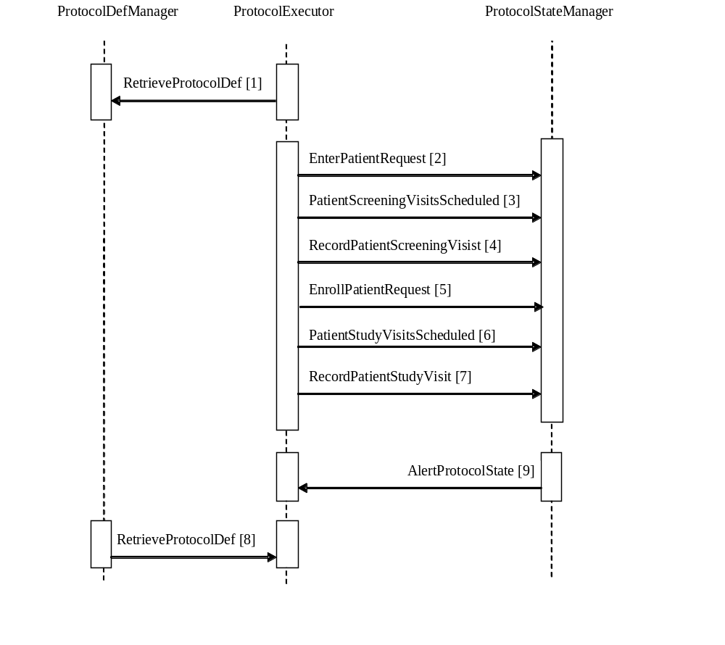
Figure X.2-1. Basic Process Flow in RPE Profile

X.4 RPE Security Considerations
<Description of the Profile specific security considerations. This should include the outcomes of a risk assessment. This likely will include profile groupings, and residual risks that need to be assigned to the product design, system administration, or policy.>
(Security Consult / Risk Analysis)
Threats and risks that are exposed. Critical for Ballot. (Robert.Horn@agfa.com)

<Appendix A> Actor Summary Definitions
<add any actor definitions for new actors defined specifically for this profile>
Protocol Definition Manager - A system that manages clinical research protocol definitions. An example would be an EDC vendor that wishes to allow access to the list of clinical research protocol definitions contained within the EDC system.
Protocol Executor - A system wanting to access clinical research protocol definitions from a system that manages clinical research protocol definitions. An example would be an EHR vendor that wants to participate in clinical studies by accessing clinical research protocol definitions. This entity would also consume and execute the protocol definition within the application.
Protocol State Manager - A system wanting to receive clinical research data from a supplying entity. An example would be an EDC vendor wanting to consume data from an EHR.

<Appendix B> Transaction Summary Definitions
<Add any transaction definitions for new transactions defined specifically for this profile>
RetrieveProtocolDef - The RetreiveProtocolDef transaction is used to allow a site to retrieve an instance of a protocol definition for a particular study from a manager of protocol definitions. This can be used by a site attempting to retrieve a protocol definition once they have finalized all Prerequisites/Dependencies to execute this transaction. This also can be used by an EDC vendor attempting to retrieve a protocol from a sponsor.
EnterPatientRequest - The EnterPatientRequest transaction allows a site to request that a patient be entered into a clinical study of an external system. Prior to executing this transaction, the patient shall meet pre-screening eligibility criteria and sign the consent.
PatientScreeningVisitsScheduled - The PatientScreeningVisitsScheduled transaction allows a site to schedule a patient’s screening visits into an external system. Prior to executing this transaction, the patient must have already been entered into the external system.
RecordPatientScreeningVisit - The RecordPatientScreeningVisit transaction allows a site to record a patient’s screening visit into an external system. Prior to executing this transaction, the patient must have already been entered into the external system.
EnrollPatientRequest - The EnrollPatientRequest transaction allows a site to enroll a patient into a clinical study of an external system. Prior to executing this transaction, the patient must have met all screening objectives as well as all screening eligibility criteria. The reasons for failure of this transaction would be a screen failure, study put on hold or enrollment for the study is complete.
PatientStudyVisitsScheduled - The PatientStudyVisitsScheduled transaction allows a site to schedule the patient’s study visits into an external system. Prior to executing this transaction, the patient must have already been enrolled in the external system.
RecordPatientStudyVisit - The RecordPatientStudyVisit transaction allows a site to record a patient’s study visit into an external system. Prior to executing this transaction, the patient must have already been enrolled in the external system.
This transaction would also be used in the case that the site needs to let the external system know that the patient does not want to be a part of the study. RFD can also be used to withdraw the patient from the study.
Unscheduled events can also be managed using this transaction and the subsequent RFD transaction. Such events are unscheduled visits or adverse event reports.
AmendProtocolDef - The AmendProtocolDef transaction allows a protocol definition manager actor to amend a protocol definition that has been previously consumed by a clinical study site. This would occur anytime the protocol definition changes.
AlertProtocolState - The AlertProtocolState transaction allows the the protocol state manager to update the clinical study site when something needs to change with the state of the patient-specific Protocol information. Examples are (ScreenFailed, FreezePatient, Unfreeze/Thaw, LockPatient/SignOffPatient/PatientComplete, Unlock [big issue...more auditable]. This provides the protocol state manager the ability to change the status of the subject involved in the study. This transaction would be used anytime an event takes place within the protocol state manager which would change the status of the patient within the ProtocolExecutor.

Volume 2 - Transactions
Add section 3.Y

3 IHE Transactions

3.Y1 RetrieveProtocolDef transaction
This section corresponds to transaction QRPH-Y1 of the IHE QRPH Framework. Transaction QRPH-Y1 is used by the ProtocolDefManager and ProtocolExecutor actors.

3.Y1.1 Scope
This transaction involves a ProtocolExecutor requesting a protocol definition from a ProtocolDefManager. The ProtocolExecutor has a set of protocol definition identifiers obtained by means outside the scope of this profile. The ProtocolDefManager will return a list of protocol definitions corresponding to the given set of protocol definition IDs or else it returns an error response.

3.Y1.2 Use Case Roles
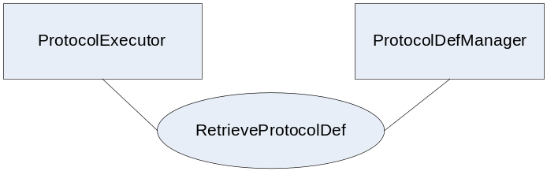
Actor: ProtocolExecutor
Role: A system that knows how to execute protocol definitions.
Actor: ProtocolDefManager
Role: A system that provides a set of protocol definitions based upon request. The system accepts requests based on a set of protocol definition IDs.

3.Y1.3 Referenced Standards
Implementers of this transaction shall comply with all requirements described in ITI TF-2: Appendix V: Web-Services for IHE Transactions
Additional educational information may be found on the IHE Wiki.
Extensible Markup Language (XML) 1.0 (Second Edition). W3C Recommendation 6 October 2000. http://www.w3.org/TR/REC-xml.
HL7v3 Study Design Topic - http://www.hl7.org/v3ballot/html/domains/uvrt/uvrt_StudyDesign.htm#PORT_DO000001UV-Studydesign-

3.Y1.4 Interaction Diagram
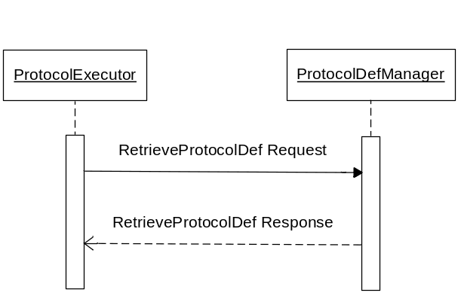

3.Y1.4.1 RetrieveProtocolDef Request message
The RetreiveProtocolDef request involves a ProtocolExecutor requesting a protocol definition from the ProtocolDefManager. The ProtocolExecutor must supply a well formed xml query that represents a set of protocol definition IDs in order to make the RetrieveProtocolDef transaction.

3.Y1.4.1.1 Trigger Events
The ProtocolExecutor, based upon human decision or application of a rule for automatic operation, wants to obtain a set of protocol definitions from the ProtocolDefManager. The ProtocolExecutor contains a set of protocol definition IDs obtained by means outside the scope of this profile.

3.Y1.4.1.2 Message Semantics
Implementers of this transaction shall comply with all requirements described in ITI TF-2: Appendix V: Web-Services for IHE Transactions.
The following parameters are specified for this transaction.
Parameter Name | REQ | Description | Value
RetrieveProtocolDefType | R | The xml representation of a query. | A well formed xml document representing a query for a set of protocol definitions.
The RetrieveProtocolDefType contains information on a protocol definition and a clinical study. The xml structure will look like:
<RetrieveProtocolDefType>
<query>an xml structure representing a list of protocol definition IDs</query>
<study>an xml structure represented by the HL7v3:StudyParticipationType</study>
</RetrieveProtocolDefType>
See schema provided in support materials.

3.Y1.4.1.3 Expected Actions
Upon reception of the RetrieveProtocolDef request, the ProtocolDefManager shall parse the request and shall return the requested response in the RetreiveProtocolDefResponse element, or errors with SOAP faults.
- If there is missing information, such as no protocol definition IDs, then the return shall be a SOAP fault. This fault should include: (faultcode: Client, faultstring: Required Information Missing) and may provide further information in the details element.
- If no protocol definition is available, then the return shall be a SOAP fault. This fault should include (faultcode: Client, faultstring: Unknown ProtocolDefID) and may provide further information in the details element.
- The successful response by the ProtocolDefManager shall be a structured XML represented by the RetrieveProtocolDefResponse element in the RPE schema. This shall contain a set of protocol definitions that are directly represented by the protocol definition IDs that were supplied in the query.
The set of protocol definition IDs have been supplied by the ProtocolDefManager prior to the RetrieveProtocolDef transaction by a means outside of this profile.
(Put error faults in the wsdl.)

3.Y1.4.2 RetrieveProtocolDef Response message

3.Y1.4.2.1 Trigger Events
The delivery of a set of protocol definitions is triggered by a ProtocolExecutor actor responding to a RetreiveProtocolDef request.

3.Y1.4.2.2 Message Semantics
A set of protocol definitions are returned. The format of the protocol definition can be found in the RPE schema.

3.Y1.4.2.3 Expected Actions
The ProtocolExecutor shall consume the set of protocol definitions based on the business rules of the system. If a SOAP fault is received then this fault should be handled based on the business rules of the system.

3.Y1.5 Security Considerations
<description of the transaction specific security consideration. Such as use of security profiles.>

3.Y1.5.1 Security Audit Considerations
<This section should specifiy any specific ATNA security audit event that is associated with this transaction and requirements on the encoding of that audit event. >

3.Y1.5.1.(z) Actor Specific Security Considerations
<This section should specifiy any specific security considerations on an Actor by Actor basis.>

3.Y1.6 Protocol Requirements
The RetreiveProtocolDef request and response shall be transmitted using Synchronous Web Services Exchange, according to the requirements specified in ITI TF-2: Appendix V.
The RetrieveProtocolDef transaction shall use SOAP 12.
WSDL Namespace Definitions
Ihe | urn:ihe:iti:rfd:2007
soap12 | http://schemas.xmlsoap.org/wsdl/soap12/
Wsaw | http://www.w3.org/2005/08/addressing
Xsd | http://www.w3.org/2001/XMLSchema
These are the requirements for the RetrieveProtocolDef transaction presented in the order in which they would appear in the WSDL definition:
- The following types shall be imported (xds:import) in the /definitions/types section:
  - Namespace=”urn:ihe:qrph:rpe:2009”, schema=”RPE.xsd”
- The /definitions/message/part/@element attribute of the RetrieveProtocolDef Request message shall be defined as: “ihe:RetrieveProtocolDefRequest”
- The /definitions/message/part/@element attribute of the RetrieveProtocolDef Response message shall be defined as: “ihe:RetrieveProtocolDefResponse”
- The /definitions/portType/operation/input/@wsaw:Action attribute for the RetrieveProtocolDef Request message shall be defined as “urn:ihe:qrph:2009:RetrieveProtocolDefRequest”
- The /definitions/portType/operation/output/@wsaw:Action attribute for the RetrieveProtocolDef Response message shall be defined as: “urn:ihe:qrph:2009:RetrieveProtocolDefResponse”
- The /definitions/binding/operation/soap12:operation/@soapAction attribute shall be defined as “urn:ihe:qrph:2009:RetrieveProtocolDef”
These are the requirements that affect the wire format of the SOAP message. The other WSDL properties are only used within the WSDL definition and do not affect interoperability. Full sample request and response messages are in the section 3.Y1.5.1 Sample SOAP Messages.
For informative WSDL for the ProtocolDefManager see Appendix W. A full XML Schema Document for the RPE types is available online on the IHE FTP site. See Appendix W.

3.Y1.6.1 Sample SOAP Messages
The samples in the following two sections show a typical SOAP request and its relative SOAP response. The sample messages also show the WS-Addressing headers <Action/>, <MessageID/>, .;these WS-Addressing headers are populated according to the IHE Appendix V: Web Services for IHE Transactions. Some of the body of the SOAP message is omitted for brevity.

3.Y1.6.2 Sample RetrieveProtocolDef SOAP Request
Note to the editor: please keep the following format for the sample text – courier new, 8pt, no spacing before and after the paragraph, tab stops every 1/8 of an inch for the first inch.
<soap:Envelope xmlns:soap="http://www.w3.org/2003/05/soap-envelope" xmlns:xsi="http://www.w3.org/2001/XMLSchema-instance" xmlns:xsd="http://www.w3.org/2001/XMLSchema">
<soap:Header>
<wsa:To>http://localhost:4040/axis2/services/someservice</wsa:To>
<wsa:MessageID>urn:uuid:76A2C3D9BCD3AECFF31217932910053</wsa:MessageID>
<wsa:Action soap:mustUnderstand="1">urn:ihe:iti:rfd:2007:RetrieveForm</wsa:Action>
</soap:Header>
<soap:Body>
<RetrieveFormRequest xmlns="urn:ihe:iti:rfd:2007">
<prepopData>...some xml content...</prepopdata>
<workflowData>
<formID>1</formID>
<encodedResponse>false</encodedResponse>
<archiveURL />
<context />
</workflowData>
</RetrieveFormRequest>
</soap:Body>
</soap:Envelope>

3.Y1.6.3 Sample RetireveProtocolDef SOAP Response
Note to the editor: please keep the following format for the sample text – courier new, 8pt, no spacing before and after the paragraph, tab stops every 1/8 of an inch for the first inch.
<soap:Envelope xmlns:soap="http://www.w3.org/2003/05/soap-envelope" xmlns:xsi="http://www.w3.org/2001/XMLSchema-instance" xmlns:xsd="http://www.w3.org/2001/XMLSchema">
<soap:Header>
<wsa:To>http://localhost:4040/axis2/services/someservice</wsa:To>
<wsa:MessageID>urn:uuid:76A2C3D9BCD3AECFF31217932910053</wsa:MessageID>
<wsa:Action soap:mustUnderstand="1">urn:ihe:iti:rfd:2007:RetrieveFormResponse</wsa:Action>
</soap:Header>
<soap:Body>
<RetrieveFormResponse xmlns="urn:ihe:iti:rfd:2007">
<form>
<URL>http://somehost/xxx/services/someForm</URL>
</form>
<contentType />
<responseCode />
</RetrieveFormResponse>
</soap:Body>
</soap:Envelope>

3.Y2 EnterPatientRequest transaction
This section corresponds to transaction QRPH-Y2 of the IHE Technical Framework. The transaction QRPH-Y2 is used by the ProtocolExecutor and ProtocolStateManager actors.

3.Y2.1 Scope
This transaction involves a ProtocolExecutor requesting to enter patient information into a ProtocolStateManager. The ProtocolExecutor has a protocol definition ID obtained by means outside the scope of this profile. The ProtocolStateManager will return candidateID for the patient being entered into the clinical study based on the protocol definition ID or else it returns an error response.

3.Y2.2 Use Case Roles
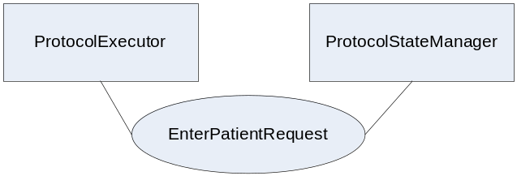
Actor: ProtocolExecutor
Role: A system that knows how to execute protocol definitions.
Actor: ProtocolStateManager
Role: A system that knows how to manage a clinical research study. The system accepts information related to the workflow of a ProtocolDef.

3.Y2.3 Referenced Standards
Implementers of this transaction shall comply with all requirements described in ITI TF-2: Appendix V: Web-Services for IHE Transactions
Additional educational information may be found on the IHE Wiki.
Extensible Markup Language (XML) 1.0 (Second Edition). W3C Recommendation 6 October 2000. http://www.w3.org/TR/REC-xml.
HL7v3 Study Participation - http://www.hl7.org/v3ballot/html/domains/uvrt/uvrt_StudyParticipation.htm

3.Y2.4 Interaction Diagram
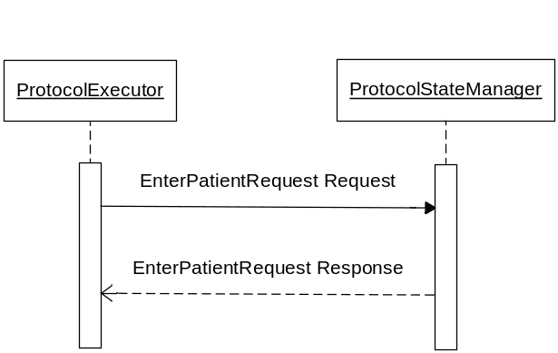

3.Y2.4.1 EnterPatientRequest Request message
The EnterPatientRequest request involves a ProtocolExecutor requesting a patient to be entered into a clinical study from the ProtocolStateManager. The ProtocolExecutor must supply a well formed xml structure that represents a protocol definition ID and patient information in order to make the EnterPatientRequest transaction.

3.Y2.4.1.1 Trigger Events
The ProtocolExecutor based on human decision or application of a rule for automatic operation, wants to request the entry of a patient into a ProtocolStateManager. The ProtocolStateManager has obtained the protocol definition ID by a means outside the scope of this profile.

3.Y2.4.1.2 Message Semantics
Implementers of this transaction shall comply with all requirements described in ITI TF-2:Appendix V:Web-Services for IHE Transactions.
The following parameters are specified for this transaction.
Parameter Name | REQ | Description | Value
EnterPatientRequestType | R | An xml structure containing information on a patient and study | This value is a well-formed xml document.
The EnterPatientRequestType contains information on a patient and a clinical study. The xml structure will look like:

<EnterPatientRequestType>
<patient>an xml structure represented by the rpe:PatientType</patient>
<study>an xml structure represented by the HL7v3:StudyParticipationType</study>
</EnterPatientRequestType>
See schema provided with the support materials.

3.Y2.4.1.3 Expected Actions
Upon reception of the EnterPatientRequest request, the ProtocolStateManager shall parse the request and shall return the requested response in the EnterPatientRequest response element, or errors with SOAP faults.
- If there is missing information, such as no patient or no study, then the return shall be a SOAP fault. This SOAP fault shall use the following (faultcode: Client, faultstring: Required Information Missing) and may provide further information in the details element.
- If there is no related study available then the return shall be a SOAP fault. This shall use the following (faultcode: Client, faultstring: Unknown study) and may provide further information in the details element.
- The successful response by the ProtocolStateManager shall return a EnterPatientRequest response message, containing candidateID information relating to the patient that was entered into the study.
(Put error faults in the wsdl.)

3.Y2.4.2 EnterPatientRequest Response message

3.Y2.4.2.1 Trigger Events
The delivery of the candidateID is triggered by a ProtocolStateManager actor responding to an EnterPatientRequest request.

3.Y2.4.2.2 Message Semantics
The EnterPatientRequestType that is returned contains the candidateID information.

3.Y2.4.2.3 Expected Actions
The ProtocolExecutor shall store the returned candidateID in the system associating it to the related patient.
If a candidateID was not returned in the response, then the ProtocolExecutor shall not associate any information with the patient and the patient shall not be entered into any study.

3.Y2.5 Security Considerations
<description of the transaction specific security consideration. Such as use of security profiles.>

3.Y2.5.1 Security Audit Considerations
<This section should specifiy any specific ATNA security audit event that is associated with this transaction and requirements on the encoding of that audit event. >

3.Y2.5.1.(z) Actor Specific Security Considerations
<This section should specifiy any specific security considerations on an Actor by Actor basis.>

3.Y2.6 Protocol Requirements
The EnterPatientRequest request and response shall be transmitted using Synchronous Web Services Exchange, according to the requirements specified in ITI TF-2: Appendix V.
The EnterPatientRequest transaction shall use SOAP 12.
WSDL Namespace Definitions
Ihe | urn:ihe:iti:rfd:2007
soap12 | http://schemas.xmlsoap.org/wsdl/soap12/
Wsaw | http://www.w3.org/2005/08/addressing
Xsd | http://www.w3.org/2001/XMLSchema
These are the requirements for the EnterPatientRequest transaction presented in the order in which they would appear in the WSDL definition:
- The following types shall be imported (xds:import) in the /definitions/types section:
  - Namespace=”urn:ihe:qrph:rpe:2009”, schema=”RPE.xsd”
- The /definitions/message/part/@element attribute of the EnterPatientRequest Request message shall be defined as: “ihe:EnterPatientRequestRequest”
- The /definitions/message/part/@element attribute of the EnterPatientRequest Response message shall be defined as: “ihe:EnterPatientRequestResponse”
- The /definitions/portType/operation/input/@wsaw:Action attribute for the EnterPatientRequest Request message shall be defined as “urn:ihe:qrph:2009:EnterPatientRequestRequest”
- The /definitions/portType/operation/output/@wsaw:Action attribute for the EnterPatientRequest Response message shall be defined as: “urn:ihe:qrph:2009:EnterPatientRequestResponse”
- The /definitions/binding/operation/soap12:operation/@soapAction attribute shall be defined as “urn:ihe:qrph:2009:EnterPatientRequest”
These are the requirements that affect the wire format of the SOAP message. The other WSDL properties are only used within the WSDL definition and do not affect interoperability. Full sample request and response messages are in the section 3.Y1.5.1 Sample SOAP Messages.
For informative WSDL for the ProtocolStateManager see Appendix W. A full XML Schema Document for the RPE types is available online on the IHE FTP site. See Appendix W.

3.Y2.6.1 Sample SOAP Messages
The samples in the following two sections show a typical SOAP request and its relative SOAP response. The sample messages also show the WS-Addressing headers <Action/>, <MessageID/>, .;these WS-Addressing headers are populated according to the IHE Appendix V: Web Services for IHE Transactions. Some of the body of the SOAP message is omitted for brevity.

3.Y2.6.2 Sample EnterPatientRequest SOAP Request

3.Y2.6.3 Sample EnterPatientRequest SOAP Response

3.Y3 PatientScreeningVisitsScheduled transaction
This section corresponds to transaction QRPH-Y3 of the QRPH Framework. Transaction QRPH-Y3 is used by the ProtocolExecutor and ProtocolStateManager actors.

3.Y3.1 Scope
This transaction involves a ProtocolExecutor requesting to schedule the patient’s screening visits into a ProtocolStateManager. The ProtocolExecutor has a protocol definition ID obtained by means outside the scope of this profile. The ProtocolStateManager will return a success message for the screening visits being scheduled or else it returns an error response.

3.Y3.2 Use Case Roles
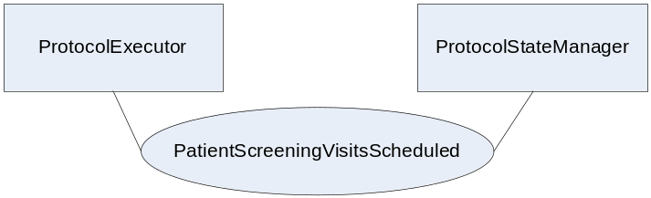
Actor: ProtocolExecutor
Role: A system that knows how to execute protocol definitions.
Actor: ProtocolStateManager
Role: A system that knows how to manage a clinical research study. The system accepts information related to the workflow of a protocol definition.

3.Y3.3 Referenced Standards
Implementers of this transaction shall comply with all requirements described in ITI TF-2: Appendix V: Web-Services for IHE Transactions
Additional educational information may be found on the IHE Wiki.
Extensible Markup Language (XML) 1.0 (Second Edition). W3C Recommendation 6 October 2000. http://www.w3.org/TR/REC-xml.
HL7v3 Study Participation – http://www.hl7.org/v3ballot/html/domains/uvrt/uvrt_StudyParticipation.htm

3.Y3.4 Interaction Diagram
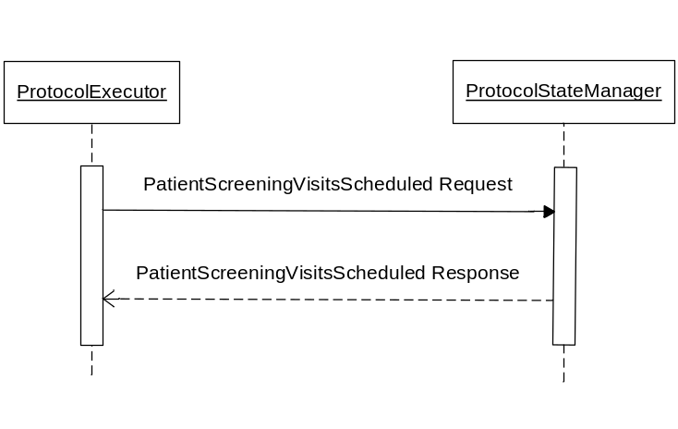

3.Y3.4.1 PatientScreeningVisitsScheduled Request message
The PatientScreeningVisitsScheduled request involves a ProtocolExecutor requesting that a patient’s screening visits be scheduled within the ProtocolStateManager. The ProtocolExecutor must supply a well formed xml structure that represents a protocol definition ID, a patient and a schedule. This is represented by the PatientScreeningVisitsScheduledType in the RPE schema.

3.Y3.4.1.1 Trigger Events
The ProtocolExecutor based upon human decision or application of a rule for automatic operation, wants to schedule a patient’s screening visits.
The ProtocolExecutor and ProtocolStateManager must have previously entered the patient into the study.

3.Y3.4.1.2 Message Semantics
Implementers of this transaction shall comply with all requirements described in ITI TF-2:Appendix V:Web-Services for IHE Transactions.
The following parameters are specified for this transaction.
Parameter Name | REQ | Description | Value
PatientScreeningVisitsScheduledType | R | An xml structure containing information on a patient, study and schedule | This value is a well-formed xml document.
The PatientScreeningVisitsScheduledType contains information on a patient, study and schedule. The xml structure will look like:

<PatientScreeningVisitsScheduledType>
<patient>an xml structure represented by the rpe:PatientType</patient>
<study>an xml structure represented by the HL7v3:StudyParticipationType</study>
<schedule>an xml structure represented by the rpe:ScreeningVisitScheduledType</schedule>
</PatientScreeningVisitsScheduledType>
See schema provided with the support materials.

3.Y3.4.1.3 Expected Actions
Upon reception of the PatientScreeningVisitsScheduled request, the ProtocolStateManager shall parse the request and shall return the requested response in the PatientScreeningVisitsScheduled response element, or errors with SOAP faults.
- If there is missing information, such as no patient, no study or no schedule, then the return shall be a SOAP fault. This SOAP fault shall use the following (faultcode: Client, faultstring: Required Information Missing) and may provide further information in the details element.
- If there is no related study available then the return shall be a SOAP fault. This shall use the following (faultcode: Client, faultstring: Unknown study) and may provide further information in the details element.
- The successful response by the ProtocolStatemanager shall return a PatientScreeningVisitsScheduled response message, containing acknowledgement that the patient’s screening visits were scheduled.
(Put error faults in the wsdl.)

3.Y3.4.2 PatientScreeningVisitsScheduled Response message

3.Y3.4.2.1 Trigger Events
The delivery of the acknowledgement that a patient’s screening schedule was received is triggered by a ProtocolStateManager actor responding to a PatientScreeningVisitsScheduled request.

3.Y3.4.2.2 Message Semantics
The PatientScreeningVisitsScheduled is returned containing the acknowledgement that the patient’s screening visits have been scheduled.

3.Y3.4.2.3 Expected Actions
The ProtocolExecutor shall store the returned scheduled study visits in the system associating it to the related patient. If an acknowledgement was not returned in the response, then the ProtocolExecutor shall not associate any scheduling information with the patient.

3.Y3.5 Security Considerations
<description of the transaction specific security consideration. Such as use of security profiles.>

3.Y3.5.1 Security Audit Considerations
<This section should specifiy any specific ATNA security audit event that is associated with this transaction and requirements on the encoding of that audit event. >

3.Y3.5.1.(z) Actor Specific Security Considerations
<This section should specifiy any specific security considerations on an Actor by Actor basis.>

3.Y3.6 Protocol Requirements
The PatientScreeningVisitsScheduled request and response shall be transmitted using Synchronous Web Services Exchange, according to the requirements specified in ITI TF-2: Appendix V.
The PatientScreeningVisitsScheduled transaction shall use SOAP 12.
WSDL Namespace Definitions
Ihe | urn:ihe:iti:rfd:2007
soap12 | http://schemas.xmlsoap.org/wsdl/soap12/
Wsaw | http://www.w3.org/2005/08/addressing
Xsd | http://www.w3.org/2001/XMLSchema
These are the requirements for the PatientScreeningVisitsScheduled transaction presented in the order in which they would appear in the WSDL definition:
- The following types shall be imported (xds:import) in the /definitions/types section:
  - Namespace=”urn:ihe:qrph:rpe:2009”, schema=”RPE.xsd”
- The /definitions/message/part/@element attribute of the PatientScreeningVisitsScheduled Request message shall be defined as: “ihe:PatientScreeningVisitsScheduled”
- The /definitions/message/part/@element attribute of the PatientScreeningVisitsScheduled Response message shall be defined as: “ihe:PatientScreeningVisitsScheduled”
- The /definitions/portType/operation/input/@wsaw:Action attribute for the PatientScreeningVisitsScheduled Request message shall be defined as “urn:ihe:qrph:2009:PatientScreeningVisitsScheduled”
- The /definitions/portType/operation/output/@wsaw:Action attribute for the PatientScreeningVisitsScheduled Response message shall be defined as: “urn:ihe:qrph:2009:PatientScreeningVisitsScheduled”
- The /definitions/binding/operation/soap12:operation/@soapAction attribute shall be defined as “urn:ihe:qrph:2009:PatientScreeningVisitsScheduled”
These are the requirements that affect the wire format of the SOAP message. The other WSDL properties are only used within the WSDL definition and do not affect interoperability. Full sample request and response messages are in the section 3.Y1.5.1 Sample SOAP Messages.
For informative WSDL for the ProtocolStateManager see Appendix W. A full XML Schema Document for the RPE types is available online on the IHE FTP site. See Appendix W.

3.Y3.6.1 Sample SOAP Messages
The samples in the following two sections show a typical SOAP request and its relative SOAP response. The sample messages also show the WS-Addressing headers <Action/>, <MessageID/>, .;these WS-Addressing headers are populated according to the IHE Appendix V: Web Services for IHE Transactions. Some of the body of the SOAP message is omitted for brevity.

3.Y3.6.2 Sample PatientScreeningVisitsScheduled SOAP Request

3.Y3.6.3 Sample PatientScreeningVisitsScheduled SOAP Response

3.Y4 RecordPatientScreeningVisit transaction
This section corresponds to transaction QRPH-Y4 of the QRPH Framework. transaction QRPH-Y4 is used by the ProtocolExecutor and ProtocolStateManager actors.

3.Y4.1 Scope
This transaction involves a ProtocolExecutor requesting to record a patient’s screening visit into a ProtocolStateManager. The ProtocolExecutor contains a protocol definition obtained by means outside the scope of this profile. The ProtocolStateManager will return a success message for the screening visits being scheduled or else it returns an error response.

3.Y4.2 Use Case Roles
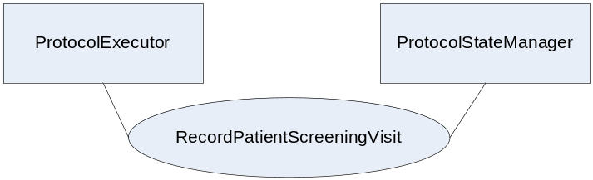
Actor: ProtocolExecutor
Role: A system that knows how to execute protocol definitions.
Actor: ProtocolStateManager
Role: A system that knows how to manage a clinical research study. The system accepts information related to the workflow of a protocol definition.

3.Y4.3 Referenced Standards
Implementers of this transaction shall comply with all requirements described in ITI TF-2: Appendix V: Web-Services for IHE Transactions
Additional educational information may be found on the IHE Wiki.
Extensible Markup Language (XML) 1.0 (Second Edition). W3C Recommendation 6 October 2000. http://www.w3.org/TR/REC-xml.
HL7v3 Study Participation - http://www.hl7.org/v3ballot/html/domains/uvrt/uvrt_StudyParticipation.htm

3.Y4.4 Interaction Diagram
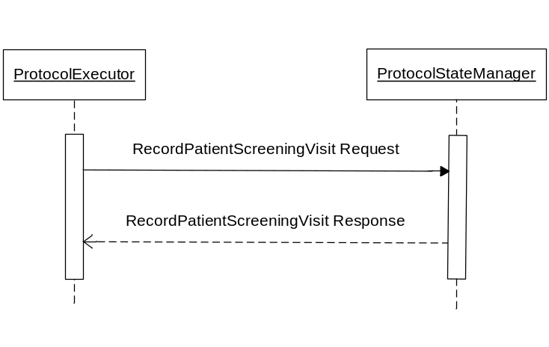

3.Y4.4.1 RecordPatientScreeningVisit Request message
The RecordPatientScreeningVisit request involves a ProtocolExecutor requesting to record a patient’s screening visit into a ProtocolStateManager. The ProtocolExecutor must supply a well formed xml structure that represents a protocol definition ID, a patient and a visit. This is represented by the RecordPatientScreeningVisitType in the RPE schema.

3.Y4.4.1.1 Trigger Events
The ProtocolExecutor based upon human decision or application of a rule for automatic operation, wants to record a patient’s screening visit.
The ProtocolExecutor and ProtocolStateManager must have previously stored the scheduling information for the patient and study.

3.Y4.4.1.2 Message Semantics
Implementers of this transaction shall comply with all requirements described in ITI TF-2:Appendix V:Web-Services for IHE Transactions.
The following parameters are specified for this transaction.
Parameter Name | REQ | Description | Value
RecordPatientScreeningVisitType | R | An xml structure containing information on a patient, study and visit | This value is a well-formed xml document.
The RecordPatientScreeningVisitType contains information on a patient, study and visit. The xml structure will look like:

<RecordPatientScreeningVisitType>
<patient>an xml structure represented by the rpe:PatientType</patient>
<study>an xml structure represented by the HL7v3:StudyParticipationType</study>
<visit>an xml structure represented by the rpe:ScreenVisitType</visit>
</RecordPatientScreeningVisitType>
See schema provided with the support materials.

3.Y4.4.1.3 Expected Actions
Upon reception of the RecordPatientScreeningVisit request, the ProtocolStateManager shall parse the request and shall return the requested response in the RecordPatientScreeningVisit response element, or errors with SOAP faults
- If there is missing information, such as no patient, no study or no visit, then the return shall be a SOAP fault. This SOAP fault shall use the following (faultcode: Client, faultstring: Required Information Missing) and may provide further information in the details element.
- If there is no related study available then the return shall be a SOAP fault. This shall use the following (faultcode: Client, faultstring: Unknown study) and may provide further information in the details element.
- The successful response by the ProtocolStatemanager shall return a RecordPatientScreeningVisit response message, containing acknowledgement that the patient’s screening visits were scheduled.
(Put error faults in the wsdl.)

3.Y4.4.2 RecordPatientScreeningVisit Response message

3.Y4.4.2.1 Trigger Events
The delivery of the acknowledgement that a patient’s screening visit being recorded was received is triggered by a ProtocolStateManager actor responding to a RecordPatientScreeningVisit request.

3.Y4.4.2.2 Message Semantics
The RecordPatientScreeningVisit is returned containing the acknowledgement that the patient’s screening visits have been scheduled.

3.Y4.4.2.3 Expected Actions
The ProtocolExecutor shall store the returned recorded patient’s screening visit in the system associating it to the related patient. If an acknowledgement was not returned in the response, then the ProtocolExecutor shall not associate any visit information with the patient.

3.Y4.5 Security Considerations
<description of the transaction specific security consideration. Such as use of security profiles.>

3.Y4.5.1 Security Audit Considerations
<This section should specifiy any specific ATNA security audit event that is associated with this transaction and requirements on the encoding of that audit event. >

3.Y4.5.1.(z) Actor Specific Security Considerations
<This section should specifiy any specific security considerations on an Actor by Actor basis.>

3.Y4.6 Protocol Requirements
The RecordPatientScreeningVisit request and response shall be transmitted using Synchronous Web Services Exchange, according to the requirements specified in ITI TF-2: Appendix V.
The RecordPatientScreeningVisit transaction shall use SOAP 12.
WSDL Namespace Definitions
Ihe | urn:ihe:iti:rfd:2007
soap12 | http://schemas.xmlsoap.org/wsdl/soap12/
Wsaw | http://www.w3.org/2005/08/addressing
Xsd | http://www.w3.org/2001/XMLSchema
These are the requirements for the RecordPatientScreeningVisit transaction presented in the order in which they would appear in the WSDL definition:
- The following types shall be imported (xds:import) in the /definitions/types section:
  - Namespace=”urn:ihe:qrph:rpe:2009”, schema=”RPE.xsd”
- The /definitions/message/part/@element attribute of the RecordPatientScreeningVisit Request message shall be defined as: “ihe:RecordPatientScreeningVisit”
- The /definitions/message/part/@element attribute of the RecordPatientScreeningVisit Response message shall be defined as: “ihe:RecordPatientScreeningVisit”
- The /definitions/portType/operation/input/@wsaw:Action attribute for the RecordPatientScreeningVisit Request message shall be defined as “urn:ihe:qrph:2009:RecordPatientScreeningVisit”
- The /definitions/portType/operation/output/@wsaw:Action attribute for the RecordPatientScreeningVisit Response message shall be defined as: “urn:ihe:qrph:2009:RecordPatientScreeningVisit”
- The /definitions/binding/operation/soap12:operation/@soapAction attribute shall be defined as “urn:ihe:qrph:2009:RecordPatientScreeningVisit”
These are the requirements that affect the wire format of the SOAP message. The other WSDL properties are only used within the WSDL definition and do not affect interoperability. Full sample request and response messages are in the section 3.Y1.5.1 Sample SOAP Messages.
For informative WSDL for the ProtocolStateManager see Appendix W. A full XML Schema Document for the RPE types is available online on the IHE FTP site. See Appendix W.

3.Y4.6.1 Sample SOAP Messages
The samples in the following two sections show a typical SOAP request and its relative SOAP response. The sample messages also show the WS-Addressing headers <Action/>, <MessageID/>, .;these WS-Addressing headers are populated according to the IHE Appendix V: Web Services for IHE Transactions. Some of the body of the SOAP message is omitted for brevity.

3.Y4.6.2 Sample RecordPatientScreeningVisit SOAP Request

3.Y4.6.3 Sample RecordPatientScreeningVisit SOAP Response

3.Y5 EnrollPatientRequest transaction
This section corresponds to transaction QRPH-Y5 of the IHE Technical Framework. Transaction QRPH-Y5 is used by the ProtocolExecutor and ProtocolStateManager actors.

3.Y5.1 Scope
This transaction involves a ProtocolExecutor requesting to enroll a patient into a clinical study to a ProtocolStateManager. The ProtocolExecutor has a protocol definition ID obtained by means outside the scope of this profile. The ProtocolStateManager will return a subjectID for the patient being enrolled into the clinical study based on the protocol definition ID or else it returns an error response.

3.Y5.2 Use Case Roles
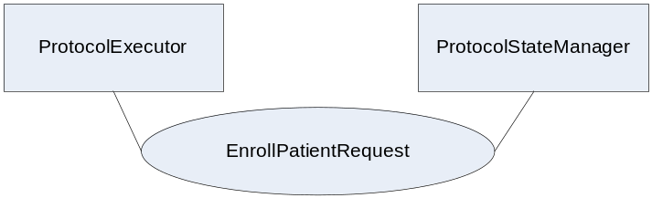
Actor: ProtocolExecutor
Role: A system that knows how to execute protocol definitions.
Actor: ProtocolStateManager
Role: A system that knows how to manage a clinical research study. The system accepts information related to the workflow of a protocol definition.

3.Y5.3 Referenced Standards
Implementers of this transaction shall comply with all requirements described in ITI TF-2: Appendix V: Web-Services for IHE Transactions
Additional educational information may be found on the IHE Wiki.
Extensible Markup Language (XML) 1.0 (Second Edition). W3C Recommendation 6 October 2000. http://www.w3.org/TR/REC-xml.
HL7v3 Study Participation - http://www.hl7.org/v3ballot/html/domains/uvrt/uvrt_StudyParticipation.htm

3.Y5.4 Interaction Diagram
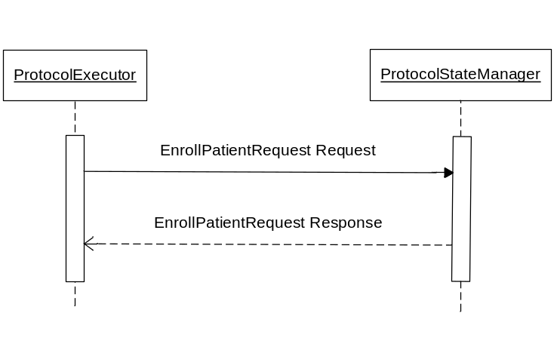

3.Y5.4.1 EnrollPatientRequest Request message
The EnrollPatientRequest request involves a ProtocolExecutor requesting a patient to be enrolled into a clinical study from the ProtocolStateManager. The ProtocolExecutor must supply a well formed xml structure that represents a protocol definition ID and patient information in order to make the EnrollPatientRequest transaction.

3.Y5.4.1.1 Trigger Events
The ProtocolExecutor based on human decision or application of a rule for automatic operation, wants to request the enrollment of a patient into a ProtocolStateManager. The ProtocolStateManager has obtained the protocol definition ID by a means outside the scope of this profile.
The ProtocolExecutor and ProtocolStateManager must have previously completed the study visits defined in the ProtocolDef.

3.Y5.4.1.2 Message Semantics
Implementers of this transaction shall comply with all requirements described in ITI TF-2:Appendix V:Web-Services for IHE Transactions.
The following parameters are specified for this transaction.
Parameter Name | REQ | Description | Value
EnrollPatientRequestType | R | An xml structure containing information on a patient and study | This value is a well-formed xml document.
The EnrollPatientRequestType contains information on a patient and a clinical study. The xml structure will look like:

<EnrollPatientRequestType>
<patient>an xml structure represented by the rpe:PatientType</patient>
<study>an xml structure represented by the HL7v3:StudyParticipationType</study>
</EnrollPatientRequestType>
See schema provided with the support materials.

3.Y5.4.1.3 Expected Actions
Upon reception of the EnrollPatientRequest request, the ProtocolStateManager shall parse the request and shall return the requested response in the EnrollPatientRequest response element, or errors with SOAP faults.
- If there is missing information, such as no patient or no study, then the return shall be a SOAP fault. This SOAP fault shall use the following (faultcode: Client, faultstring: Required Information Missing) and may provide further information in the details element.
- If there is no related study available then the return shall be a SOAP fault. This shall use the following (faultcode: Client, faultstring: Unknown study) and may provide further information in the details element.
- The successful response by the ProtocolStatemanager shall return a EnrollPatientRequest response message, containing candidateID information relating to the patient that was entered into the study.
- If the ProtocolStateManager determines that there has been a screen failure, that the study has been put on hold or that the enrollment count for the study is complete then this transaction shall fail and there shall be a SOAP fault. This SOAP fault shall use the following (faultcode: Client, faultstring: Enrollment Failure based on screen failure, study put on hold or enrollment count for the study is complete) and may provide further information in the details element.

(Put error faults in the wsdl.)

3.Y5.4.2 EnrollPatientRequest Response message

3.Y5.4.2.1 Trigger Events
The delivery of the subjectID information is triggred by a ProtocolStateManager actor responding to an EnrollPatientRequest request.

3.Y5.4.2.2 Message Semantics
The EnrollPatientRequestType is returned containing the subjectID information.

3.Y5.4.2.3 Expected Actions
The ProtocolExecutor shall store the returned subjectID in the system associating it to the related patient information.
If a subjectID was not returned in the response, then the ProtocolExecutor shall not associate any information with the patient and the patient shall not be entered into any study.
If a SOAP fault is returned, then the ProtocolExecutor shall not associate any information with the patient and the patient shall not be entered into any study.

3.Y5.5 Security Considerations
<description of the transaction specific security consideration. Such as use of security profiles.>

3.Y5.5.1 Security Audit Considerations
<This section should specifiy any specific ATNA security audit event that is associated with this transaction and requirements on the encoding of that audit event. >

3.Y5.5.1.(z) Actor Specific Security Considerations
<This section should specifiy any specific security considerations on an Actor by Actor basis.>

3.Y5.6 Protocol Requirements
The EnrollPatientRequest request and response shall be transmitted using Synchronous Web Services Exchange, according to the requirements specified in ITI TF-2: Appendix V.
The EnrollPatientRequest transaction shall use SOAP 12.
WSDL Namespace Definitions
Ihe | urn:ihe:iti:rfd:2007
soap12 | http://schemas.xmlsoap.org/wsdl/soap12/
Wsaw | http://www.w3.org/2005/08/addressing
Xsd | http://www.w3.org/2001/XMLSchema
These are the requirements for the EnrollPatientRequest transaction presented in the order in which they would appear in the WSDL definition:
- The following types shall be imported (xds:import) in the /definitions/types section:
  - Namespace=”urn:ihe:qrph:rpe:2009”, schema=”RPE.xsd”
- The /definitions/message/part/@element attribute of the EnrollPatientRequest Request message shall be defined as: “ihe:EnrollPatientRequestRequest”
- The /definitions/message/part/@element attribute of the EnrollPatientRequest Response message shall be defined as: “ihe:EnrollPatientRequestResponse”
- The /definitions/portType/operation/input/@wsaw:Action attribute for the EnrollPatientRequest Request message shall be defined as “urn:ihe:qrph:2009:EnrollPatientRequestRequest”
- The /definitions/portType/operation/output/@wsaw:Action attribute for the EnrollPatientRequest Response message shall be defined as: “urn:ihe:qrph:2009:EnrollPatientRequestResponse”
- The /definitions/binding/operation/soap12:operation/@soapAction attribute shall be defined as “urn:ihe:qrph:2009:EnrollPatientRequest”
These are the requirements that affect the wire format of the SOAP message. The other WSDL properties are only used within the WSDL definition and do not affect interoperability. Full sample request and response messages are in the section 3.Y1.5.1 Sample SOAP Messages.
For informative WSDL for the ProtocolStateManager see Appendix W. A full XML Schema Document for the RPE types is available online on the IHE FTP site. See Appendix W.

3.Y5.6.1 Sample SOAP Messages
The samples in the following two sections show a typical SOAP request and its relative SOAP response. The sample messages also show the WS-Addressing headers <Action/>, <MessageID/>, .;these WS-Addressing headers are populated according to the IHE Appendix V: Web Services for IHE Transactions. Some of the body of the SOAP message is omitted for brevity.

3.Y5.6.2 Sample EnrollPatientRequest SOAP Request

3.Y5.6.3 Sample EnrollPatientRequest SOAP Response

3.Y6 PatientStudyVisitsScheduled transaction
This section corresponds to transaction QRPH-Y6 of the QRPH Framework. Transaction QRPH-Y6 is used by the ProtocolExecutor and ProtocolStateManager actors.

3.Y6.1 Scope
This transaction involves a ProtocolExecutor requesting to schedule the patient’s study visits into a ProtocolStateManager. The ProtocolExecutor has a protocol definition ID obtained by means outside the scope of this profile. The ProtocolStateManager will return a success message for the study visits being scheduled or else it returns an error response.

3.Y6.2 Use Case Roles
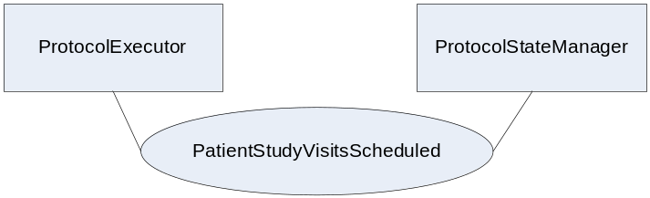
Actor: ProtocolExecutor
Role: A system that knows how to execute ProtocolDefs.
Actor: ProtocolStateManager
Role: A system that knows how to manage a clinical research study (ProtocolDef). The system accepts information related to the workflow of a ProtocolDef.

3.Y6.3 Referenced Standards
Implementers of this transaction shall comply with all requirements described in ITI TF-2: Appendix V: Web-Services for IHE Transactions
Additional educational information may be found on the IHE Wiki.
Extensible Markup Language (XML) 1.0 (Second Edition). W3C Recommendation 6 October 2000. http://www.w3.org/TR/REC-xml.
HL7v3 Study Participation – http://www.hl7.org/v3ballot/html/domains/uvrt/uvrt_StudyParticipation.htm

3.Y6.4 Interaction Diagram
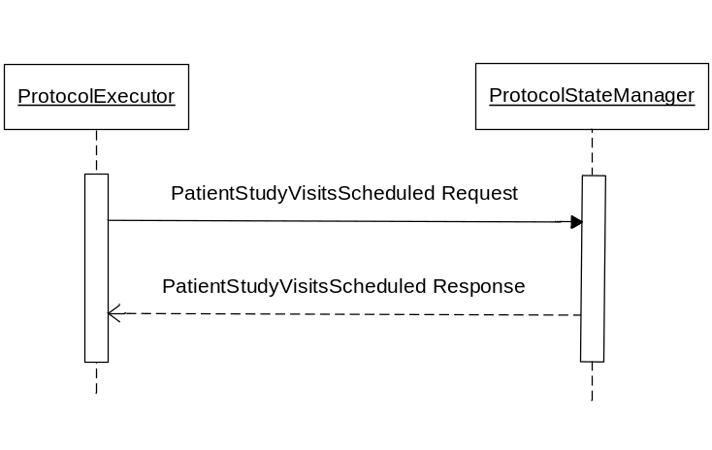

3.Y6.4.1 PatientStudyVisitsScheduled Request message
The PatientStudyVisitsScheduled request involves a ProtocolExecutor requesting that a patient’s study visits be scheduled within the ProtocolStateManager. The ProtocolExecutor must supply a well formed xml structure that represents a protocol definition ID, a patient and a schedule. This is represented by the PatientStudyVisitsScheduledType in the RPE schema.

3.Y3.4.1.1 Trigger Events
The ProtocolExecutor based upon human decision or application of a rule for automatic operation, wants to schedule a patient’s study visits.
The ProtocolExecutor and ProtocolStateManager must have previously enrolled the patient into the study.

3.Y6.4.1.2 Message Semantics
Implementers of this transaction shall comply with all requirements described in ITI TF-2:Appendix V:Web-Services for IHE Transactions.
The following parameters are specified for this transaction.
Parameter Name | REQ | Description | Value
PatientStudyVisitsScheduledType | R | An xml structure containing information on a patient, study and schedule | This value is a well-formed xml document.
The PatientStudyVisitsScheduledType contains information on a patient, study and schedule. The xml structure will look like:

<PatientStudyVisitsScheduledType>
<patient>an xml structure represented by the rpe:PatientType</patient>
<study>an xml structure represented by the HL7v3:StudyParticipationType</study>
<schedule>an xml structure represented by the rpe:ScreeningVisitScheduledType</schedule>
</PatientStudyVisitsScheduledType>
See schema provided with the support materials.

3.Y6.4.1.3 Expected Actions
Upon reception of the PatientStudyVisitsScheduled request, the ProtocolStateManager shall parse the request and shall return the requested response in the PatientStudyVisitsScheduled response element, or errors with SOAP faults.
- If there is missing information, such as no patient, no study or no schedule, then the return shall be a SOAP fault. This SOAP fault shall use the following (faultcode: Client, faultstring: Required Information Missing) and may provide further information in the details element.
- If there is no related study available then the return shall be a SOAP fault. This shall use the following (faultcode: Client, faultstring: Unknown study) and may provide further information in the details element.
- The successful response by the ProtocolStatemanager shall return a PatientStudyVisitsScheduled response message, containing acknowledgement that the patient’s screening visits were scheduled.
(Put error faults in the wsdl.)

3.Y6.4.2 PatientStudyVisitsScheduled Response message

3.Y6.4.2.1 Trigger Events
The delivery of the acknowledgement that a patient’s study schedule was received is triggered by a ProtocolStateManager actor responding to a PatientStudyVisitsScheduled request.

3.Y6.4.2.2 Message Semantics
The PatientStudyVisitsScheduled is returned containing the acknowledgement that the patient’s study visits have been scheduled.

3.Y6.4.2.3 Expected Actions
The ProtocolExecutor shall store the returned scheduled study visits in the system associating it to the related patient. If an acknowledgement was not returned in the response, then the ProtocolExecutor shall not associate any scheduling information with the patient.

3.Y6.5 Security Considerations
<description of the transaction specific security consideration. Such as use of security profiles.>

3.Y6.5.1 Security Audit Considerations
<This section should specifiy any specific ATNA security audit event that is associated with this transaction and requirements on the encoding of that audit event. >

3.Y6.5.1.(z) Actor Specific Security Considerations
<This section should specifiy any specific security considerations on an Actor by Actor basis.>

3.Y6.6 Protocol Requirements
The PatientStudyVisitsScheduled request and response shall be transmitted using Synchronous Web Services Exchange, according to the requirements specified in ITI TF-2: Appendix V.
The PatientStudyVisitsScheduled transaction shall use SOAP 12.
WSDL Namespace Definitions
Ihe | urn:ihe:iti:rfd:2007
soap12 | http://schemas.xmlsoap.org/wsdl/soap12/
Wsaw | http://www.w3.org/2005/08/addressing
Xsd | http://www.w3.org/2001/XMLSchema
These are the requirements for the PatientStudyVisitsScheduled transaction presented in the order in which they would appear in the WSDL definition:
- The following types shall be imported (xds:import) in the /definitions/types section:
  - Namespace=”urn:ihe:qrph:rpe:2009”, schema=”RPE.xsd”
- The /definitions/message/part/@element attribute of the PatientStudyVisitsScheduled Request message shall be defined as: “ihe:PatientStudyVisitsScheduled”
- The /definitions/message/part/@element attribute of the PatientStudyVisitsScheduled Response message shall be defined as: “ihe:PatientStudyVisitsScheduled”
- The /definitions/portType/operation/input/@wsaw:Action attribute for the PatientStudyVisitsScheduled Request message shall be defined as “urn:ihe:qrph:2009:PatientStudyVisitsScheduled”
- The /definitions/portType/operation/output/@wsaw:Action attribute for the PatientStudyVisitsScheduled Response message shall be defined as: “urn:ihe:qrph:2009:PatientStudyVisitsScheduled”
- The /definitions/binding/operation/soap12:operation/@soapAction attribute shall be defined as “urn:ihe:qrph:2009:PatientStudyVisitsScheduled”
These are the requirements that affect the wire format of the SOAP message. The other WSDL properties are only used within the WSDL definition and do not affect interoperability. Full sample request and response messages are in the section 3.Y1.5.1 Sample SOAP Messages.
For informative WSDL for the ProtocolStateManager see Appendix W. A full XML Schema Document for the RPE types is available online on the IHE FTP site. See Appendix W.

3.Y6.6.1 Sample SOAP Messages
The samples in the following two sections show a typical SOAP request and its relative SOAP response. The sample messages also show the WS-Addressing headers <Action/>, <MessageID/>, .;these WS-Addressing headers are populated according to the IHE Appendix V: Web Services for IHE Transactions. Some of the body of the SOAP message is omitted for brevity.

3.Y6.6.2 Sample PatientStudyVisitsScheduled SOAP Request

3.Y6.6.3 Sample PatientStudyVisitsScheduled SOAP Response

3.Y7 RecordPatientStudyVisit transaction
This section corresponds to transaction QRPH-Y7 of the QRPH Framework. Transaction QRPH-Y7 is used by the ProtocolExecutor and ProtocolStateManager actors.

3.Y7.1 Scope
This transaction involves a ProtocolExecutor requesting to record a patient’s study visit into a ProtocolStateManager. The ProtocolExecutor contains a ProtocolDef obtained by means outside the scope of this profile. The ProtocolStateManager will return a success message for the study visits being scheduled or else it returns an error response.

3.Y7.2 Use Case Roles
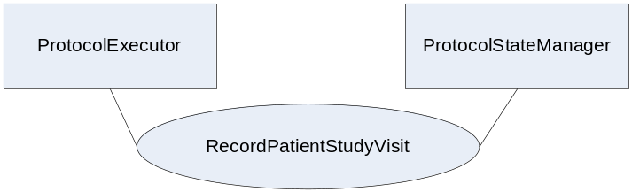
Actor: ProtocolExecutor
Role: A system that knows how to execute ProtocolDefs.
Actor: ProtocolStateManager
Role: A system that knows how to manage a clinical research study (ProtocolDef). The system accepts information related to the workflow of a ProtocolDef.

3.Y7.3 Referenced Standards
Implementers of this transaction shall comply with all requirements described in ITI TF-2: Appendix V: Web-Services for IHE Transactions
Additional educational information may be found on the IHE Wiki.
Extensible Markup Language (XML) 1.0 (Second Edition). W3C Recommendation 6 October 2000. http://www.w3.org/TR/REC-xml.
HL7v3 Study Participation - http://www.hl7.org/v3ballot/html/domains/uvrt/uvrt_StudyParticipation.htm

3.Y7.4 Interaction Diagram
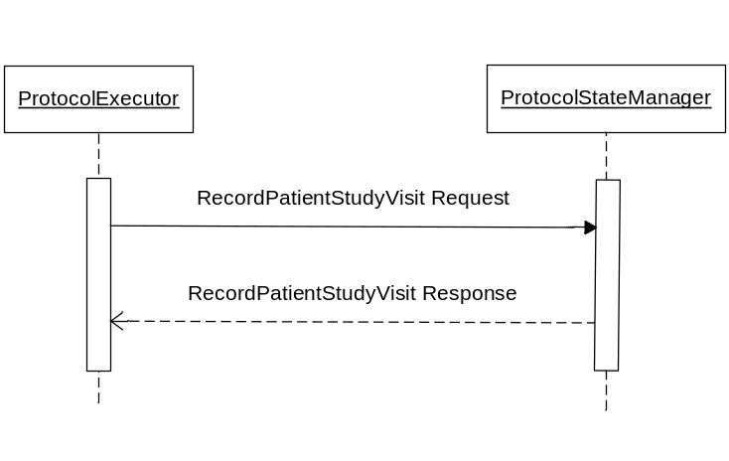

3.Y7.4.1 RecordPatientStudyVisit Request message
The RecordPatientStudyVisit request involves a ProtocolExecutor requesting to record a patient’s study visit into a ProtocolStateManager. The ProtocolExecutor must supply a well formed xml structure that represents a protocol definition ID, a patient and a visit. This is represented by the RecordPatientStudyVisitType in the RPE schema.

3.Y7.4.1.1 Trigger Events
The ProtocolExecutor based upon human decision or application of a rule for automatic operation, wants to record a patient’s study visit.
The ProtocolExecutor and ProtocolStateManager must have previously stored the scheduling information for the patient and study.
If the RecordPatientStudyVisit is triggered by the patient dying:
- If the identification of the death of the patient was determined within the ProtocolExecutor, then an associated RFD transaction would be used in conjunction with a RecordPatientStudyVisit to submit this information to the ProtocoStateManager.
- One reason for submitting an alert protocol state message is if the patient dies. In this case the ProtocolStateManager would submit an AlertProtocolState message letting the ProtocolExecutor know that the state of the patient within the study has changed.
This transaction would also be triggered by the site needing to let the external system know that the patient does not want to be a part of the study. RFD can also be used to withdraw the patient from the study.
This transaction can also be used to manage unscheduled events as well as the subsequent RFD transaction. Such events are unscheduled visits or adverse event reports.

3.Y7.4.1.2 Message Semantics
Implementers of this transaction shall comply with all requirements described in ITI TF-2:Appendix V:Web-Services for IHE Transactions.
The following parameters are specified for this transaction.
Parameter Name | REQ | Description | Value
RecordPatientStudyVisitType | R | An xml structure containing information on a patient, study and visit | This value is a well-formed xml document.
The RecordPatientStudyVisitType contains information on a patient, study and visit. The xml structure will look like:

<RecordPatientStudyVisitType>
<patient>an xml structure represented by the rpe:PatientType</patient>
<study>an xml structure represented by the HL7v3:StudyParticipationType</study>
<visit>an xml structure represented by the rpe:StudyVisitType</visit>
</RecordPatientStudyVisitType>
See schema provided with the support materials.

3.Y7.4.1.3 Expected Actions
Upon reception of the RecordPatientStudyVisit request, the ProtocolStateManager shall parse the request and shall return the requested response in the RecordPatientStudyVisit response element, or errors with SOAP faults.
- If there is missing information, such as no patient, no study or no visit, then the return shall be a SOAP fault. This SOAP fault shall use the following (faultcode: Client, faultstring: Required Information Missing) and may provide further information in the details element.
- If there is no related study available then the return shall be a SOAP fault. This shall use the following (faultcode: Client, faultstring: Unknown study) and may provide further information in the details element.
- The successful response by the ProtocolStatemanager shall return a RecordPatientStudyVisit response message, containing acknowledgement that the patient’s screening visits were scheduled.
(Put error faults in the wsdl.)

3.Y7.4.2 RecordPatientStudyVisit Response message

3.Y7.4.2.1 Trigger Events
The delivery of the acknowledgement that a patient’s study visit being recorded was received is triggered by a ProtocolStateManager actor responding to a RecordPatientStudyVisit request.

3.Y7.4.2.2 Message Semantics
The RecordPatientStudyVisit is returned containing the acknowledgement that the patient’s study visits have been scheduled.

3.Y7.4.2.3 Expected Actions
The ProtocolExecutor shall store the returned recorded patient’s study visit in the system associating it to the related patient. If an acknowledgement was not returned in the response, then the ProtocolExecutor shall not associate any visit information with the patient.

3.Y7.5 Security Considerations
<description of the transaction specific security consideration. Such as use of security profiles.>

3.Y7.5.1 Security Audit Considerations
<This section should specifiy any specific ATNA security audit event that is associated with this transaction and requirements on the encoding of that audit event. >

3.Y7.5.1.(z) Actor Specific Security Considerations
<This section should specifiy any specific security considerations on an Actor by Actor basis.>

3.Y7.6 Protocol Requirements
The RecordPatientStudyVisit request and response shall be transmitted using Synchronous Web Services Exchange, according to the requirements specified in ITI TF-2: Appendix V.
The RecordPatientStudyVisitRequest transaction shall use SOAP 12.
WSDL Namespace Definitions
Ihe | urn:ihe:iti:rfd:2007
soap12 | http://schemas.xmlsoap.org/wsdl/soap12/
Wsaw | http://www.w3.org/2005/08/addressing
Xsd | http://www.w3.org/2001/XMLSchema
These are the requirements for the RecordPatientStudyVisit transaction presented in the order in which they would appear in the WSDL definition:
- The following types shall be imported (xds:import) in the /definitions/types section:
  - Namespace=”urn:ihe:qrph:rpe:2009”, schema=”RPE.xsd”
- The /definitions/message/part/@element attribute of the RecordPatientStudyVisit Request message shall be defined as: “ihe:RecordPatientStudyVisit”
- The /definitions/message/part/@element attribute of the RecordPatientStudyVisit Response message shall be defined as: “ihe:RecordPatientStudyVisit”
- The /definitions/portType/operation/input/@wsaw:Action attribute for the RecordPatientStudyVisit Request message shall be defined as “urn:ihe:qrph:2009:RecordPatientStudyVisit”
- The /definitions/portType/operation/output/@wsaw:Action attribute for the RecordPatientStudyVisit Response message shall be defined as: “urn:ihe:qrph:2009:RecordPatientStudyVisit”
- The /definitions/binding/operation/soap12:operation/@soapAction attribute shall be defined as “urn:ihe:qrph:2009:RecordPatientStudyVisit”
These are the requirements that affect the wire format of the SOAP message. The other WSDL properties are only used within the WSDL definition and do not affect interoperability. Full sample request and response messages are in the section 3.Y1.5.1 Sample SOAP Messages.
For informative WSDL for the ProtocolStateManager see Appendix W. A full XML Schema Document for the RPE types is available online on the IHE FTP site. See Appendix W.

3.Y7.6.1 Sample SOAP Messages
The samples in the following two sections show a typical SOAP request and its relative SOAP response. The sample messages also show the WS-Addressing headers <Action/>, <MessageID/>, .;these WS-Addressing headers are populated according to the IHE Appendix V: Web Services for IHE Transactions. Some of the body of the SOAP message is omitted for brevity.

3.Y7.6.2 Sample RecordPatientStudyVisit SOAP Request

3.Y7.6.3 Sample RecordPatientStudyVisit SOAP Response

3.Y8 AmendProtocolDef transaction
This section corresponds to transaction QRPH-Y8 of the QRPH Framework. transaction QRPH-Y8 is used by the ProtocolDefManager and ProtocolExecutor actors.

3.Y8.1 Scope
This transaction involves a ProtocolDefManager requesting to amend a protocol definition within a ProtocolExecutor. The ProtocolDefManager and ProtocolExecutor contain a ProtocolDef obtained by means outside the scope of this profile. The ProtocolExecutor will return a success message for the protocol definition being amended or else it returns an error response.

3.Y8.2 Use Case Roles
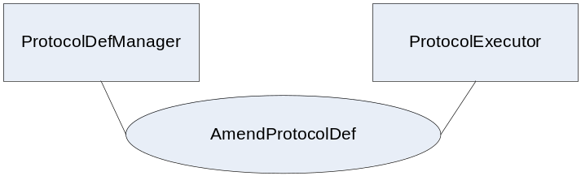
Actor: ProtocolDefManager
Role: A system that knows how to manage a clinical research study. The system accepts information related to the workflow of a protocol definition.
Actor: ProtocolExecutor
Role: A system that knows how to execute protocol definitions.

3.Y8.3 Referenced Standards
Implementers of this transaction shall comply with all requirements described in ITI TF-2: Appendix V: Web-Services for IHE Transactions
Additional educational information may be found on the IHE Wiki.
Extensible Markup Language (XML) 1.0 (Second Edition). W3C Recommendation 6 October 2000. http://www.w3.org/TR/REC-xml.
HL7v3 Study Design Topic - http://www.hl7.org/v3ballot/html/domains/uvrt/uvrt_StudyDesign.htm#PORT_DO000001UV-Studydesign-

3.Y8.4 Interaction Diagram
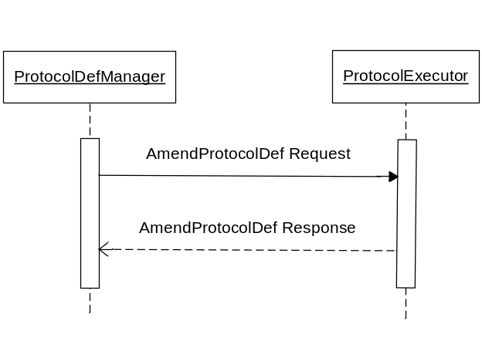

3.Y8.4.1 AmendProtocolDef Request message
The AmendProtocolDef request involves a ProtocolDefManager requesting to amend a protocol definition within a ProtocolExecutor. The ProtocolDefManager must supply a well formed xml structure that represents a protocol definition. This is represented by the AmendProtocolDefType in the RPE schema.

3.Y8.4.1.1 Trigger Events
The ProtocolDefManager based upon human decision or application of a rule for automatic operation, wants to amend a protocol definition.
The ProtocolDefManager and ProtocolExecutor must have previously stored the protocol definition information.

3.Y8.4.1.2 Message Semantics
Implementers of this transaction shall comply with all requirements described in ITI TF-2:Appendix V:Web-Services for IHE Transactions
The following parameters are specified for this transaction.
Parameter Name | REQ | Description | Value
AmendProtocolDefType | R | An xml structure containing information on a protocol definition | This value is a well-formed xml document.
The AmendProtocolDefType contains information on a protocol definition. The xml structure will look like:

<AmendProtocolDefType>
<protocolDef>an xml structure represented by the HL7v3:StudyDesign</protocolDef>
</AmendProtocolDefType>
See schema provided with the support materials.

3.Y8.4.1.3 Expected Actions
Upon reception of the AmendProtocolDef request, the ProtocolExecutor shall parse the request and shall return the requested response in the RecordPatientStudyVisit response element, or errors with SOAP faults.
- If there is missing information, such as no study then the return shall be a SOAP fault. This SOAP fault shall use the following (faultcode: Client, faultstring: Required Information Missing) and may provide further information in the details element.
- If there is no related study available then the return shall be a SOAP fault. This shall use the following (faultcode: Client, faultstring: Unknown study) and may provide further information in the details element.
- The successful response by the ProtocolStatemanager shall return a AmendProtocolDef response message, containing acknowledgement that the patient’s screening visits were scheduled.
(Put error faults in the wsdl.)

3.Y8.4.2 AmendProtocolDef Response message

3.Y8.4.2.1 Trigger Events
The delivery of the acknowledgement that a protocol definition amendment was received is triggered by a ProtocolExecutor actor responding to a AmendProtocolDef request.

3.Y8.4.2.2 Message Semantics
The AmendProtocolDef is returned containing the acknowledgement that the protocol definition has been amended.

3.Y8.4.2.3 Expected Actions
The ProtocolDefManager shall acknowledge that the ProtocolExecutor has amended the protocol definition. If an acknowledgement was not returned in the response, then the ProtocolDefManager shall attempt to resubmit the amendment based on the business rules of the system.

3.Y8.5 Security Considerations
<description of the transaction specific security consideration. Such as use of security profiles.>

3.Y8.5.1 Security Audit Considerations
<This section should specifiy any specific ATNA security audit event that is associated with this transaction and requirements on the encoding of that audit event. >

3.Y8.5.1.(z) Actor Specific Security Considerations
<This section should specifiy any specific security considerations on an Actor by Actor basis.>

3.Y8.6 Protocol Requirements
The AmendProtocolDefRequest request and response shall be transmitted using Synchronous Web Services Exchange, according to the requirements specified in ITI TF-2: Appendix V.
The AmendProtocolDefRequest transaction shall use SOAP 12.
WSDL Namespace Definitions
Ihe | urn:ihe:iti:rfd:2007
soap12 | http://schemas.xmlsoap.org/wsdl/soap12/
Wsaw | http://www.w3.org/2005/08/addressing
Xsd | http://www.w3.org/2001/XMLSchema
These are the requirements for the AmendProtocolDef transaction presented in the order in which they would appear in the WSDL definition:
- The following types shall be imported (xds:import) in the /definitions/types section:
  - Namespace=”urn:ihe:qrph:rpe:2009”, schema=”RPE.xsd”
- The /definitions/message/part/@element attribute of the AmendProtocolDef Request message shall be defined as: “ihe:AmendProtocolDef”
- The /definitions/message/part/@element attribute of the AmendProtocolDef Response message shall be defined as: “ihe:AmendProtocolDef”
- The /definitions/portType/operation/input/@wsaw:Action attribute for the AmendProtocolDef Request message shall be defined as “urn:ihe:qrph:2009:AmendProtocolDef”
- The /definitions/portType/operation/output/@wsaw:Action attribute for the AmendProtocolDef Response message shall be defined as: “urn:ihe:qrph:2009:AmendProtocolDef”
- The /definitions/binding/operation/soap12:operation/@soapAction attribute shall be defined as “urn:ihe:qrph:2009:AmendProtocolDef”
These are the requirements that affect the wire format of the SOAP message. The other WSDL properties are only used within the WSDL definition and do not affect interoperability. Full sample request and response messages are in the section 3.Y1.5.1 Sample SOAP Messages.
For informative WSDL for the ProtocolDefManager see Appendix W. A full XML Schema Document for the RPE types is available online on the IHE FTP site. See Appendix W.

3.Y8.6.1 Sample SOAP Messages
The samples in the following two sections show a typical SOAP request and its relative SOAP response. The sample messages also show the WS-Addressing headers <Action/>, <MessageID/>, .;these WS-Addressing headers are populated according to the IHE Appendix V: Web Services for IHE Transactions. Some of the body of the SOAP message is omitted for brevity.

3.Y8.6.2 Sample AmendProtocolDef SOAP Request

3.Y8.6.3 Sample AmendProtocolDef SOAP Response

3.Y9 AlertProtocolState transaction
This section corresponds to transaction QRPH-Y9 of the QRPH Framework. transaction QRPH-Y9 is used by the ProtocolStateManager and ProtocolExecutor actors.

3.Y9.1 Scope
This transaction involves a ProtocolStateManager requesting to alert a protocol state within a ProtocolExecutor. The ProtocolStateManager and ProtocolExecutor contain a protocol definition obtained by means outside the scope of this profile. The ProtocolExecutor will return a success message for the protocol alert or else it returns an error response.
This provides the ProtocolStateManager the ability to change the status of the subject involved in the study. This transaction would be used anytime an event takes place within the ProtocolStateManager which would change the status of the patient within the ProtocolExecutor.

3.Y9.2 Use Case Roles
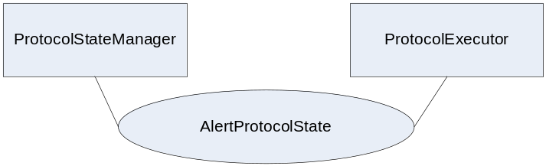
Actor: ProtocolStateManager
Role: A system that knows how to manage a clinical research study. The system accepts information related to the workflow of a protocol definition.
Actor: ProtocolExecutor
Role: A system that knows how to execute protocol definitions.

3.Y9.3 Referenced Standards
Implementers of this transaction shall comply with all requirements described in ITI TF-2: Appendix V: Web-Services for IHE Transactions
Additional educational information may be found on the IHE Wiki.
Extensible Markup Language (XML) 1.0 (Second Edition). W3C Recommendation 6 October 2000. http://www.w3.org/TR/REC-xml.
HL7v3 Study Participation - http://www.hl7.org/v3ballot/html/domains/uvrt/uvrt_StudyParticipation.htm

3.Y9.4 Interaction Diagram
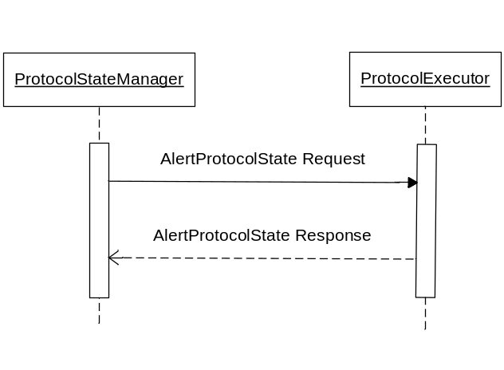

3.Y9.4.1 AlertProtocolState Request message
The AlertProtocolState request involves a ProtocolStateManager requesting to alert a protocol state within a ProtocolExecutor. The ProtocolStateManager must supply a well formed xml structure that represents a protocol defintions and patient. This is represented by the AlertProtocolStateType in the RPE schema.

3.Y9.4.1.1 Trigger Events
The ProtocolStateManager based upon human decision or application of a rule for automatic operation, wants to alert the ProtocolExecutor that the state of a subject involved in a clinical study has changed. This provides the ProtocolStateManager the ability to change the status of the subject involved in the study. This transaction would be used anytime an event takes place within the ProtocolStateManager which would change the status of the patient within the ProtocolExecutor.
If the RecordPatientStudyVisit is triggered by the patient dying:
- One reason for submitting an alert protocol state message is if the patient dies. In this case the ProtocolStateManager would submit an AlertProtocolState message letting the ProtocolExecutor know that the state of the patient within the study has changed.
- If the identification of the death of the patient was determined within the ProtocolExecutor, then an associated RFD transaction would be used in conjunction with a RecordPatientStudyVisit to submit this information to the ProtocoStateManager.
The ProtocolStateManager and ProtocolExecutor must have previously stored the protocol definition information.

3.Y9.4.1.2 Message Semantics
Implementers of this transaction shall comply with all requirements described in ITI TF-2:Appendix V:Web-Services for IHE Transactions
The following parameters are specified for this transaction.
Parameter Name | REQ | Description | Value
AlertProtocolStateType | R | An xml structure containing information on a patient and a study | This value is a well-formed xml document.
The AlertProtocolState contains information on a patient and a study. The xml structure will look like:

<AlertProtocolState>
<patient>an xml structure represented by the rpe:PatientType</patient>
<study>an xml structure represented by the HL7v3:StudyParticipationType</study>
</AlertProtocolState>
See schema provided with the support materials.

3.Y9.4.1.3 Expected Actions
Upon reception of the AlertProtocolState request, the ProtocolExecutor shall parse the request and shall return the requested response in the AlertProtocolState response element, or errors with SOAP faults.
- If there is missing information, such as no patient or study then the return shall be a SOAP fault. This SOAP fault shall use the following (faultcode: Client, faultstring: Required Information Missing) and may provide further information in the details element.
- If there is no related patient or study available then the return shall be a SOAP fault. This shall use the following (faultcode: Client, faultstring: Unknown patient or study) and may provide further information in the details element.
- The successful response by the ProtocolExecutor shall return an AlertProtocolState response message, containing acknowledgement that the alert was received.

3.Y9.4.2 AlertProtocolState Response message

3.Y9.4.2.1 Trigger Events
The delivery of the acknowledgement that an alert about the protocol state was received is triggered by a ProtocolExecutor actor responding to a AlertProtocolState request.

3.Y9.4.2.2 Message Semantics
The AlertProtocolState is returned containing the acknowledgement that an alert about the protocol state was received.

3.Y9.4.2.3 Expected Actions
The ProtocolStateManager shall acknowledge that the ProtocolExecutor has received the alert to the protocol state. If an acknowledgement was not returned in the response, then the ProtocolStateManager shall attempt to resubmit the alert based on the business rules of the system.

3.Y9.5 Security Considerations
<description of the transaction specific security consideration. Such as use of security profiles.>

3.Y9.5.1 Security Audit Considerations
<This section should specifiy any specific ATNA security audit event that is associated with this transaction and requirements on the encoding of that audit event. >

3.Y9.5.1.(z) Actor Specific Security Considerations
<This section should specifiy any specific security considerations on an Actor by Actor basis.>

3.Y9.6 Protocol Requirements
The AlertProtocolState request and response shall be transmitted using Synchronous Web Services Exchange, according to the requirements specified in ITI TF-2: Appendix V.
The AlertProtocolStateRequest transaction shall use SOAP 12.
WSDL Namespace Definitions
Ihe | urn:ihe:iti:rfd:2007
soap12 | http://schemas.xmlsoap.org/wsdl/soap12/
Wsaw | http://www.w3.org/2005/08/addressing
Xsd | http://www.w3.org/2001/XMLSchema
These are the requirements for the AlertProtocolState transaction presented in the order in which they would appear in the WSDL definition:
- The following types shall be imported (xds:import) in the /definitions/types section:
  - Namespace=”urn:ihe:qrph:rpe:2009”, schema=”RPE.xsd”
- The /definitions/message/part/@element attribute of the AlertProtocolState Request message shall be defined as: “ihe:AlertProtocolState”
- The /definitions/message/part/@element attribute of the AlertProtocolState Response message shall be defined as: “ihe:AlertProtocolState”
- The /definitions/portType/operation/input/@wsaw:Action attribute for the AlertProtocolState Request message shall be defined as “urn:ihe:qrph:2009:AlertProtocolState”
- The /definitions/portType/operation/output/@wsaw:Action attribute for the AlertProtocolState Response message shall be defined as: “urn:ihe:qrph:2009:AlertProtocolState”
- The /definitions/binding/operation/soap12:operation/@soapAction attribute shall be defined as “urn:ihe:qrph:2009:AlertProtocolState”
These are the requirements that affect the wire format of the SOAP message. The other WSDL properties are only used within the WSDL definition and do not affect interoperability. Full sample request and response messages are in the section 3.Y1.5.1 Sample SOAP Messages.
For informative WSDL for the ProtocolStateManager see Appendix W. A full XML Schema Document for the RPE types is available online on the IHE FTP site. See Appendix W.

3.Y9.6.1 Sample SOAP Messages
The samples in the following two sections show a typical SOAP request and its relative SOAP response. The sample messages also show the WS-Addressing headers <Action/>, <MessageID/>, .;these WS-Addressing headers are populated according to the IHE Appendix V: Web Services for IHE Transactions. Some of the body of the SOAP message is omitted for brevity.

3.Y9.6.2 Sample AlertProtocolState SOAP Request

3.Y9.6.3 Sample AlertProtocolState SOAP Response

