Integrating the Healthcare Enterprise



IHE Quality Research and Public Health
Technical Framework Supplement

Retrieve Protocol for Execution
(RPE)

Public Comment

Date: April 22, 2009
Author: Daemon Whittenburg
Email: ihe@himss.org

This is a supplement to the IHE Quality Research Public Health.

It is submitted for Public Comment between June 01, 2009 and July 01, 2009.
Comments shall be submitted within that period to http://forums.rsna.org:
Select the “IHE” forum
Select QRPH
Select 2009-2010 Supplements for Public Comment
Select Supplement Name
Please use the Public Comment Template provided there when starting your New Thread.

Details about IHE may be found at: www.ihe.net

Details about the IHE QRPH may be found at: http://www.ihe.net/Domains/index.cfm

Details about the structure of IHE Technical Frameworks and Supplements may be found at: http://www.ihe.net/About/process.cfm and http://www.ihe.net/profiles/index.cfm

The current version of the IHE QRPH Technical Framework may be found at:http://www.ihe.net/Technical_Framework/index.cfm

Table of Contents
Introduction 5
Profile Abstract 5
Open Issues and Questions 5
Closed Issues 5
Volume 1 – Integration Profiles 6
Glossary 6
1.7 History of Annual Changes 6
2.1 Dependencies among Integration Profiles 6
2.2.X RPE Integration Profile 6
X RPE Integration Profile 7
X.1 Actors/ Transactions 7
X.1.1 RPE Actors 8
X.1.1.1 ProtocolDefManager 8
X.1.1.2 ProtocolExecutor 8
X.1.1.3 ProtocolStateManager 8
X.1.2 RPE Transactions 9
X.1.2.1 RetrieveProtocolDef 9
X.1.2.2 EnterPatientRequest 9
X.1.2.3 PatientScreeningVisitScheduled 9
X.1.2.4 RecordPatientScreeningVisit 9
X.1.2.5 EnrollPatientRequest 9
X.1.2.6 PatientStudyVisitsScheduled 9
X.1.2.7 RecordPatientStudyVisit 9
X.1.2.8 AmendProtocolDef 9
X.1.2.9 AlertProtocolState 9
X.2 Retrieve Protocol for Execution Integration Profile Options 10
X.3 Retrieve Protocol for Execution Process Flow 10
X.4 RPE Security Considerations 11
<Appendix A> Actor Summary Definitions 12
<Appendix B> Transaction Summary Definitions 13
Volume 2 - Transactions 14
3 IHE Transactions 14
3.Y1 RetrieveProtocolDef transaction 14
3.Y1.1 Scope 14
3.Y1.2 Use Case Roles 14
3.Y1.3 Referenced Standard 14
3.Y1.4 Interaction Diagram 14
3.Y1.5 Security Considerations 16
3.Y2 EnterPatientRequest transaction 16
3.Y2.1 Scope 16
3.Y2.2 Use Case Roles 16
3.Y2.3 Referenced Standard 17
3.Y2.4 Interaction Diagram 17
3.Y3 PatientScreeningVisitsScheduled transaction 18
3.Y3.1 Scope 19
3.Y3.2 Use Case Roles 19
3.Y3.3 Referenced Standard 19
3.Y3.4 Interaction Diagram 19
3.Y4 RecordPatientScreeningVisit transaction 21
3.Y4.1 Scope 21
3.Y4.2 Use Case Roles 21
3.Y4.3 Referenced Standard 21
3.Y4.4 Interaction Diagram 21
3.Y5 EnrollPatientRequest transaction 23
3.Y5.1 Scope 23
3.Y5.2 Use Case Roles 23
3.Y5.3 Referenced Standard 23
3.Y5.4 Interaction Diagram 24
3.Y6 PatientStudyVisitsScheduled transaction 25
3.Y6.1 Scope 26
3.Y6.2 Use Case Roles 26
3.Y6.3 Referenced Standard 26
3.Y6.4 Interaction Diagram 26
3.Y7 RecordPatientStudyVisit transaction 28
3.Y7.1 Scope 28
3.Y7.2 Use Case Roles 28
3.Y7.3 Referenced Standard 28
3.Y7.4 Interaction Diagram 28
3.Y8 AmendProtocolDef transaction 30
3.Y8.1 Scope 30
3.Y8.2 Use Case Roles 30
3.Y8.3 Referenced Standard 30
3.Y8.4 Interaction Diagram 31
3.Y9 AlertProtocolState transaction 32
3.Y9.1 Scope 32
3.Y9.2 Use Case Roles 32
3.Y9.3 Referenced Standard 33
3.Y9.4 Interaction Diagram 33

Introduction
The Retrieve Protocol for Execution Profile (RPE) provides an automated mechanism for an Electronic Health Record (EHR) to retrieve a complex set of clinical research instructions (Protocol Definition) from an Electronic Data Capture (EDC) system to execute within the EHR.
Profile Abstract
The Retrieve Protocol for Execution Profile (RPE) provides an automated mechanism for an Electronic Health Record (EHR) to retrieve a complex set of clinical research instructions (Protocol Definition) from an Electronic Data Capture (EDC) system to execute within the EHR.
Many health care sites supplement their core patient care activities by participating in clinical trials. Currently, the tasks required for clinical research participation are served by EDC systems entirely separate from the site's EHR. The ITI profile Retrieve Form for Data-capture (RFD), along with its complementary content profile Clinical Research Data-capture (CRD) have set a path towards integrating site-based clinical research into the workflow of the EHR. This new profile, RPE, expands the scope of workflow integration between clinical research and an EHR.
A standard protocol document is being developed by the CDISC's Protocol Representation Group (PRG). This protocol representation includes the Trial Design Model (TDM), a standard structure for representing the planned sequence of events and the treatment plan of a trial. This planned sequence of events includes many tasks that could be executed by an EHR's workflow engine. These standards will be used to insert the executable workflow tasks into the EHR without hindering the normal activities of the site.

Open Issues and Questions
< List of open issues/questions that need to be addressed prior to publishing of the Technical Framework>
Does it make sense for each of the Actors in Table X.1-1 to be required to implement each of the transactions?

Closed Issues
< List of closed issues/ questions with their resolutions that have been addressed prior to publishing of the Technical Framework>

Volume 1 – Integration Profiles

Glossary
Add the following terms to the Glossary:
Clinical Trial Protocol - The ICH (International Conference on Harmonization) GCP (Good Clinical Practice) defines a Clinical Trail Protocol to be "a document that describes the objective(s), design, methodology, statistical considerations, and organization of a clinical trial. The protocol usually also gives the background and reason the trial is being conducted, but these could be provided in other documents referenced in the protocol (such as an Investigator's Brochure)."
ProtocolDef - The protocol documentation created by an eClinical Research sponsor that describes a clinical research study. The ProtocolDef will be maintained by the ProtocolManager.
ProtocolState - The protocol state at the point in which a patient is involved in a clinical study.

1.7 History of Annual Changes

2.1 Dependencies among Integration Profiles
Add the following to Table 2-1
RPE is dependent on RFD
<RPE> | <?> | <?> | <->

Add the following section to section 2.2

2.2.X RPE Integration Profile

The Retrieve Protocol for Execution Profile (RPE) provides an automated mechanism for an Electronic Health Record (EHR) to retrieve a complex set of clinical research instructions (Protocol Definition) from an Electronic Data Capture (EDC) system to execute within the EHR.
Many healthcare sites supplement their core patient care activities by participating in clinical trials. Currently, the tasks required for clinical research participation are served by systems entirely separate from the site's EHR. The ITI profile Retrieve Form for Data-capture (RFD), along with its complementary content profile Clinical Research Data-capture, have set a path towards integrating site-based clinical research workflow into the task manager of an electronic health record. This new profile, Retrieve Protocol for Execution, expands the scope of workflow integration between clinical research and EHR systems.
Add Section X to the QRPH Framework

X RPE Integration Profile

The Retrieve Protocol for Execution Profile (RPE) provides an automated mechanism for an Electronic Health Record (EHR) to retrieve a complex set of clinical research instructions (Protocol Definition) from an Electronic Data Capture (EDC) system to execute within the EHR.
Many healthcare sites supplement their core patient care activities by participating in clinical trials. Currently, the tasks required for clinical research participation are served by systems entirely separate from the site's EHR. The ITI profile Retrieve Form for Data-capture (RFD), along with its complementary content profile Clinical Research Data-capture, have set a path towards integrating site-based clinical research workflow into the task manager of an electronic health record. This new profile, Retrieve Protocol for Execution, expands the scope of workflow integration between clinical research and EHR systems.

RFD specification has uses cases as X.1 and Actors/Transactions as X.2

X.1 Actors/ Transactions
Figure X.1-1 shows the actors directly involved in theRetrieve Protocol for Execution Integration Profile and the relevant transactions between them. Other actors that may be indirectly involved due to their participation in other profiles are not necessarily shown.
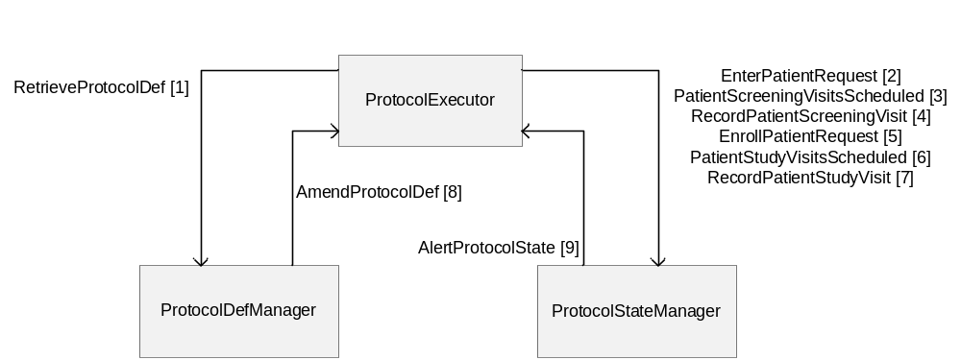
Figure X. 1-1 RPE Actor Diagram

Table X.1-1 lists the transactions for each actor directly involved in the RPE Profile. In order to claim support of this Integration Profile, an implementation must perform the required transactions (labeled “R”). Transactions labeled “O” are optional. A complete list of options defined by this Integration Profile and that implementations may choose to support is listed in Volume I, Section X.2.

Table X.1-1. Retrieve Protocol for Execution Integration Profile - Actors and Transactions
Actors | Transactions | Optionality | Section in Vol. 2
ProtocolDefManager | RetrieveProtocolDef | R | QRPH TF-2:3.Y1
ProtocolDefManager | AmendProtocolDef | R | QRPH TF-2:3.Y8
ProtocolExecutor | RetreiveProtocolDef | R | QRPH TF-2:3.Y1
ProtocolExecutor | EnterPatientRequest | R | QRPH TF-2:3.Y2
ProtocolExecutor | PatientScreeningVisitsScheduled | R | QRPH TF-2:3.Y3
ProtocolExecutor | RecordPatientScreeningVisit | R | QRPH TF-2:3.Y4
ProtocolExecutor | EnrollPatientRequest | R | QRPH TF-2:3.Y5
ProtocolExecutor | PatientStudyVisitsScheduled | R | QRPH TF-2:3.Y6
ProtocolExecutor | RecordPatientStudyVisit | R | QRPH TF-2:3.Y7
ProtocolExecutor | AmendProtocolDef | R | QRPH TF-2:3.Y8
ProtocolExecutor | AlertProtocolState | R | QRPH TF-2:3.Y9
ProtocolStateManager | EnterPatientRequest | R | QRPH TF-2:3.Y2
ProtocolStateManager | PatientScreeningVisitsScheduled | R | QRPH TF-2:3.Y3
ProtocolStateManager | RecordPatientScreeningVisit | R | QRPH TF-2:3.Y4
ProtocolStateManager | EnrollPatientRequest | R | QRPH TF-2:3.Y5
ProtocolStateManager | PatientStudyVisitsScheduled | R | QRPH TF-2:3.Y6
ProtocolStateManager | RecordPatientStudyVisit | R | QRPH TF-2:3.Y7
ProtocolStateManager | AlertProtocolState | R | QRPH TF-2:3.Y9

X.1.1 RPE Actors

X.1.1.1 ProtocolDefManager
The ProtocolDefManager manages clinical research protocol definitions. An example would be an EDC vendor that wishes to allow access to the list of clinical research protocol definitions contained within the EDC system.

X.1.1.2 ProtocolExecutor
The ProtocolExecutor accesses clinical research protocol definitions from an entity that manages clinical research protocol definitions. An example would be an EHR vendor that wants to participate in clinical studies by accessing clinical research protocol definitions. This entity would also consume and execute the protocol definition within the application.

X.1.1.3 ProtocolStateManager
The ProtocolStateManager wants to receive clinical research data from a supplying entity. An example would be an EDC vendor wanting to consume data from an EHR.

X.1.2 RPE Transactions

X.1.2.1 RetrieveProtocolDef
Used to allow a ProtocolExecutor to retrieve an instance of a ProtocolDef for a particular study from a ProtocolDefManager. Can be used by a site attempting to pull down a ProtocolDef once they have finalized all Prerequisites/Dependencies to execute this transaction.

X.1.2.2 EnterPatientRequest
prereq: patient has signed consent, meets pre-screening eligibility criteria before consent. parameters: a structure to allow for multiple patients to be entered.

X.1.2.3 PatientScreeningVisitScheduled
prereq: patient entered

X.1.2.4 RecordPatientScreeningVisit
prereq: patient entered

X.1.2.5 EnrollPatientRequest
prereq: screening complete, meets screening eligibility criteria. Reasons for failure: screen failed, study put on hold, enrollment complete

X.1.2.6 PatientStudyVisitsScheduled

X.1.2.7 RecordPatientStudyVisit
usage: ProtocolExecutor needs to alert ProtocolManager that patient doesn't want to be a part of the study from ProtocolExecutor. An RFD form to withdraw the patient from study can also be used. Unscheduled events can also be managed using this transaction and the subsequent RFD transaction. Such events are unscheduled visits or adverse event reporting.

X.1.2.8 AmendProtocolDef
Allows a ProtocolDefManager to update the ProtocolExecutor when the ProtocolDef changes

X.1.2.9 AlertProtocolState
Allows the ProtocolStateManager to update the ProtocolExecutor when something needs to change with the state of the subject-sepecific Protocol information. Examples are (ScreenFailed, FreezePatient, Unfreeze/Thaw, LockPatient/SignOffPatient/PatientComplete, Unlock [big issue...more auditable]. This provides the ProtocolStateManager the ability to change the status of the subject involved in the study. This transaction would be used anytime an event takes place within the ProtocolStateManager which would change the status of the patient within the ProtocolExecutor.

X.2 Retrieve Protocol for Execution Integration Profile Options
Options that may be selected for this Integration Profile are listed in the table X.2-1 along with the Actors to which they apply. Dependencies between options when applicable are specified in notes.
Table X.2-1 RPE - Actors and Options
Actor | Options | Vol & Section
ProtocolDefManager | No options defined | - -
ProtocolExecutor | No options defined | - -
ProtocolStateManager | No options defined | - -

X.3 Retrieve Protocol for Execution Process Flow
<Description of the process flow(s) and sequence diagram(s) covered by this profile in order to satisfy the use cases. This often will include a brief description of the use cases as well. If there are detailed behavioral rules that apply to a specific process flow or multiple process flows or descriptions then an appendix may be added as needed>
- <Need brief description of the use case. Only one use case here for now. Clinical Research>
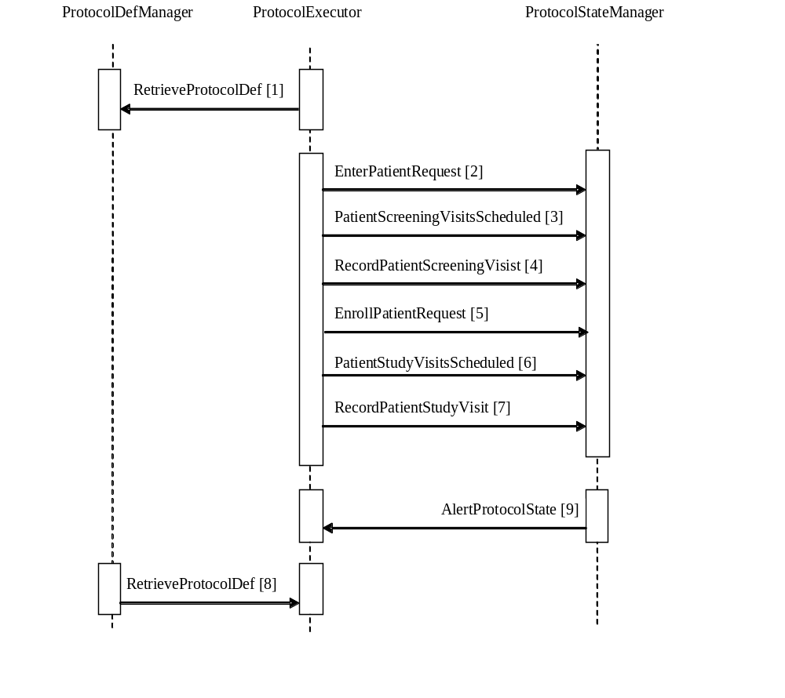
Figure X.2-1. Basic Process Flow in RPE Profile

X.4 RPE Security Considerations
<Description of the Profile specific security considerations. This should include the outcomes of a risk assessment. This likely will include profile groupings, and residual risks that need to be assigned to the product design, system administration, or policy.>
(Security Consult / Risk Analysis)
Threats and risks that are exposed. Critical for Ballot. (Robert.Horn@agfa.com)

<Appendix A> Actor Summary Definitions
<add any actor definitions for new actors defined specifically for this profile>
Protocol Definition Manager - An entity that manages clinical research protocol definitions. An example would be an EDC vendor that wishes to allow access to the list of clinical research protocol definitions contained within the EDC system.
Protocol Executor - An entity wanting to access clinical research protocol definitions from an entity that manages clinical research protocol definitions. An example would be an EHR vendor that wants to participate in clinical studies by accessing clinical research protocol definitions. This entity would also consume and execute the protocol definition within the application.
Protocol State Manager - An entity wanting to receive clinical research data from a supplying entity. An example would be an EDC vendor wanting to consume data from an EHR.

<Appendix B> Transaction Summary Definitions
<add any transaction definitions for new transactions defined specifically for this profile>
RetreiveProtocolDef - Used to allow a ProtocolExecutor to retrieve an instance of a ProtocolDef for a particular study from a ProtocolDefManager. Can be used by a site attempting to pull down a ProtocolDef once they have finalized all Prerequisites/Dependencies to execute this transaction.
EnterPatientRequest - prereq: patient has signed consent, meets pre-screening eligibility criteria before consent. parameters: a structure to allow for multiple patients to be entered.
PatientScreeningVisitsScheduled - prereq: patient entered
RecordPatientScreeningVisit - prereq: patient entered
EnrollPatientRequest - prereq: screening complete, meets screening eligibility criteria. Reasons for failure: screen failed, study put on hold, enrollment complete
PatientStudyVisitsScheduled
RecordPatientStudyVisit - usage: ProtocolExecutor needs to alert ProtocolManager that patient doesn't want to be a part of the study from ProtocolExecutor. An RFD form to withdraw the patient from study can also be used. Unscheduled events can also be managed using this transaction and the subsequent RFD transaction. Such events are unscheduled visits or adverse event reporting.
AmendProtocolDef - Allows a ProtocolDefManager to update the ProtocolExecutor when the ProtocolDef changes
AlertProtocolState - Allows the ProtocolStateManager to update the ProtocolExecutor when something needs to change with the state of the subject-sepecifif Protocol information. Examples are (ScreenFailed, FreezePatient, Unfreeze/Thaw, LockPatient/SignOffPatient/PatientComplete, Unlock [big issue...more auditable]. This provides the ProtocolStateManager the ability to change the status of the subject involved in the study. This transaction would be used anytime an event takes place within the ProtocolStateManager which would change the status of the patient within the ProtocolExecutor.

Volume 2 - Transactions
Add section 3.Y

3 IHE Transactions

3.Y1 RetrieveProtocolDef transaction
This section corresponds to transaction QRPH-Y1 of the IHE QRPH Framework. Transaction QRPH-Y1 is used by the ProtocolDefManager and ProtocolExecutor actors.

3.Y1.1 Scope
This transaction involves a ProtocolExecutor requesting a ProtocolDef from a ProtocolDefManager. The ProtocolExecutor has a set of ProtocolDefIDs obtained by means outside the scope of this profile. The ProtocolDefManager will return a list of ProtocolDefs cooresponding to the given set of ProtocolDefIDs or else it returns an error response. The set of ProtocolDefs will be returned in a standard XML format.

3.Y1.2 Use Case Roles
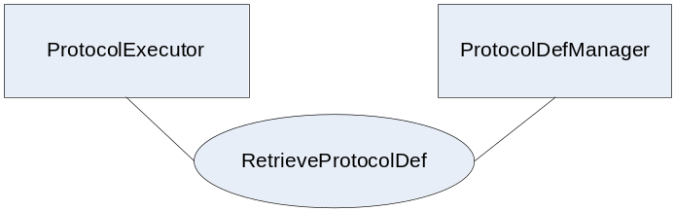
Actor: ProtocolExecutor
Role: A system that knows how to execute ProtocolDefs.
Actor: ProtocolDefManager
Role: A system that provides a set of ProtocolDefs based upon request. The system accepts requests based on a set of ProtocolDefIDs.

3.Y1.3 Referenced Standards
Implementers of this transaction shall comply with all requirements described in ITI TF-2: Appendix V: Web-Services for IHE Transactions
Additional educational information may be found on the IHE Wiki.
Extensible Markup Language (XML) 1.0 (Second Edition). W3C Recommendation 6 October 2000. http://www.w3.org/TR/REC-xml.

HL7v3 Study Design Topic - http://www.hl7.org/v3ballot/html/domains/uvrt/uvrt_StudyDesign.htm#PORT_DO000001UV-Studydesign-

3.Y1.4 Interaction Diagram
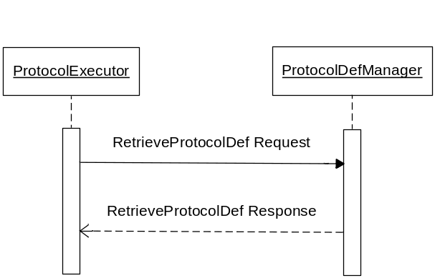

3.Y1.4.1 RetrieveProtocolDef Request message
The RetreiveProtocolDef request passes a ProtocolDef query to be requested by the ProtocolExecutor to the ProtocolDefManager.

3.Y1.4.1.1 Trigger Events
The ProtocolExecutor needs to request a ProtocolDef from a ProtocolDefManager to consume the ProtocolDef within the ProtocolExecutor
Needs to be a testable trigger. This is what the testers are setting up for testing.
Can be interpreted as pre-requisites. (Well formed query)

3.Y1.4.1.2 Message Semantics
Implementers of this transaction shall comply with all requirements described in ITI TF-2:Appendix V:Web-Services for IHE Transactions
(Add table with parameters of transaction)
(Add comment to see schema provided in support materials)

3.Y1.4.1.3 Expected Actions
The ProtocolExecutor will expect to receive a ProtocolDef from the ProtocolDefManager. The ProtocolDefManager will expect to receive a ProtocolDef identifier and will return a ProtocolDef to the ProtocolExecutor. A valid response should return HTTP responseCode 200 and an invalid response should be 404.
What should be done based on values of parameters?
The ProtocolDefManager shall... and if not, then return 404 etc.
Expect response of system to any action that the profile contemplates.
Put error faults in the wsdl.
See ITI TF-2:Appendix V:Web-Services for wsdl guidance.

3.Y1.4.2 RetrieveProtocolDef Response message
The return of the RetrieveProtocolDef transaction from the ProtocolDefManager to the ProtocolExecutor will be an HL7v3 Study Design Topic message.

3.Y1.4.2.1 Trigger Events
A request is made from the ProtocolExecutor to the ProtocolDefManager requesting a specific ProtocolDef from the ProtocolDefManager.

3.Y1.4.2.2 Message Semantics
Implementers of this transaction shall comply with all requirements described in ITI TF-2:Appendix V:Web-Services for IHE Transactions
(Add table with parameters of transaction)
The HL7v3 Study Design Topic message represents a ProtocolDef using an HL7v3 standard.
(Add comment to see schema provided in support materials)

3.Y1.4.2.3 Expected Actions
The ProtocolDefManager will be expected to send the HL7v3 Study Design Topic message as part of the return of the RetrieveProtocolDef transaction to the ProtocolExecutor.

3.Y1.5 Security Considerations
<description of the transaction specific security consideration. Such as use of security profiles.>

3.Y1.5.1 Security Audit Considerations
<This section should specifiy any specific ATNA security audit event that is associated with this transaction and requirements on the encoding of that audit event. >

3.Y1.5.1.(z) Actor Specific Security Considerations
<This section should specifiy any specific security considerations on an Actor by Actor basis.>
Protocol Requirements (add section)
XDS.b (look up RFD)

3.Y2 EnterPatientRequest transaction
This section corresponds to transaction QRPH-Y2 of the IHE Technical Framework. transaction QRPH-Y2 is used by the ProtocolExecutor and ProtocolStateManager actors.

3.Y2.1 Scope

3.Y2.2 Use Case Roles
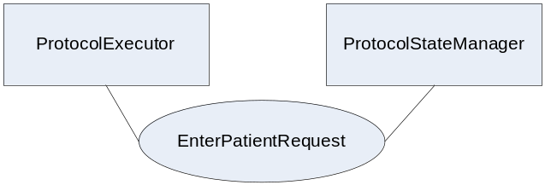
Actor: ProtocolExecutor
Role: Executes the step EnterPatientRequest of the ProtocolDef
Actor: ProtocolStateManager
Role: Records state information for a subject involved in a ProtocolDef. Approves or doesn’t allow entry of patient into the clinical study.

3.Y2.3 Referenced Standard
HL7v3 Study Participation - http://www.hl7.org/v3ballot/html/domains/uvrt/uvrt_StudyParticipation.htm

3.Y2.4 Interaction Diagram
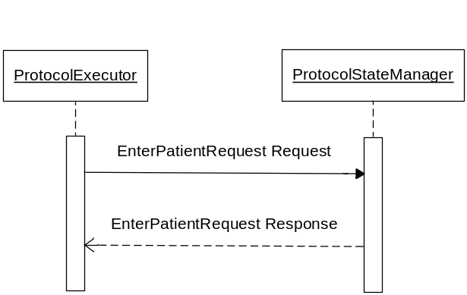

3.Y2.4.1 EnterPatientRequest Request message
The ProtocolExecutor uses the EnterPatientRequest Request message to attempt to enter a patient into a clinical study. The ProtocolExecutor passes patient and study information to the ProtocolStateManager.

3.Y2.4.1.1 Trigger Events
The ProtocolExecutor needs to attempt to enter a patient as a candidate for a clinical study.

3.Y2.4.1.2 Message Semantics
Implementers of this transaction shall comply with all requirements described in ITI TF-2:Appendix V:Web-Services for IHE Transactions
(Add table with parameters of transaction)
(Add comment to see schema provided in support materials)

3.Y2.4.1.3 Expected Actions
The ProtocolExecutor expects the patient to either be entered as a candidate for the clinical study or denied as a candidate for the clinical study. The ProtocolStateManager expects proper patient information and study information to be supplied.
What should be done based on values of parameters?

3.Y2.4.2 EnterPatientRequest Response message
The ProtocolStateManager uses the EnterPatientRequest Response message to return clinical study candidate status information about the patient to the ProtocolExecutor. The ProtocolExecutor then associates the clinical study candidate information to the correct patient within the ProtocolExecutor

3.Y2.4.2.1 Trigger Events
A request is made from the ProtocolExecutor to the ProtocolStateManager to enter the patient as a candidate for a clinical study.

3.Y2.4.2.2 Message Semantics
Implementers of this transaction shall comply with all requirements described in ITI TF-2:Appendix V:Web-Services for IHE Transactions
(Add table with parameters of transaction)
The HL7v3 Study Participation message represents a patient’s participation in a clinical study using an HL7v3 standard.
(Add comment to see schema provided in support materials)

3.Y2.4.2.3 Expected Actions
The ProtocolStateManager expects to submit candidate information for a given clinical study to the ProtocolExecutor. The ProtocolExecutor expects to receive candidate information for a given clinical study from the ProtocolStateManager. A valid response should return HTTP responseCode 200 and an invalid response should return 404.
What should be done based on values of parameters?

3.Y2.5 Security Considerations
<description of the transaction specific security consideration. Such as use of security profiles.>

3.Y2.5.1 Security Audit Considerations
<This section should specifiy any specific ATNA security audit event that is associated with this transaction and requirements on the encoding of that audit event. >

3.Y2.5.1.(z) Actor Specific Security Considerations
<This section should specifiy any specific security considerations on an Actor by Actor basis.>

3.Y3 PatientScreeningVisitsScheduled transaction
This section corresponds to transaction QRPH-Y3 of the QRPH Framework. transaction QRPH-Y3 is used by the ProtocolExecutor and ProtocolStateManager actors.

3.Y3.1 Scope

3.Y3.2 Use Case Roles
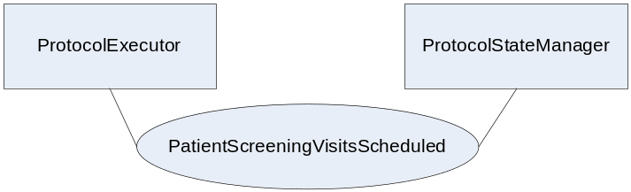
Actor: ProtocolExecutor
Role: Executes the step PatientScreeningVisitsScheduled of the ProtocolDef
Actor: ProtocolStateManager
Role: Records state information for a subject involved in a ProtocolDef

3.Y3.3 Referenced Standard
HL7v3 Study Participation - http://www.hl7.org/v3ballot/html/domains/uvrt/uvrt_StudyParticipation.htm

3.Y3.4 Interaction Diagram

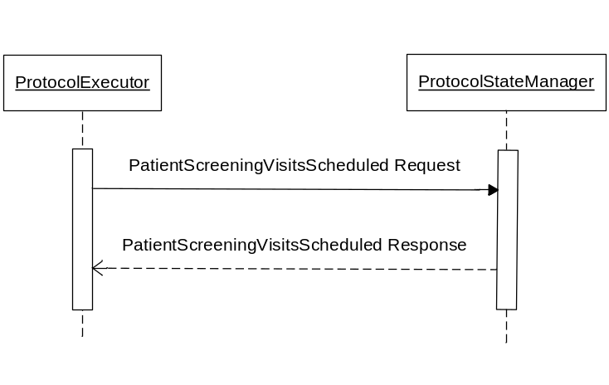

3.Y3.4.1 PatientScreeningVisitsScheduled Request message
The ProtocolExecutor uses the PatientScreeningVisitsScheduled Request message to update the ProtocolStateManager that a subject’s screening visits have been scheduled.

3.Y3.4.1.1 Trigger Events
The ProtocolExecutor schedules the patient’s screening visits.

3.Y3.4.1.2 Message Semantics
Implementers of this transaction shall comply with all requirements described in ITI TF-2:Appendix V:Web-Services for IHE Transactions
(Add table with parameters of transaction)
(Add comment to see schema provided in support materials)

3.Y3.4.1.3 Expected Actions
The ProtocolExecutor expects the patient’s screening visits to either be scheduled in the ProtocolStateManager or denied. The ProtocolStateManager expects patient, study and scheduling information.
What should be done based on values of parameters?

3.Y3.4.2 PatientScreeningVisitsScheduled Response message
The ProtocolStateManager uses the PatientScreeningVisitsScheduled Response message to return the status of acceptance or denial of the patient’s screening visits scheduled to the ProtocolExecutor. The ProtocolExecutor handles the message as needed.

3.Y3.4.2.1 Trigger Events
A request is made from the ProtocolExcutor to the ProtocolStateManager to schedule the patient’s screening visits.

3.Y3.4.2.2 Message Semantics
Implementers of this transaction shall comply with all requirements described in ITI TF-2:Appendix V:Web-Services for IHE Transactions
(Add table with parameters of transaction)
The HL7v3 Study Participation message represents a patient’s participation in a clinical study using an HL7v3 standard.
(Add comment to see schema provided in support materials)

3.Y3.4.2.3 Expected Actions
The ProtocolStateManager expects to submit acceptance or denial of the patient’s scheduled screening visits to the ProtocolExecutor. The ProtocolExecutor expects to receive the approval or denial from the ProtocolStateManager. A valid response should return HTTP responseCode 200 and an invalid response should return 404.
What should be done based on values of parameters?

3.Y3.5 Security Considerations
<description of the transaction specific security consideration. Such as use of security profiles.>

3.Y3.5.1 Security Audit Considerations
<This section should specifiy any specific ATNA security audit event that is associated with this transaction and requirements on the encoding of that audit event. >

3.Y3.5.1.(z) Actor Specific Security Considerations
<This section should specifiy any specific security considerations on an Actor by Actor basis.>

3.Y4 RecordPatientScreeningVisit transaction
This section corresponds to transaction QRPH-Y4 of the QRPH Framework. transaction QRPH-Y4 is used by the ProtocolExecutor and ProtocolStateManager actors.

3.Y4.1 Scope

3.Y4.2 Use Case Roles
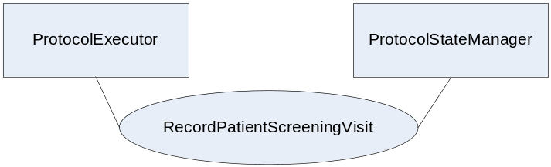
Actor: ProtocolExecutor
Role: Executes the step RecordPatientScreeningVisit of the ProtocolDef
Actor: ProtocolStateManager
Role: Records state information for a subject involved in a ProtocolDef

3.Y4.3 Referenced Standard
HL7v3 Study Participation - http://www.hl7.org/v3ballot/html/domains/uvrt/uvrt_StudyParticipation.htm

3.Y4.4 Interaction Diagram
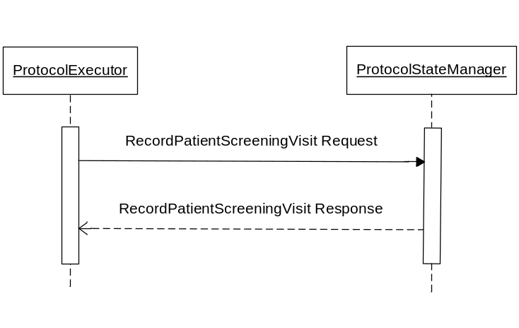

3.Y4.4.1 RecordPatientScreeningVisit Request message
The ProtocolExecutor uses the RecordPatientScreeningVisit Request message to submit recorded patient screening visit information to the ProtocolStateManager. The ProtocolExecutor passes patient, study and visit information to the ProtocolStateManager.

3.Y4.4.1.1 Trigger Events
The ProtocolExecutor records a patient screening visit.

3.Y4.4.1.2 Message Semantics
Implementers of this transaction shall comply with all requirements described in ITI TF-2:Appendix V:Web-Services for IHE Transactions
(Add table with parameters of transaction)
(Add comment to see schema provided in support materials)

3.Y4.4.1.3 Expected Actions
The ProtocolExecutor expects the recorded visit to be reported to the ProtocolStateManager. The ProtocolStateManager expects patient, study and visit information to be supplied.
What should be done based on values of parameters?

3.Y4.4.2 RecordPatientScreeningVisit Response message
The ProtocolStateManager uses the RecordPatientScreeningVisit Response message to return the status of the patient’s screening visit that was recorded to the ProtocolExecutor. The ProtocolExecutor handles the status as needed.

3.Y4.4.2.1 Trigger Events
A request is made from the ProtocolExecutor to the ProtocolStateManager that the patient’s screening visit has been recorded.

3.Y4.4.2.2 Message Semantics
Implementers of this transaction shall comply with all requirements described in ITI TF-2:Appendix V:Web-Services for IHE Transactions
(Add table with parameters of transaction)
The HL7v3 Study Participation message represents a patient’s participation in a clinical study using an HL7v3 standard.
(Add comment to see schema provided in support materials)

3.Y4.4.2.3 Expected Actions
The ProtocolStateManager expects to submit status information of the recorded patient screening visit to the ProtocolExecutor. The ProtocolExecutor expects to receive status information about the recorded patient screening visit from the ProtocolStateManager. A valid response should return HTTP responseCode 200 and an invalid response should return 404.
What should be done based on values of parameters?

3.Y4.5 Security Considerations
<description of the transaction specific security consideration. Such as use of security profiles.>

3.Y4.5.1 Security Audit Considerations
<This section should specifiy any specific ATNA security audit event that is associated with this transaction and requirements on the encoding of that audit event. >

3.Y4.5.1.(z) Actor Specific Security Considerations
<This section should specifiy any specific security considerations on an Actor by Actor basis.>

3.Y5 EnrollPatientRequest transaction
This section corresponds to transaction QRPH-Y5 of the QRPH Framework. transaction QRPH-Y5 is used by the ProtocolExecutor and ProtocolStateManager actors.

3.Y5.1 Scope

3.Y5.2 Use Case Roles
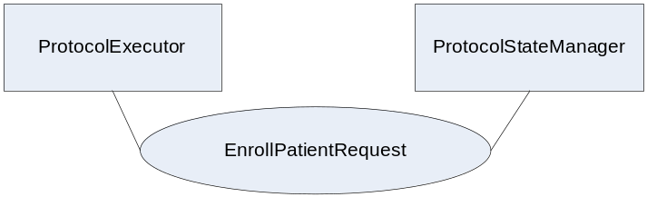
Actor: ProtocolExecutor
Role: Executes the step EnrollPatientRequest of the ProtocolDef
Actor: ProtocolStateManager
Role: Records state information for a subject involved in a ProtocolDef

3.Y5.3 Referenced Standard
HL7v3 Study Participation - http://www.hl7.org/v3ballot/html/domains/uvrt/uvrt_StudyParticipation.htm

3.Y5.4 Interaction Diagram
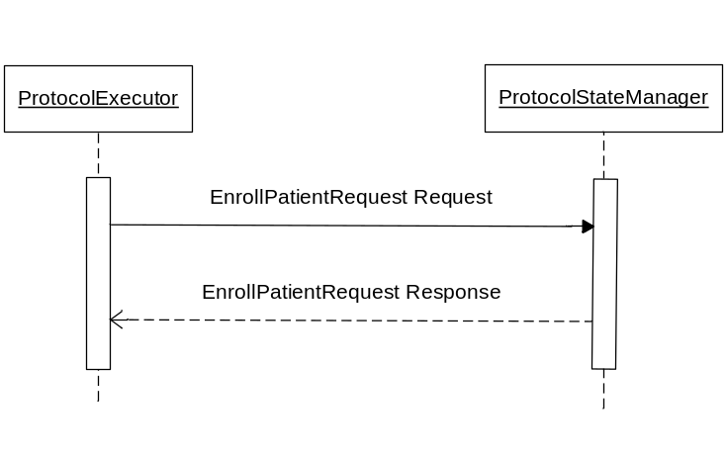

3.Y5.4.1 EnrollPatientRequest Request message
The ProtocolExecutor uses the EnrollPatientRequest Request message to attempt to enroll a patient into a clinical study. The ProtocolExecutor passes patient and study information to the ProtocolStateManager.

3.Y5.4.1.1 Trigger Events
The ProtocolExecutor attempts to enroll a patient as a subject for a clinical study.

3.Y5.4.1.2 Message Semantics
Implementers of this transaction shall comply with all requirements described in ITI TF-2:Appendix V:Web-Services for IHE Transactions
(Add table with parameters of transaction)
(Add comment to see schema provided in support materials)

3.Y5.4.1.3 Expected Actions
The ProtocolExecutor expects the patient to either be enrolled as a subject for the clinical study or denied as a subject for the clinical study. The ProtocolStateManager expects proper patient information and study information to be supplied.
What should be done based on values of parameters?

3.Y5.4.2 EnrollPatientRequest Response message
The ProtocolStateManager uses the EnterPatientRequest Response message to return clinical study subject status information about the patient to the ProtocolExecutor. The ProtocolExecutor then associates the clinical study subject information to the correct patient within the ProtocolExecutor.

3.Y5.4.2.1 Trigger Events
A request is made from the ProtocolExecutor to the ProtocolStateManager to enroll the patient as a subject for a clinical study.

3.Y5.4.2.2 Message Semantics
Implementers of this transaction shall comply with all requirements described in ITI TF-2:Appendix V:Web-Services for IHE Transactions
(Add table with parameters of transaction)
The HL7v3 Study Participation message represents a patient’s participation in a clinical study using an HL7v3 standard.
(Add comment to see schema provided in support materials)

3.Y5.4.2.3 Expected Actions
The ProtocolStateManager expects to submit subject information for a given clinical study to the ProtocolExecutor. The ProtocolExecutor expects to receive subject information for a given clinical study from the ProtocolStateManager. A valid response should return HTTP responseCode 200 and an invalid response should return 404.
What should be done based on values of parameters?

3.Y5.5 Security Considerations
<description of the transaction specific security consideration. Such as use of security profiles.>

3.Y5.5.1 Security Audit Considerations
<This section should specify any specific ATNA security audit event that is associated with this transaction and requirements on the encoding of that audit event. >

3.Y5.5.1.(z) Actor Specific Security Considerations
<This section should specifiy any specific security considerations on an Actor by Actor basis.>

3.Y6 PatientStudyVisitsScheduled transaction
This section corresponds to transaction QRPH-Y6 of the QRPH Framework. transaction QRPH-Y6 is used by the ProtocolExecutor and ProtocolStateManager actors.

3.Y6.1 Scope

3.Y6.2 Use Case Roles
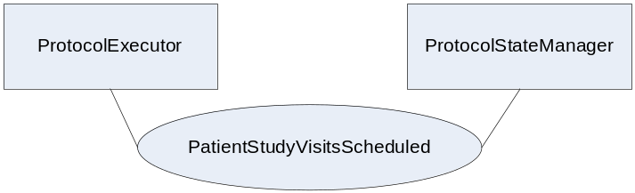
Actor: ProtocolExecutor
Role: Executes the step PatientStudyVisitsScheduled of the ProtocolDef
Actor: ProtocolStateManager
Role: Records state information for a subject involved in a ProtocolDef

3.Y6.3 Referenced Standard
HL7v3 Study Participation - http://www.hl7.org/v3ballot/html/domains/uvrt/uvrt_StudyParticipation.htm

3.Y6.4 Interaction Diagram
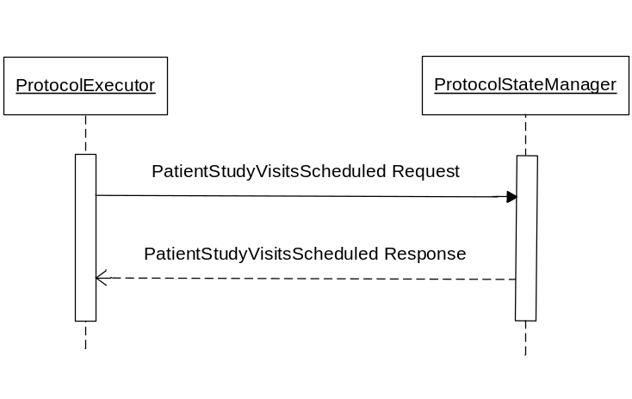

3.Y6.4.1 PatientStudyVisitsScheduled Request message

The ProtocolExecutor uses the PatientStudyVisitsScheduled Request message to update the ProtocolStateManager that a subject’s study visits have been scheduled.

3.Y6.4.1.1 Trigger Events
The ProtocolExecutor schedules the patient’s study visits.

3.Y6.4.1.2 Message Semantics
Implementers of this transaction shall comply with all requirements described in ITI TF-2:Appendix V:Web-Services for IHE Transactions
(Add table with parameters of transaction)
(Add comment to see schema provided in support materials)

3.Y6.4.1.3 Expected Actions
The ProtocolExecutor expects the patient’s study visits to either be scheduled in the ProtocolStateManager or denied. The ProtocolStateManager expects patient, study and scheduling information.
What should be done based on values of parameters?

3.Y6.4.2 PatientStudyVisitsScheduled Response message
The ProtocolStateManager uses the PatientStudyVisitsScheduled Response message to return the status of acceptance or denial of the patient’s study visits scheduled to the ProtocolExecutor. The ProtocolExecutor handles the status as needed.

3.Y6.4.2.1 Trigger Events
A request is made from the ProtocolExecutor to the ProtocolStateManager to schedule the patient’s study visits.

3.Y6.4.2.2 Message Semantics
Implementers of this transaction shall comply with all requirements described in ITI TF-2:Appendix V:Web-Services for IHE Transactions
(Add table with parameters of transaction)
The HL7v3 Study Participation message represents a patient’s participation in a clinical study using an HL7v3 standard.
(Add comment to see schema provided in support materials)

3.Y6.4.2.3 Expected Actions
The ProtocolStateManager expects to submit acceptance or denial of the patient’s scheduled subject visits to the ProtocolExecutor. The ProtocolExecutor expects to receive the approval or denial from the ProtocolStateManager. A valid response should return HTTP responseCode 200 and an invalid response should return 404.
What should be done based on values of parameters?

3.Y6.5 Security Considerations
<description of the transaction specific security consideration. Such as use of security profiles.>

3.Y6.5.1 Security Audit Considerations
<This section should specifiy any specific ATNA security audit event that is associated with this transaction and requirements on the encoding of that audit event. >

3.Y6.5.1.(z) Actor Specific Security Considerations
<This section should specifiy any specific security considerations on an Actor by Actor basis.>

3.Y7 RecordPatientStudyVisit transaction
This section corresponds to transaction QRPH-Y7 of the QRPH Framework. transaction QRPH-Y7 is used by the ProtocolExecutor and ProtocolStateManager actors.

3.Y7.1 Scope
Unscheduled events can also be managed using this transaction and the subsequent RFD transaction. Such events are unscheduled visits or adverse event reporting.

3.Y7.2 Use Case Roles
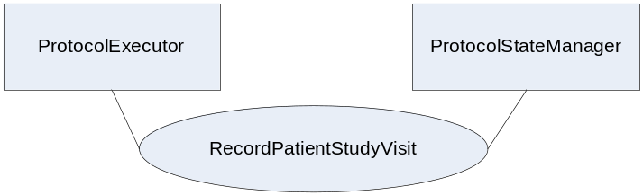
Actor: ProtocolExecutor
Role: Executes the step PatientScreeningVisitsScheduled of the ProtocolDef
Actor: ProtocolStateManager
Role: Records state information for a subject involved in a ProtocolDef

3.Y7.3 Referenced Standard
HL7v3 Study Participation - http://www.hl7.org/v3ballot/html/domains/uvrt/uvrt_StudyParticipation.htm

3.Y7.4 Interaction Diagram
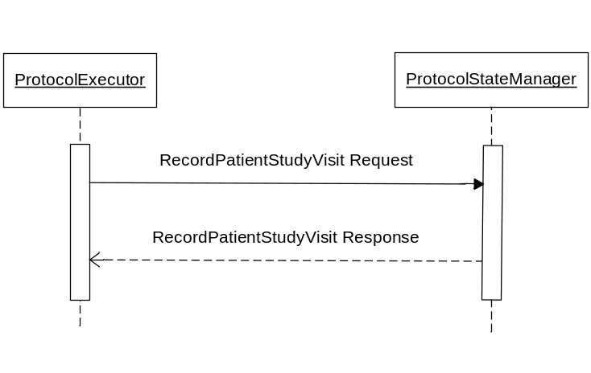

3.Y7.4.1 RecordPatientStudyVisit Request message
The ProtocolExecutor uses the RecordPatientStudyVisit Request message to submit recorded patient study visit information to the ProtocolStateManager. The ProtocolExecutor passes patient, study and visit information to the ProtocolStateManager.

3.Y7.4.1.1 Trigger Events
The ProtocolExecutor records a patient study visit. Unscheduled events can also be managed using this transaction and the subsequent RFD transaction. Such events are unscheduled visits or adverse event reporting.

3.Y7.4.1.2 Message Semantics
Implementers of this transaction shall comply with all requirements described in ITI TF-2:Appendix V:Web-Services for IHE Transactions
(Add table with parameters of transaction)
(Add comment to see schema provided in support materials)

3.Y7.4.1.3 Expected Actions
The ProtocolExecutor expects the recorded study visit to be reported to the ProtocolStateManager. The ProtocolStateManager expects patient, study and visit information to be supplied.
What should be done based on values of parameters?
Unscheduled events can also be managed using this transaction and the subsequent RFD transaction. Such events are unscheduled visits or adverse event reporting.

3.Y7.4.2 RecordPatientStudyVisit Response message
The ProtocolStateManager uses the RecordPatientStudyVisit Response message to return the status of the patient’s study visit that was recorded to the ProtocolExecutor. The ProtocolExecutor handles the status as needed.

3.Y7.4.2.1 Trigger Events
A request is made from the ProtocolExecutor to the ProtocolStateManager that the patient’s study visit has been recorded.

3.Y7.4.2.2 Message Semantics
Implementers of this transaction shall comply with all requirements described in ITI TF-2:Appendix V:Web-Services for IHE Transactions
(Add table with parameters of transaction)
The HL7v3 Study Participation message represents a patient’s participation in a clinical study using an HL7v3 standard.
(Add comment to see schema provided in support materials)

3.Y7.4.2.3 Expected Actions
The ProtocolStateManager expects to submit status information of the recorded patient study visit to the ProtocolExecutor. The ProtocolExecutor expects to receive status information about the recorded patient study visit from the ProtocolStateManager. A valid response should return HTTP responseCode 200 and an invalid response should return 404.
What should be done based on values of parameters?

3.Y7.5 Security Considerations
<description of the transaction specific security consideration. Such as use of security profiles.>

3.Y7.5.1 Security Audit Considerations
<This section should specifiy any specific ATNA security audit event that is associated with this transaction and requirements on the encoding of that audit event. >

3.Y7.5.1.(z) Actor Specific Security Considerations
<This section should specifiy any specific security considerations on an Actor by Actor basis.>

3.Y8 AmendProtocolDef transaction
This section corresponds to transaction QRPH-Y8 of the QRPH Framework. transaction QRPH-Y8 is used by the ProtocolDefManager and ProtocolExecutor actors.

3.Y8.1 Scope

3.Y8.2 Use Case Roles
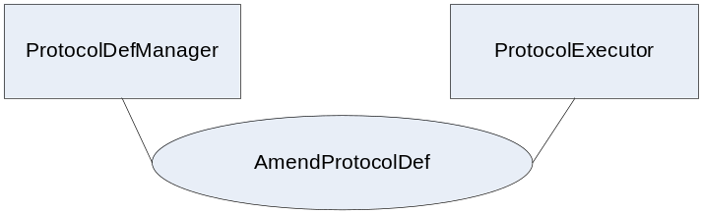
Actor: ProtocolDefManager
Role: Sends a message to the ProtocolExecutor when a ProtocolDef has been amended
Actor: ProtocolExecutor
Role: Changes the execution plan for the ProtocolDef for the given clinical study

3.Y8.3 Referenced Standard
HL7v3 Study Design Topic - http://www.hl7.org/v3ballot/html/domains/uvrt/uvrt_StudyDesign.htm#PORT_DO000001UV-Studydesign-

3.Y8.4 Interaction Diagram
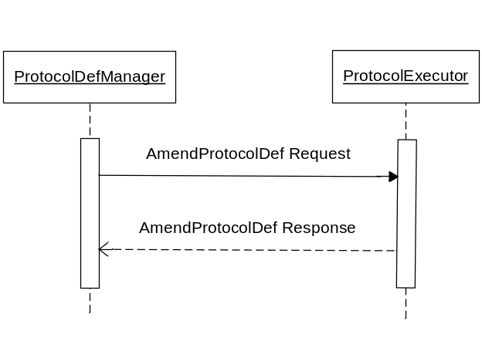

3.Y8.4.1 AmendProtocolDef Request message
The ProtocolDefManager uses the AmendProtocolDef Request message to alert the ProtocolExecutor that the ProtocolDef has changed. The ProtocolDefManager passes study information to the ProtocolExecutor.

3.Y8.4.1.1 Trigger Events
The ProtocolDefManager exposes a change to the ProtocolDef.

3.Y8.4.1.2 Message Semantics
Implementers of this transaction shall comply with all requirements described in ITI TF-2:Appendix V:Web-Services for IHE Transactions
(Add table with parameters of transaction)
(Add comment to see schema provided in support materials)

3.Y8.4.1.3 Expected Actions
The ProtocolDefManager expects the changes to the ProtocolDef to be expressed within the ProtocolExecutor. The ProtocolExecutor expects correct study information to be submitted.
What should be done based on values of parameters?

3.Y8.4.2 AmendProtocolDef Response message
The ProtocolExecutor uses the AmendProtocolDef Response message to return a status of what was done with the message within the ProtocolExecutor to the ProtocolDefManager. The ProtocolDefManager handles the status message appropriately.

3.Y8.4.2.1 Trigger Events
A request is made from the ProtocolDefManager to the ProtocolExecutor to amend the protocol definition.

3.Y8.4.2.2 Message Semantics
Implementers of this transaction shall comply with all requirements described in ITI TF-2:Appendix V:Web-Services for IHE Transactions
(Add table with parameters of transaction)
The HL7v3 Study Design Topic message represents a ProtocolDef using an HL7v3 standard.
(Add comment to see schema provided in support materials)

3.Y8.4.2.3 Expected Actions
The ProtocolDefManager is expected to submit proper ProtocolDef information for a given clinical study protocol to the ProtocolExecutor. The ProtocolExecutor expects to receive the ProtocolDef information. A valid response should return HTTP responseCode 200 and an invalid response should return 404.
What should be done based on values of parameters?

3.Y8.5 Security Considerations
<description of the transaction specific security consideration. Such as use of security profiles.>

3.Y8.5.1 Security Audit Considerations
<This section should specifiy any specific ATNA security audit event that is associated with this transaction and requirements on the encoding of that audit event. >

3.Y8.5.1.(z) Actor Specific Security Considerations
<This section should specifiy any specific security considerations on an Actor by Actor basis.>

3.Y9 AlertProtocolState transaction
This section corresponds to transaction QRPH-Y9 of the QRPH Framework. transaction QRPH-Y9 is used by the ProtocolStateManager and ProtocolExecutor actors.

3.Y9.1 Scope
This provides the ProtocolStateManager the ability to change the status of the subject involved in the study. This transaction would be used anytime an event takes place within the ProtocolStateManager which would change the status of the patient within the ProtocolExecutor.

3.Y9.2 Use Case Roles
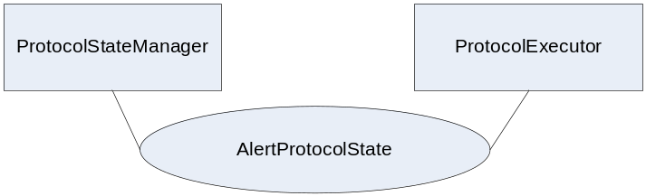
Actor: ProtocolStateManager
Role: Sends a message to the ProtocolExecutor when the status of a patient involved in a clinical study or ProtocolDef has been changed
Actor: ProtocolExecutor
Role: Acts on the message sent from the ProtocolStateManager

3.Y9.3 Referenced Standard
HL7v3 Study Participation - http://www.hl7.org/v3ballot/html/domains/uvrt/uvrt_StudyParticipation.htm

3.Y9.4 Interaction Diagram
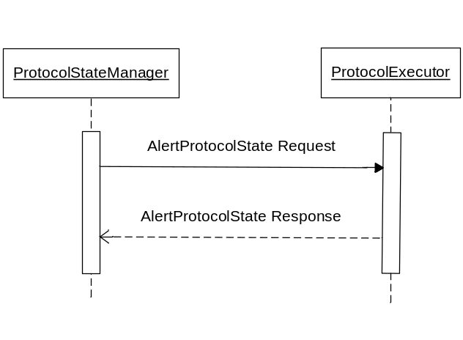

3.Y9.4.1 AlertProtocolState Request message
The ProtocolStateManager uses the AlertProtocolState Request message to alert the ProtocolExecutor that the state of the subject involved in a study has changed. The ProtocolStateManager passes patient and study information to the ProtocolExecutor.

3.Y9.4.1.1 Trigger Events
The ProtocolStateManager needs to alert the ProtocolExecutor that the state of the subject involved in a study has changed. This provides the ProtocolStateManager the ability to change the status of the subject involved in the study. This transaction would be used anytime an event takes place within the ProtocolStateManager which would change the status of the patient within the ProtocolExecutor.

3.Y9.4.1.2 Message Semantics
Implementers of this transaction shall comply with all requirements described in ITI TF-2:Appendix V:Web-Services for IHE Transactions
(Add table with parameters of transaction)
(Add comment to see schema provided in support materials)

3.Y9.4.1.3 Expected Actions
The ProtocolStateManager expects the ProtocolExecutor to act accordingly to the alert being passed. The ProtocolExecutor expects proper patient and study information to be supplied.
What should be done based on values of parameters?

3.Y9.4.2 AlertProtocolState Response message
The ProtocolExecutor uses the AlertProtocolState Response message to return the status of how the AlertProtocolState Request message was handled. The ProtocolStateManager handles the response message appropriately.

3.Y9.4.2.1 Trigger Events
A request is made from the ProtocolStateManager to the ProtocolExecutor alerting that the state has changed.

3.Y9.4.2.2 Message Semantics
Implementers of this transaction shall comply with all requirements described in ITI TF-2:Appendix V:Web-Services for IHE Transactions
(Add table with parameters of transaction)
The HL7v3 Study Design Topic message represents a ProtocolDef using an HL7v3 standard.
(Add comment to see schema provided in support materials)

3.Y9.4.2.3 Expected Actions
The ProtocolStateManager is expected to submit proper information related to the subject information and study information for a given clinical study to the ProtocolExecutor. The ProtocolExecutor expects to receive the subject information and study information. A valid response should return HTTP responseCode 200 and an invalid response should return 404.
What should be done based on values of parameters?

3.Y9.5 Security Considerations
<description of the transaction specific security consideration. Such as use of security profiles.>

3.Y9.5.1 Security Audit Considerations
<This section should specifiy any specific ATNA security audit event that is associated with this transaction and requirements on the encoding of that audit event. >

3.Y9.5.1.(z) Actor Specific Security Considerations
<This section should specifiy any specific security considerations on an Actor by Actor basis.>

